3.2.2 Number of workshops/seminars conducted on Research Methodology, Intellectual Property Rights (IPR) and entrepreneurship during the year
Year | Name of the workshop/ seminar | Number of Participants | Date From – To | Link to the Activity report on the website
2024 | " Cutting Edge Research in Life Science, Methodology and Patent" | 101 | 2/17/2024
2023 | online Workshop on " Revised Syllabus of S.Y.B.com " | 130 | 02-11-2023
2023 | online Workshop on "Revised Syllabus of M.sc Biotechnology – w.e.f. June 2023 as per NEP" | 103 | 07-10-2023
2023 | Udyogdhara | 50 | 9-9-2023

" Cutting Edge Research in Life Science, Methodology and Patent"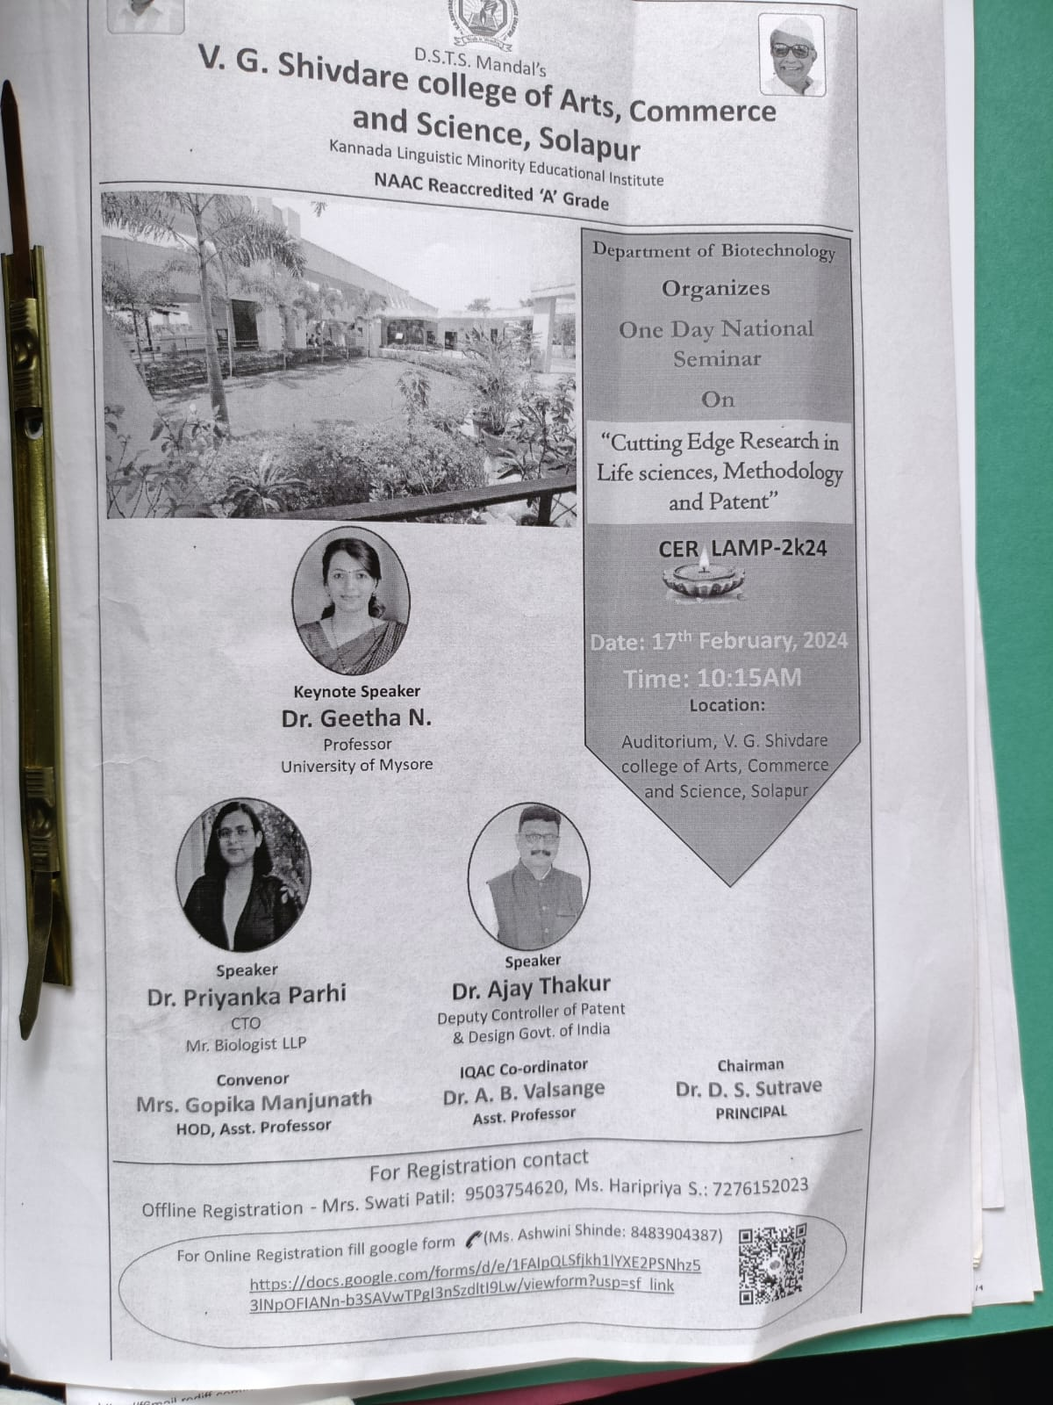
Felicitation to Speaker Dr. Ajay Thakur Deputy Controller of Patent & Desing, Gov. of India
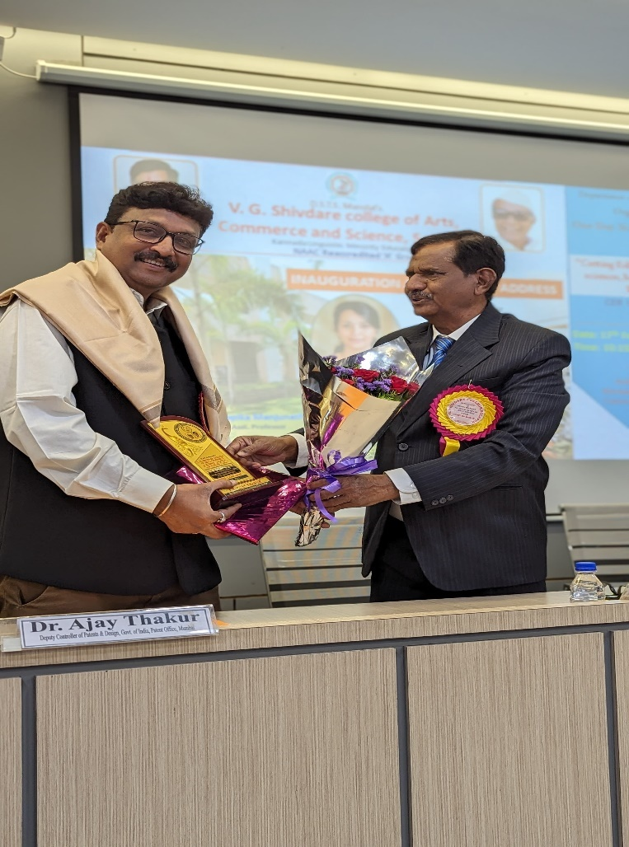
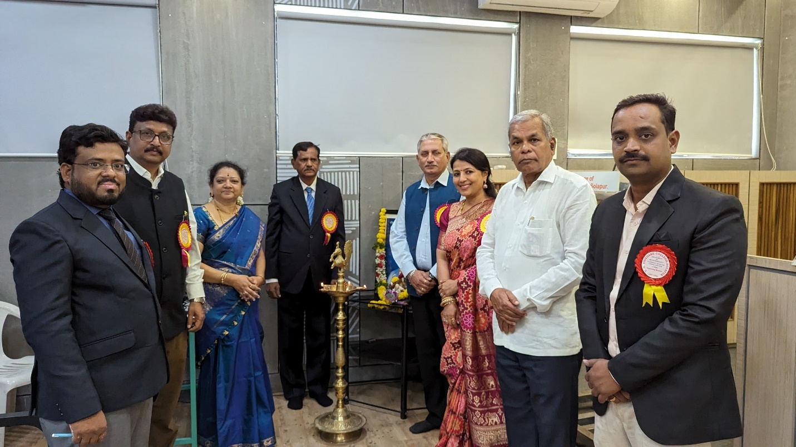
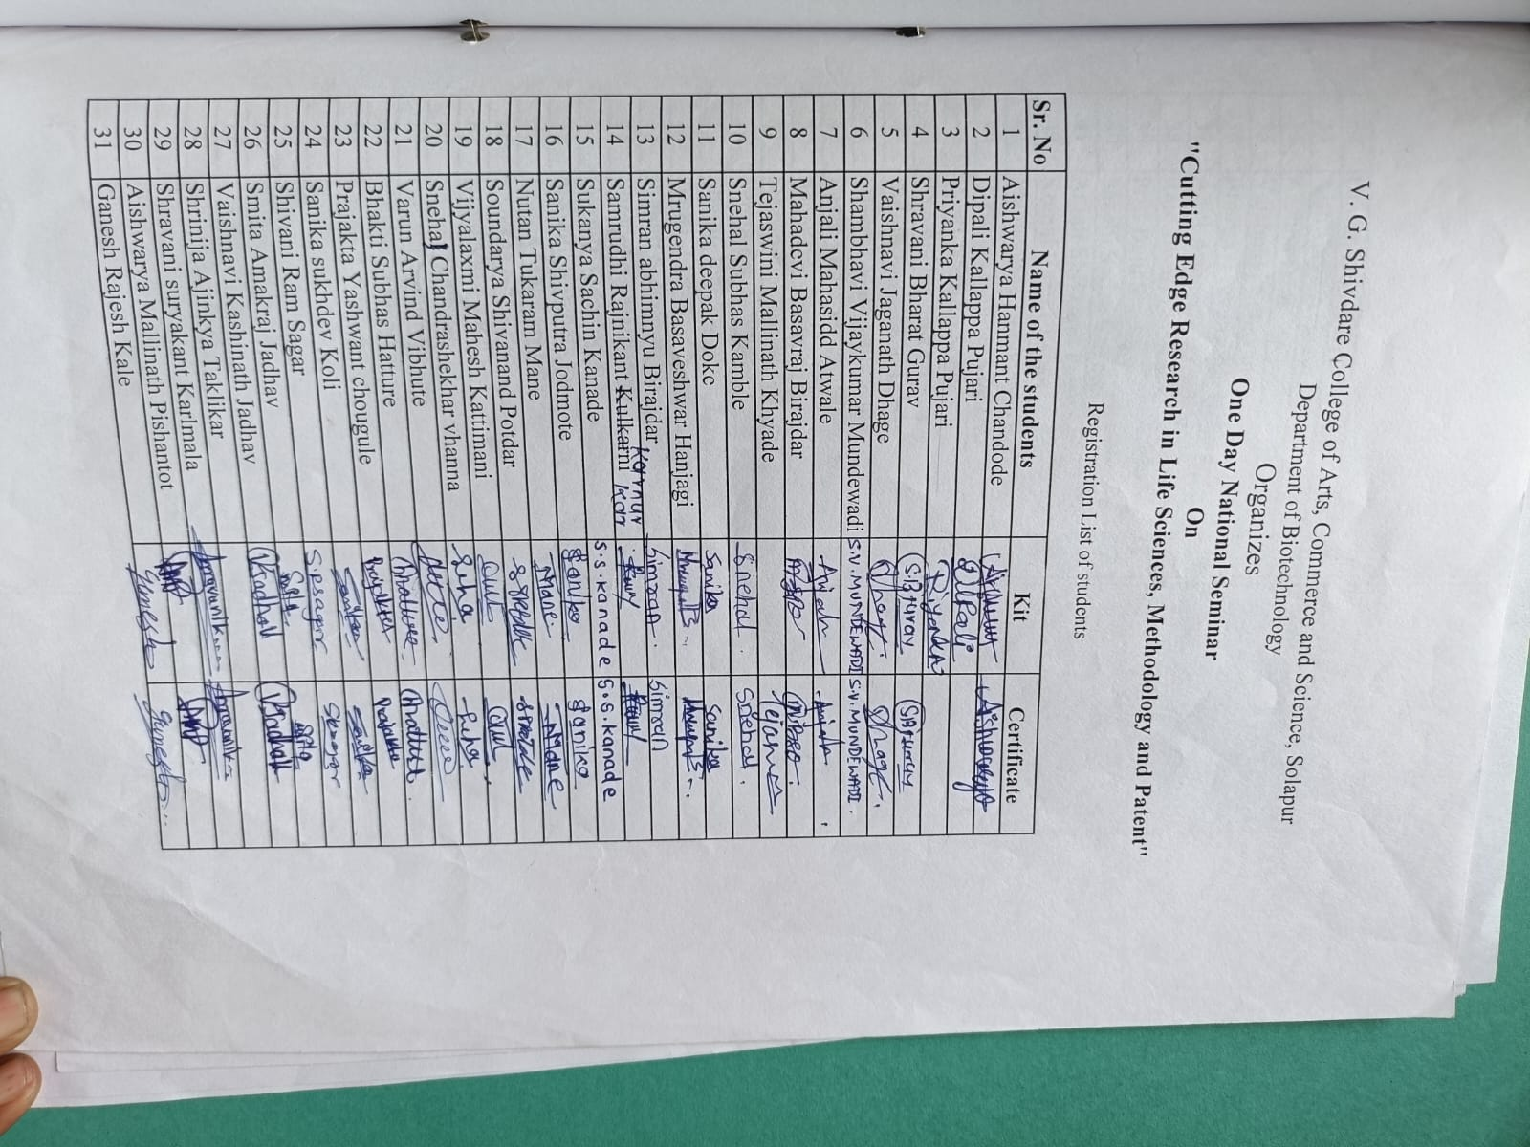

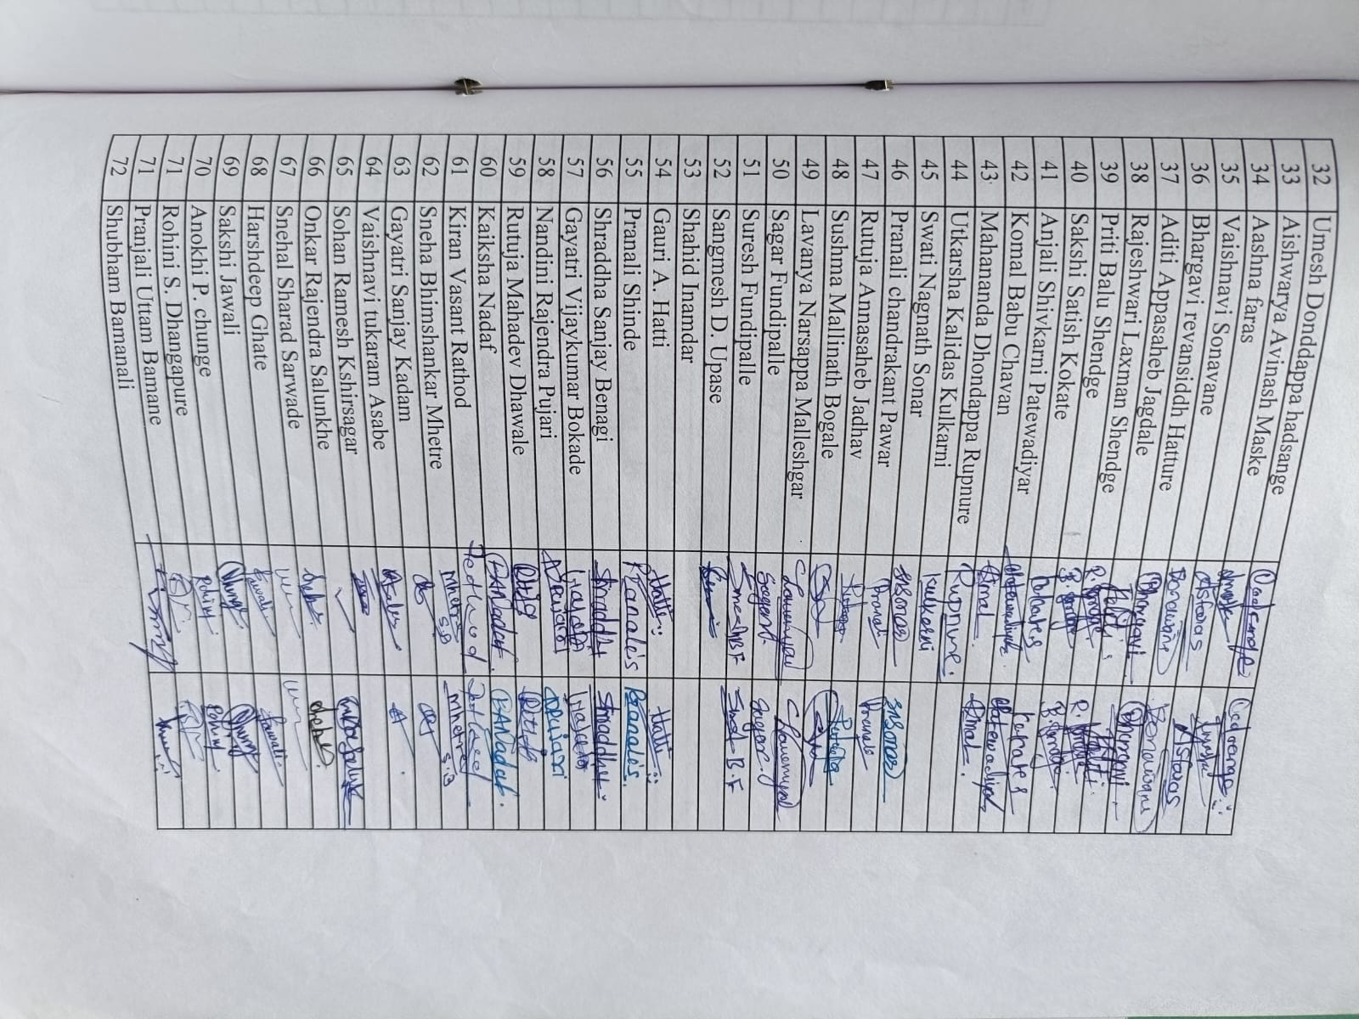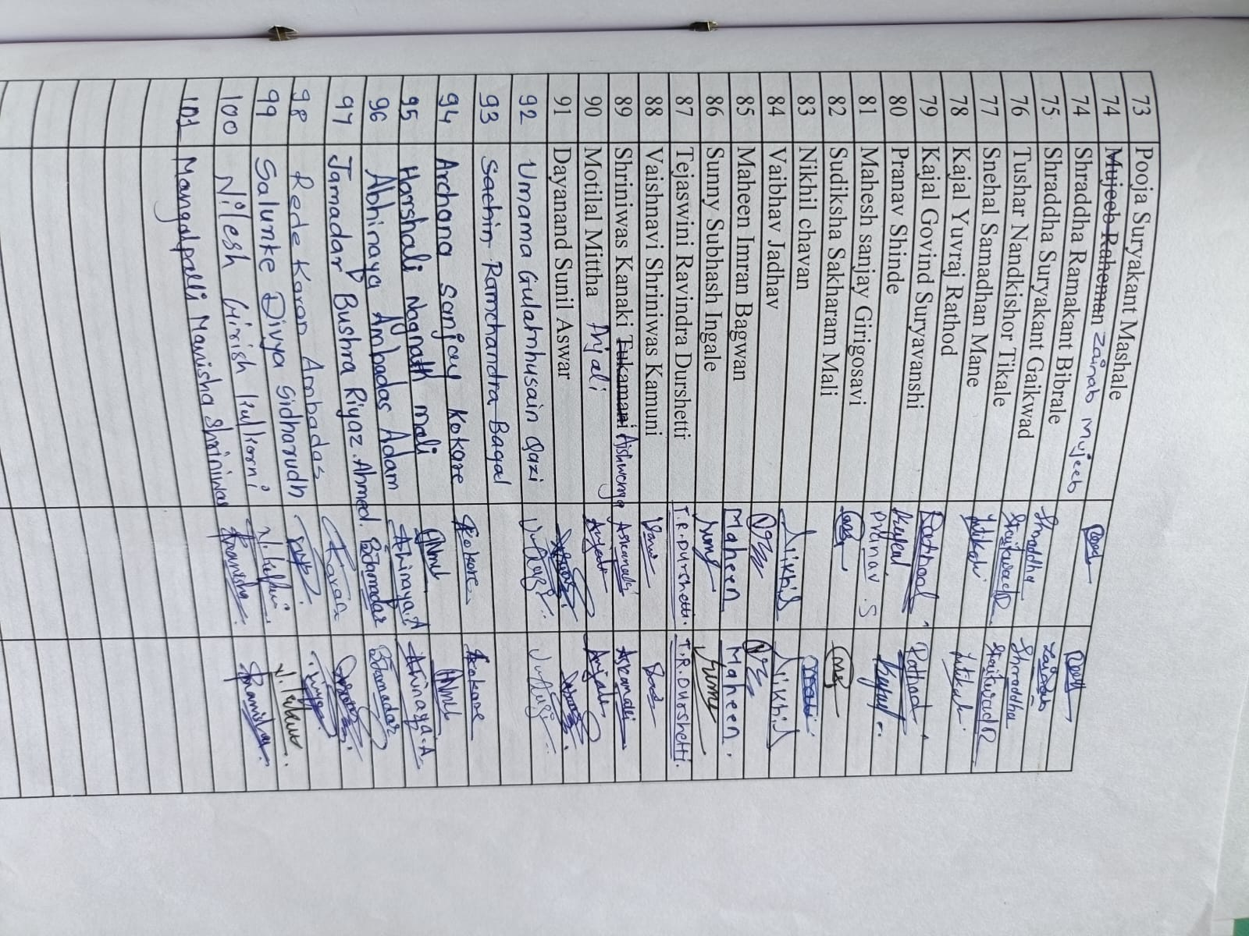

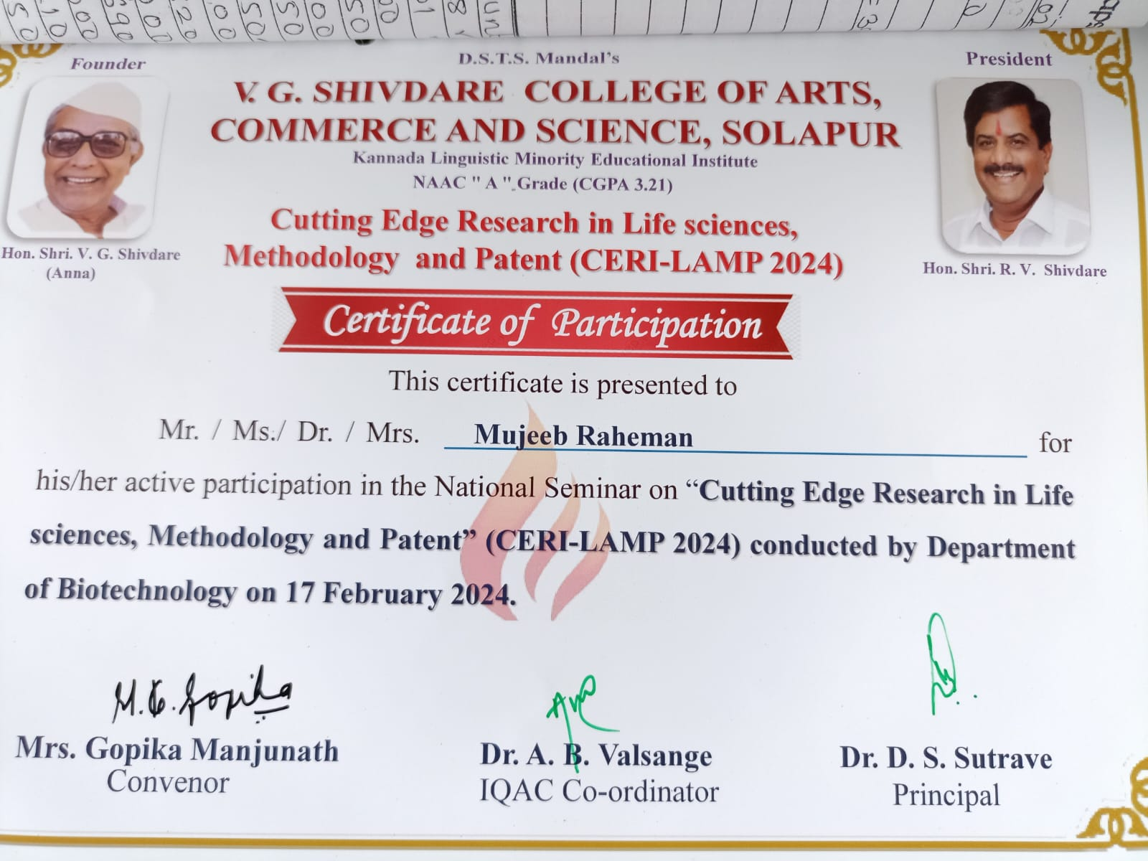

Workshop on Revised syllabus of SY B,Com on 2/11/2023
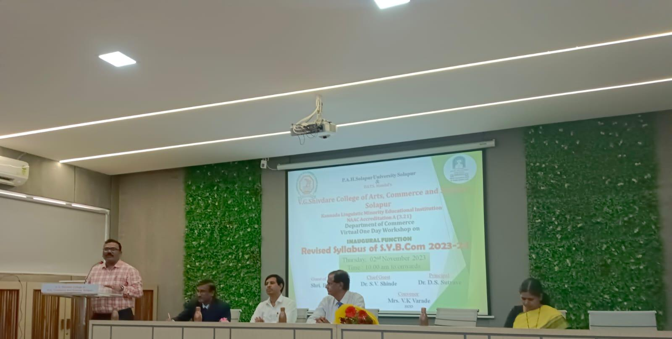

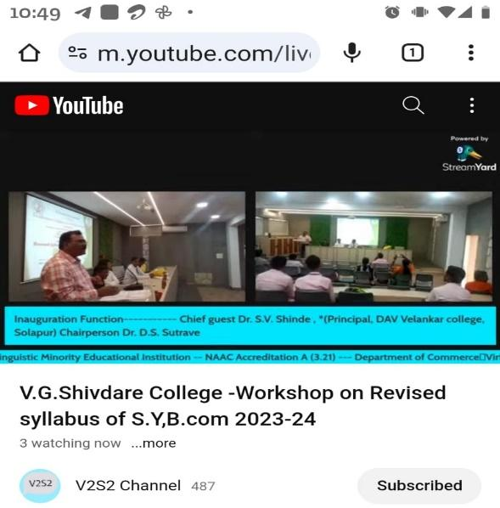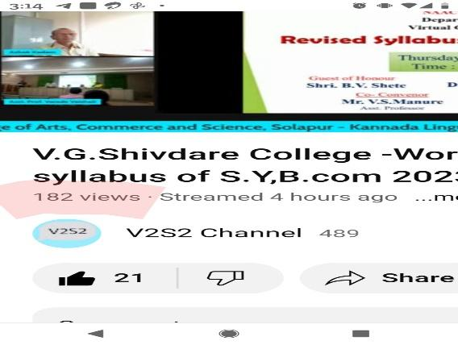
Workshop link : https://www.youtube.com/live/aTeafrAP0B0?si=g4pmeig0lFqmdsoH

