3.4.3 Number of extension and outreach Programmes conducted by the institution through NSS/ NCC/ Red Cross/ YRC etc., (including the programmes such as Swachh Bharat, AIDS awareness, Gender issues etc. ) and/or those organised in collaboration with industry, community and NGOs during the year & 3.4.4 Number of students participating in extension activities at 3.4.3. above during
Name of the activity | Organising unit/ agency/ collaborating agency | Name of the scheme | Year of the activity | Number of students participated in such activities
NSS Week: Guest lecture on National Equility and Young Genration by Dr. Santosh Rajguru | NSS V.G. Shivdare College, Solapur | NSS Work Publicity Week | 2023-24 | 116
Guest lecture on Stri shikshanachya Agradut Savitribai Fule by Dr. Rajani Dalavi | NSS & Women Cell | Gender Sensitivity | 2023-24 | 110
Guest lecture on Life Skill by Shri Virendra Pardesh, Project Manager Family Plaining Association Solapur Branch | NSS & Family Plaining Association | MOU & NSS regular Activity | 2023-24 | 75
National Voters Day: Voter Awairness and Registration Programme by Prof. C.P.Umarajkar | NSS, V.G. Shivdare College, Solapur & Election Commision, Govt. of India | Election Awareness | 2023-24 | 100
Blood donation camp | NSS, V.G. Shivdare College, Solapur & Indian Red Cross Soci. : Damani Blood Bank Solapur | NSS Regular Program | 2023-24 | 50
HB check up camp | NSS, V.G. Shivdare College, Solapur & Family Planning Association of India, Solapur | NSS Regular Program | 2023-24 | 505
Health Checkup Camp in Unique Eglish Medium School, Solapur | NSS, V.G. Shivdare College, Solapur & Family Planning Association of India, Solapur | Health Awareness | 2023-24 | 200
World Organ Donation awareness rally | NSS, V.G. Shivdare College, Solapur & Family planning asso. fo india and Vyshyapayan Medical College Solapur | World Organ Donation Day awareness | 2023-24 | 100
AIDS awareness rally | NSS, V.G. Shivdare College, Solapur & Family planning asso. Of india & Civil Hospital Solapur | AIDS awareness | 2023-24 | 130
Self Defence Workshop for Girls and Women | NSS, IQAC, Sports, Womens Cell, Solapur Laathi Kaathi Association | Women Empowerment | 2023-24 | 100
work shop on Dister Management and Ledership Development | NSS deparment Shivaji Night College Solapur | NSS Regular Program | 2023-24 | 10
Health Awareness Workshop for Girls: Dr. Bharat Mule | NSS, V.G. Shivdare College, Solapur,Womens Cell, V.G. Shivdare College, Solapur | Health Awareness | 2023-24 | 120
Swachha Bharat Abhiyan: Cleanliness activity | NSS, V.G. Shivdare College, Solapur & Govt. of India | Swachha Bharat Abhiyan | 2023-24 | 98
International Yoga Day | NSS, V.G. Shivdare College, Solapur & Govt. of India | International Yoga Day | 2023-24 | 135
Vigilance Awareness Week | NSS, IQAC and Indian Oil Corporation Ltd. | Vigilance Awareness Programme | 2023-24 | 100
NSS Camp at Hattur, South Solapur. | NSS & Grampanchayat Hattur, South Solapur | NSS Special Program | 2023-24 | 98

NSS Activity Report 2023-24
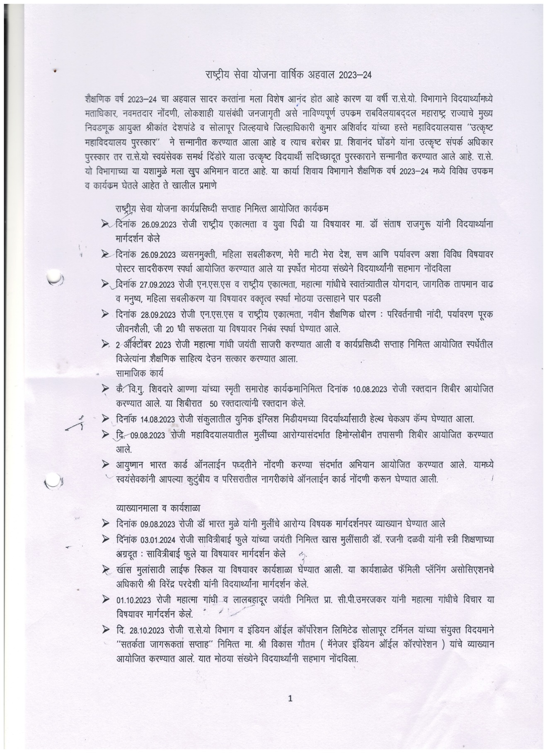
NSS Activity Report 2023-24
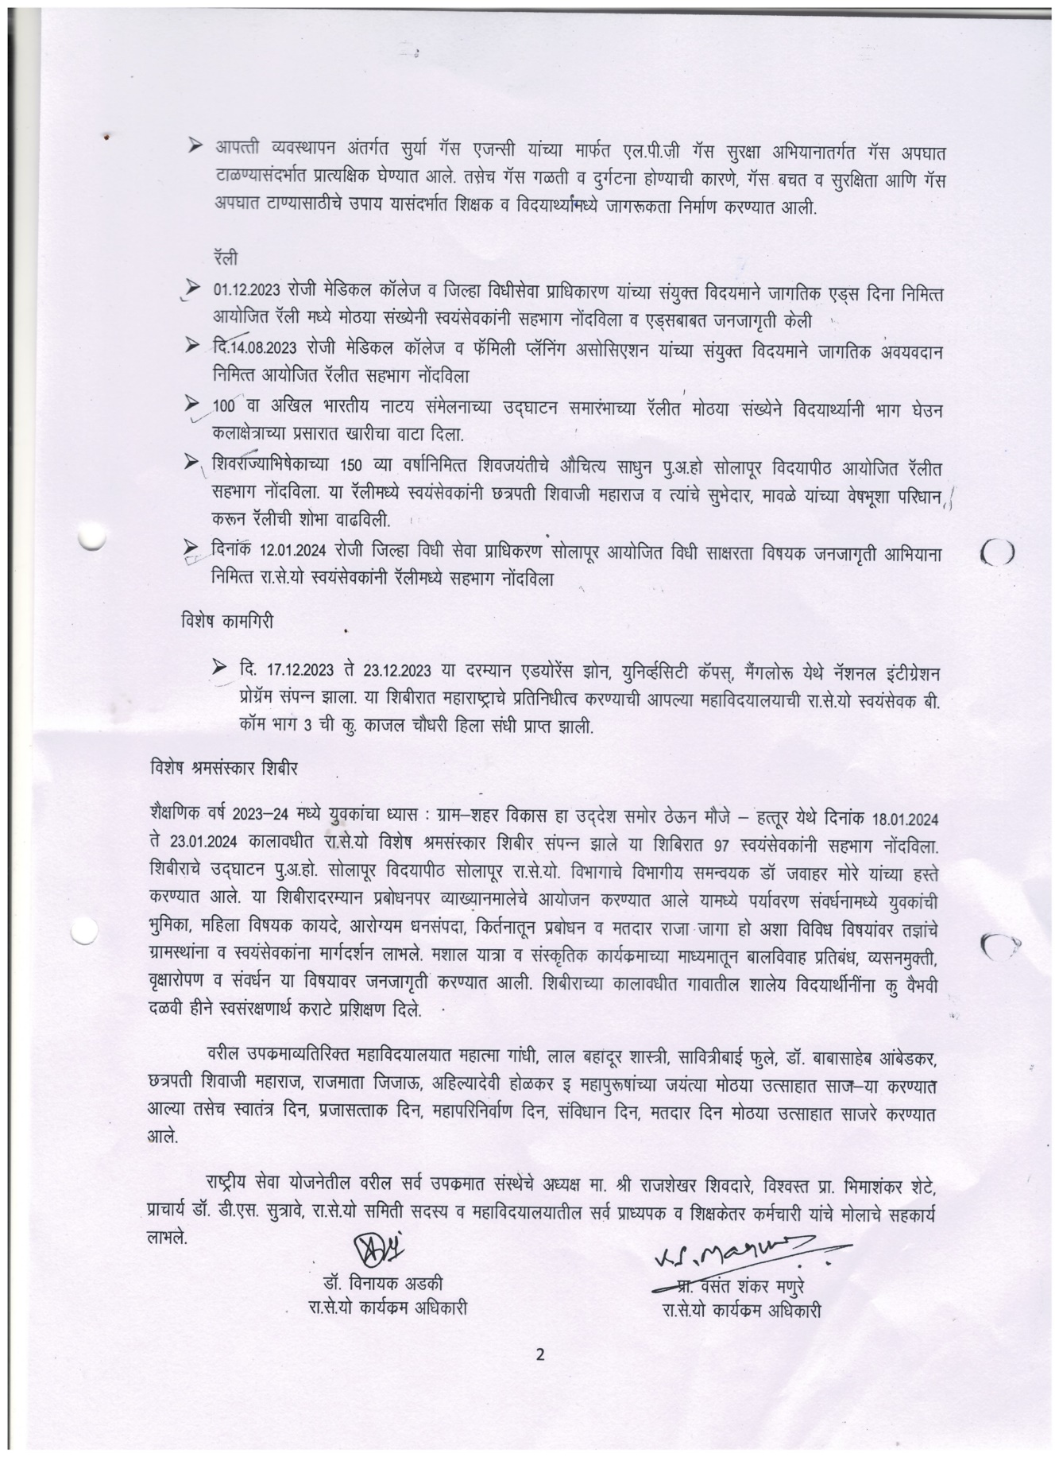
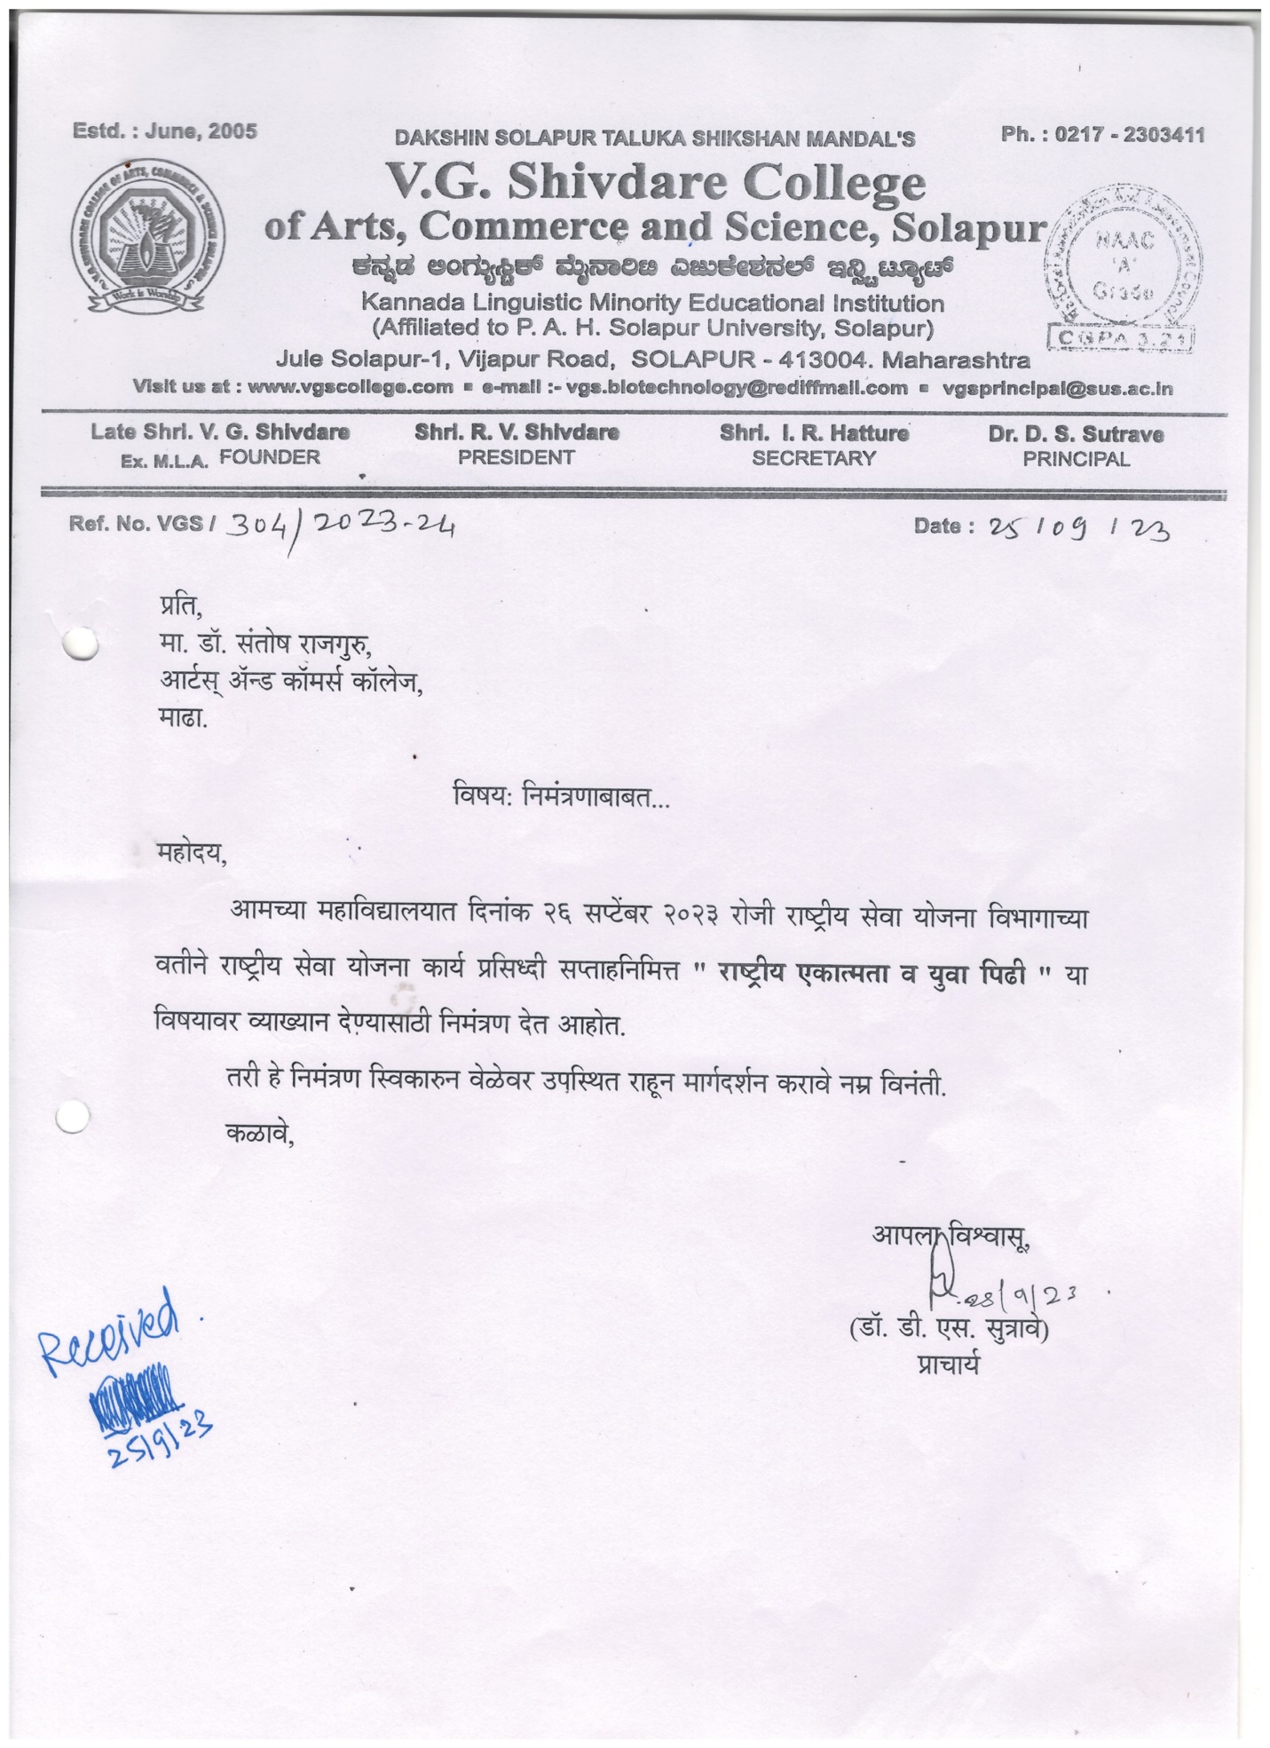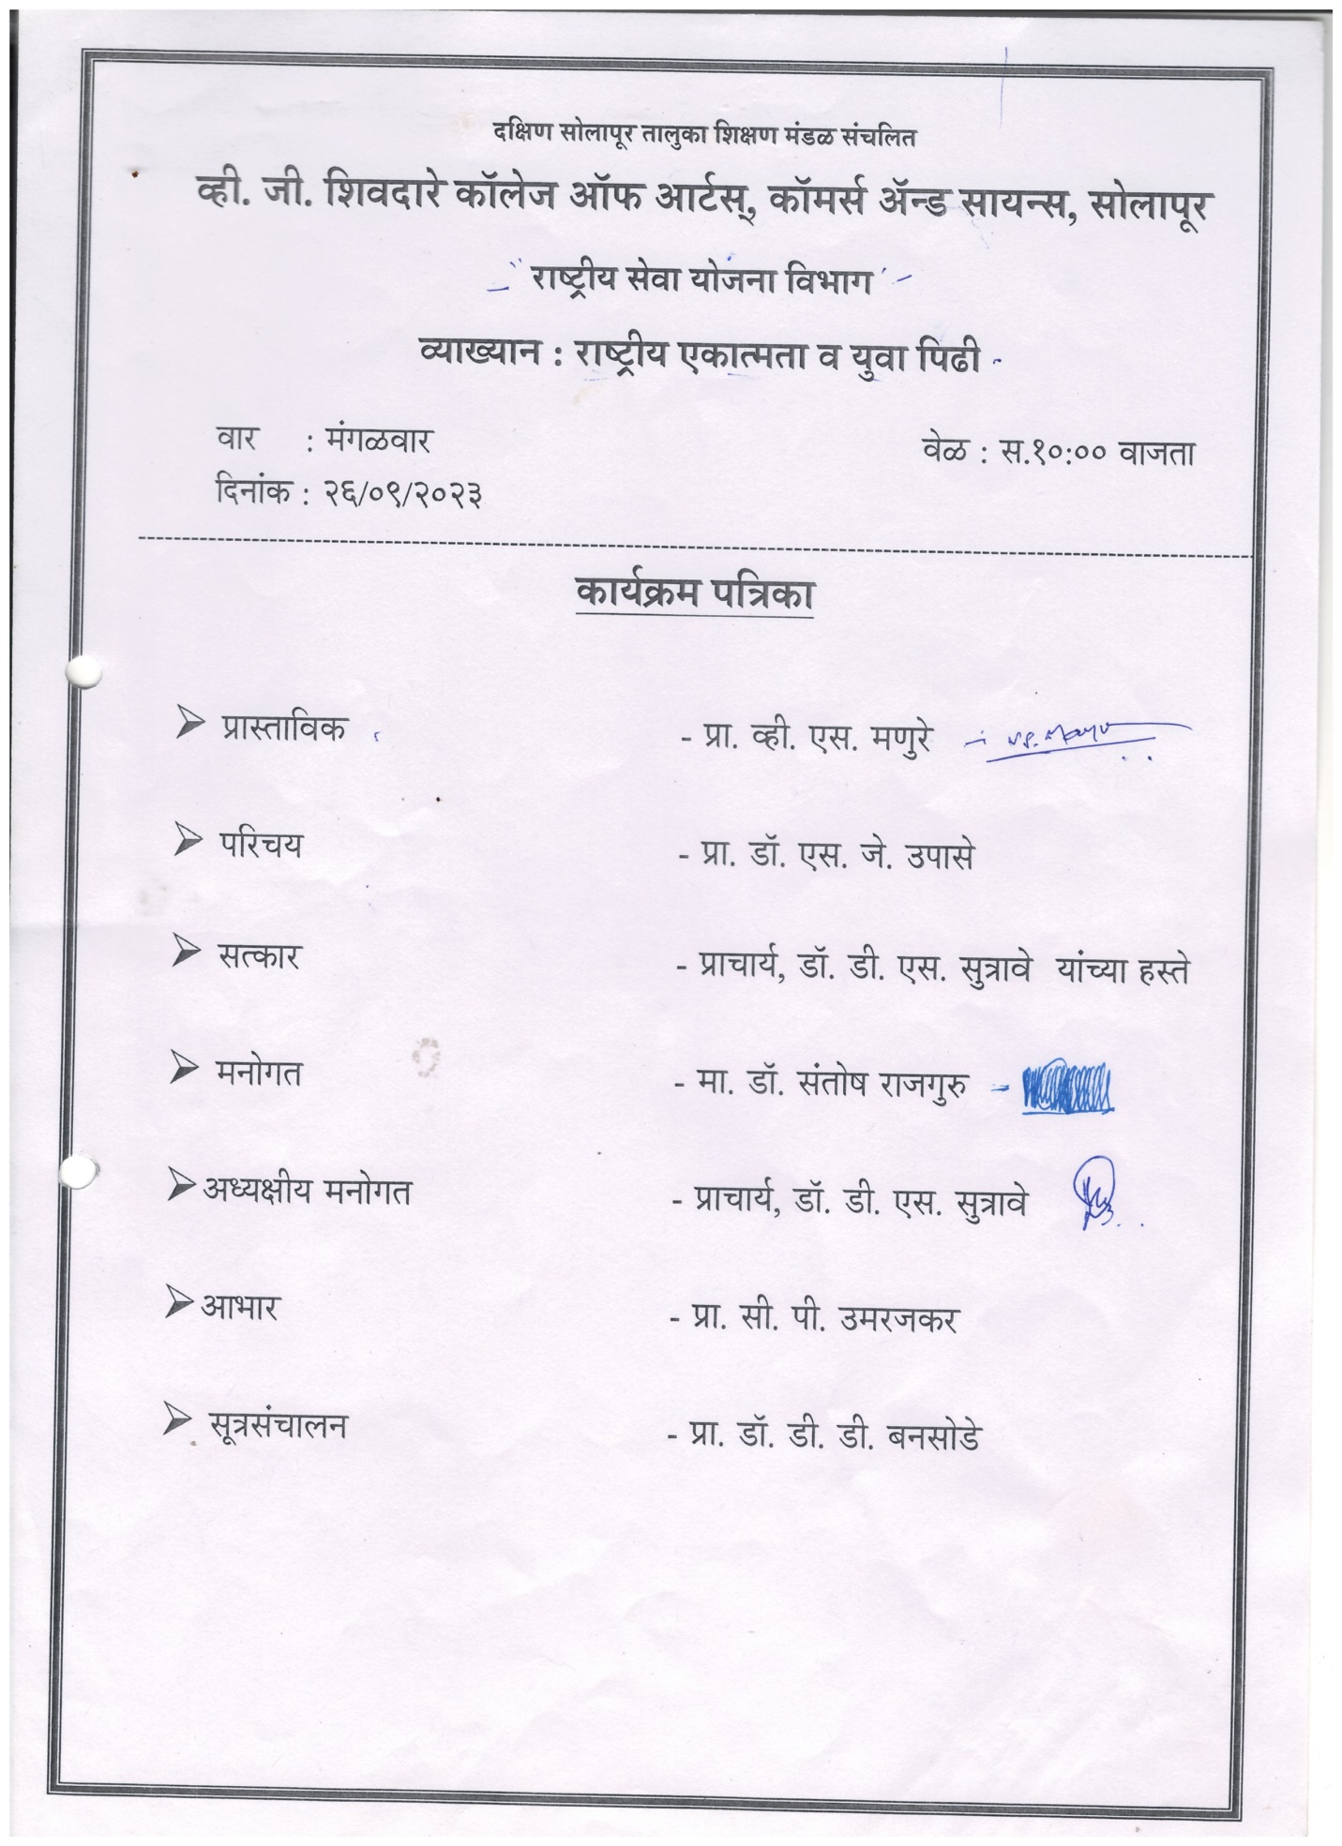
NSS Week: Guest lecture on National Equility and Young Genration by Dr. Santosh Rajguru
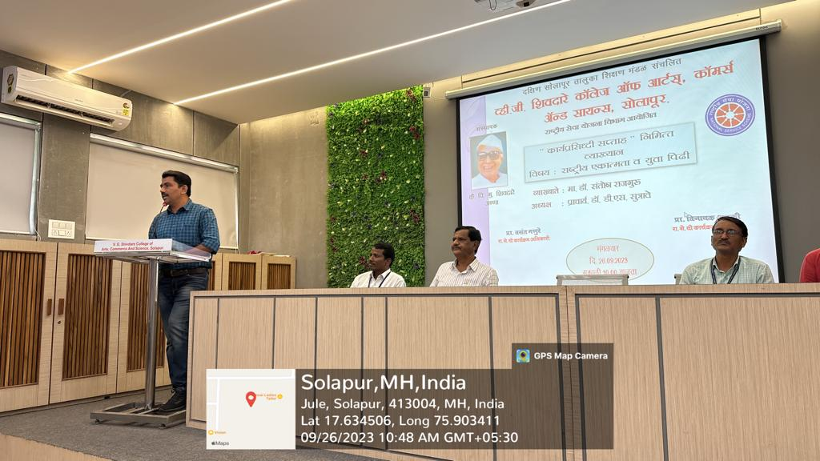
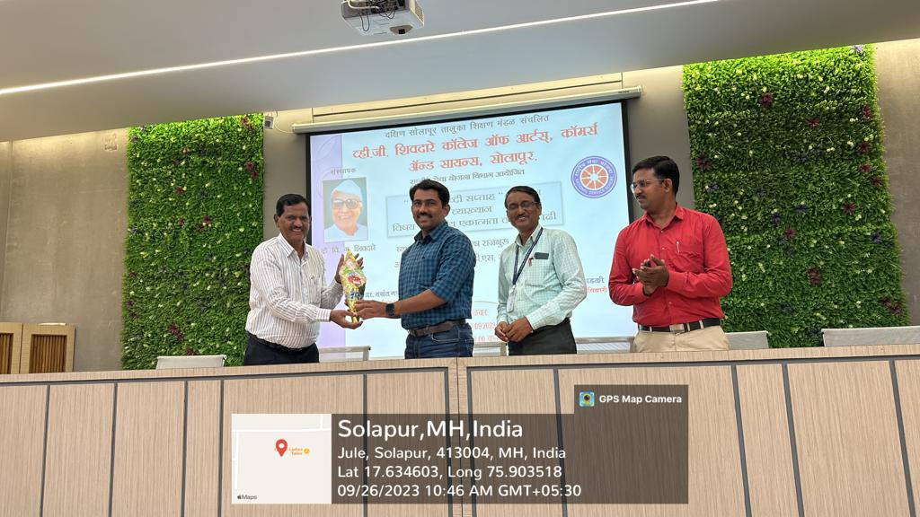

List of Students
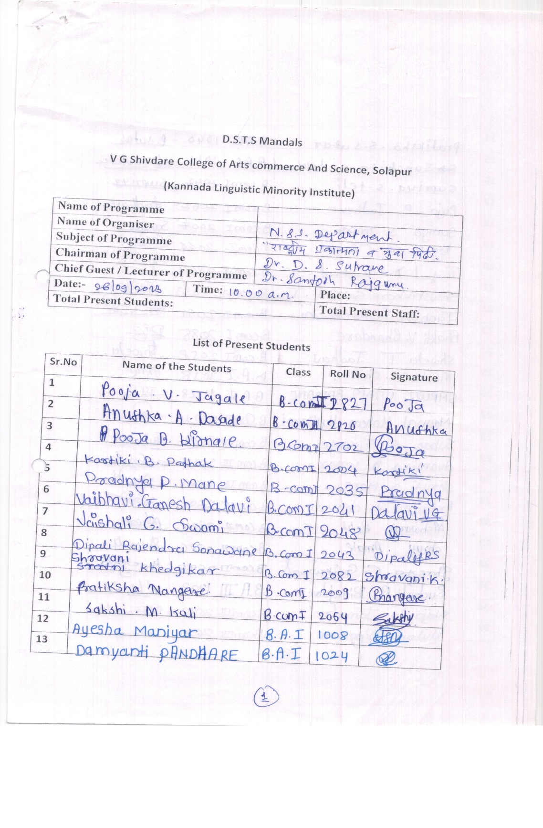
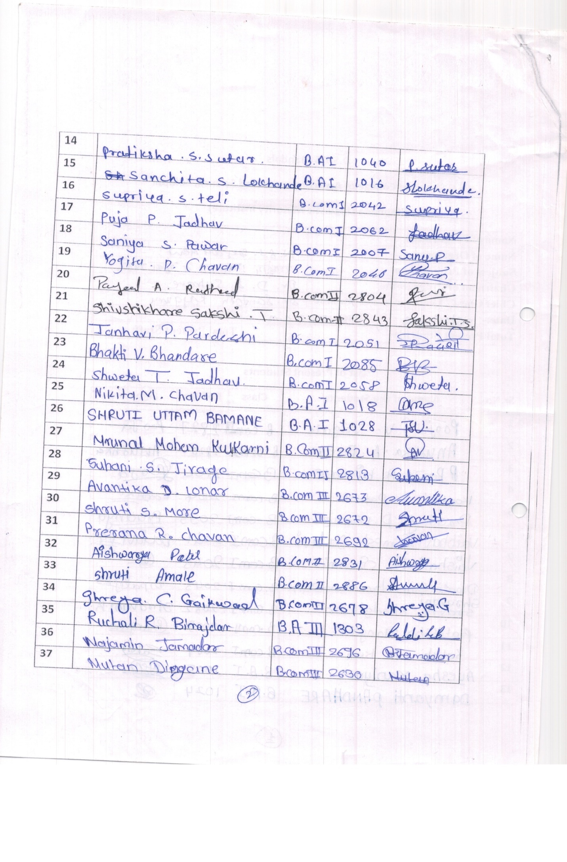
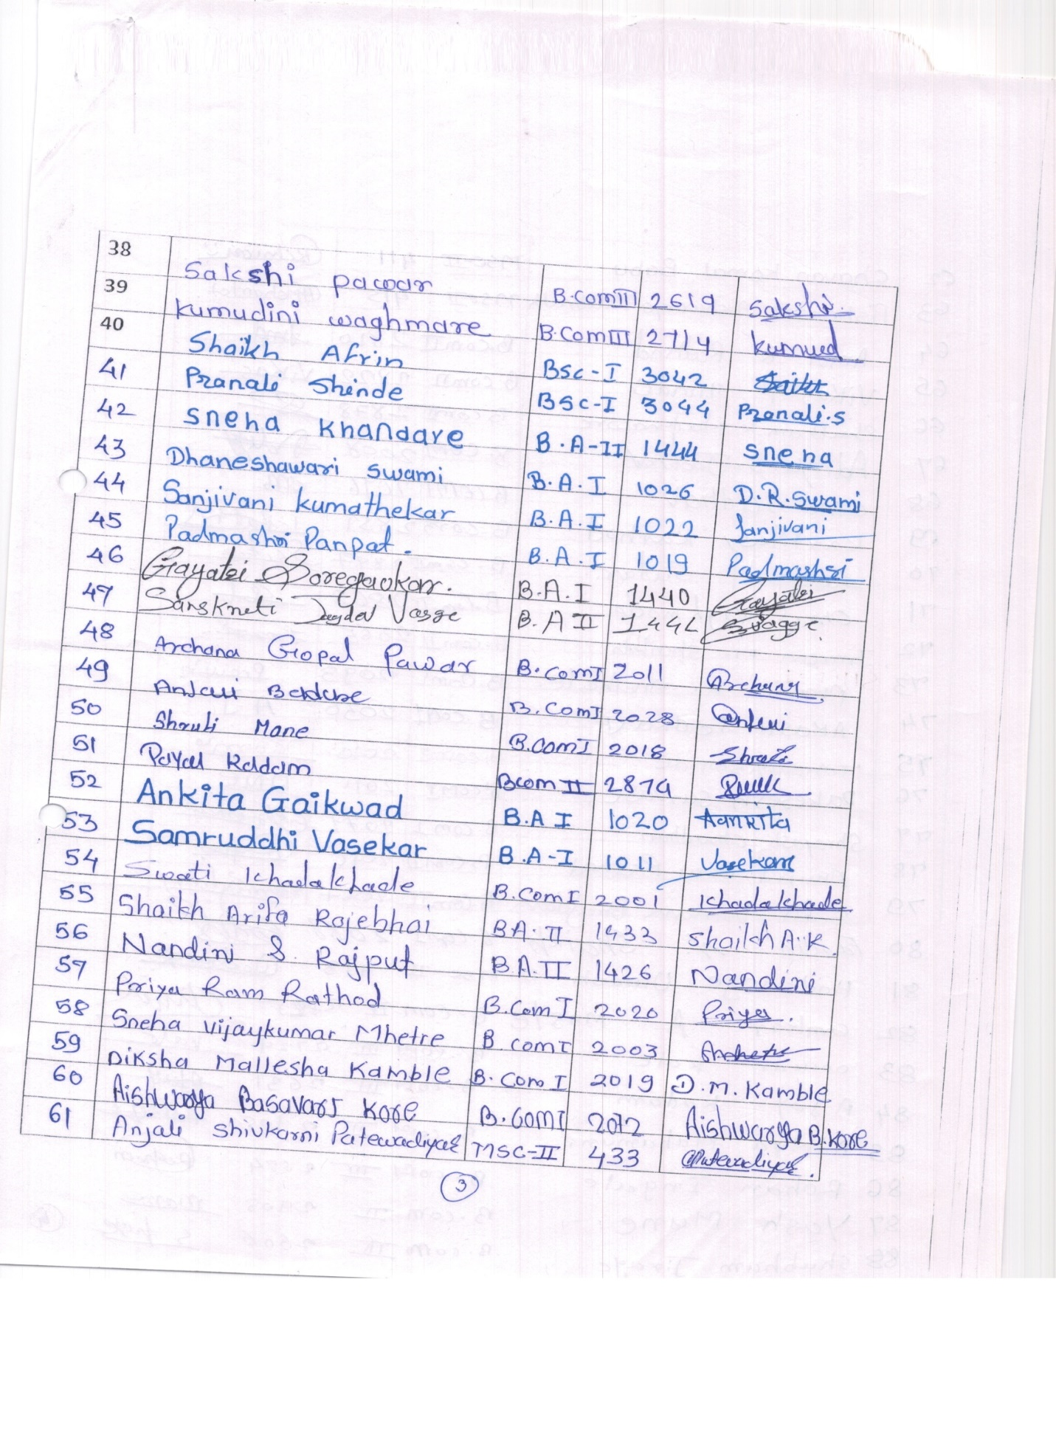
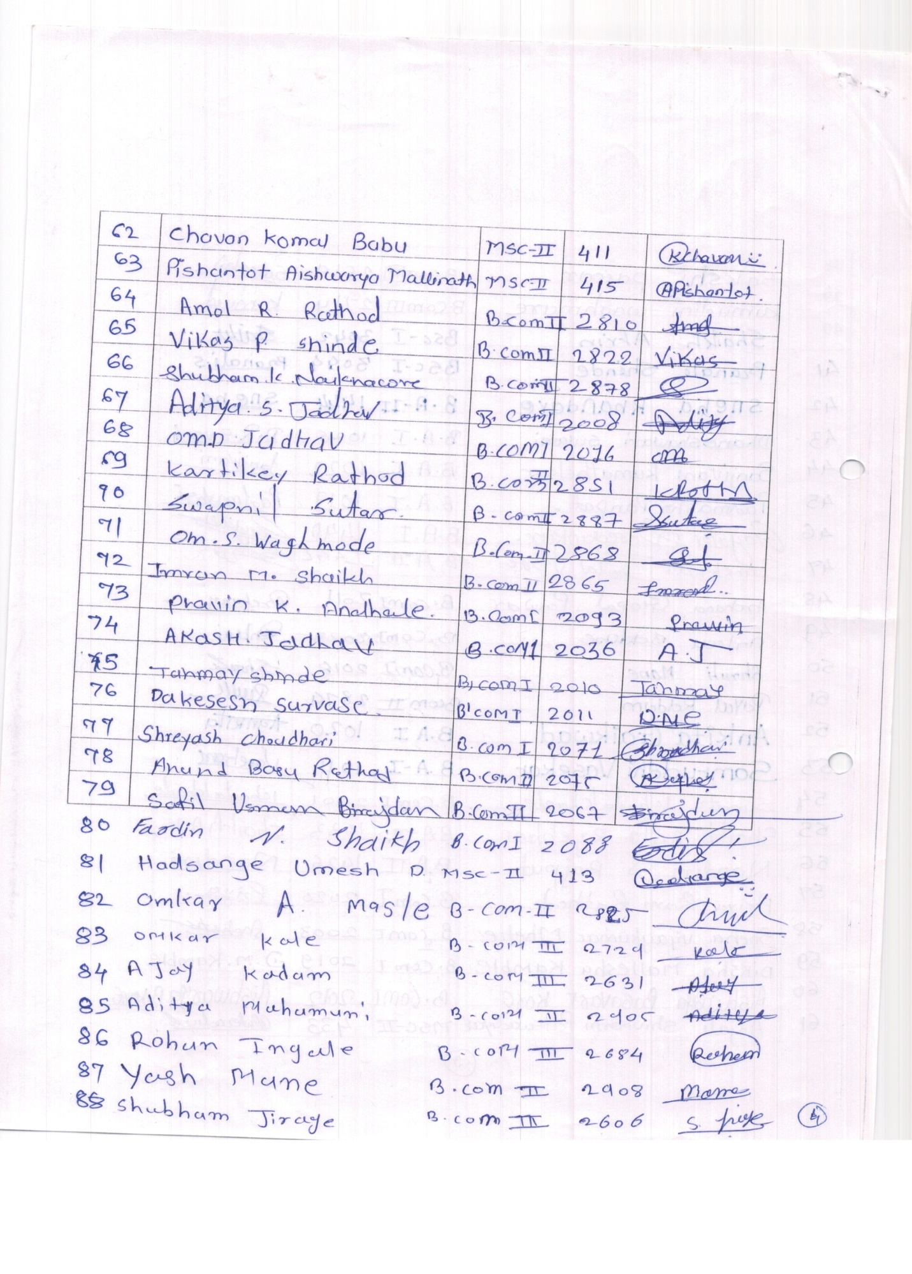
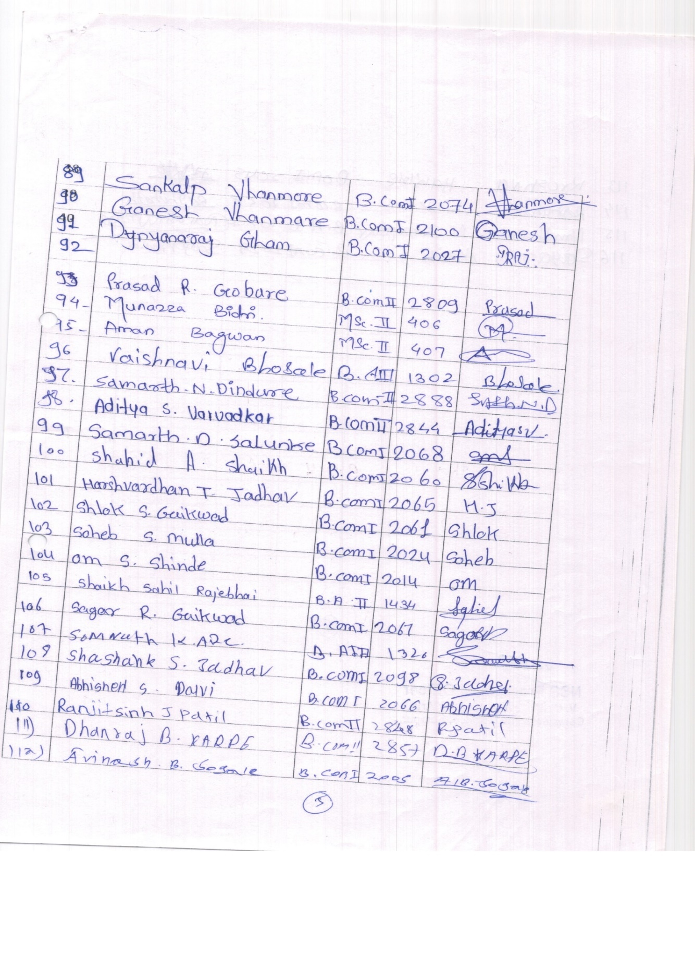
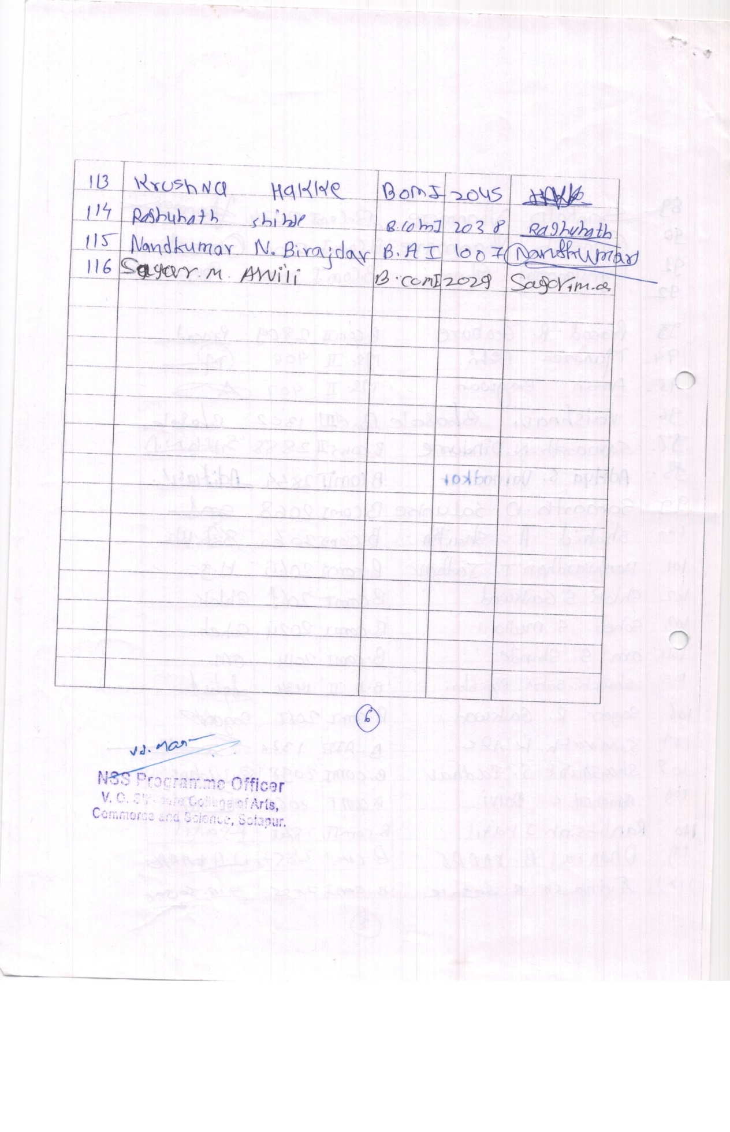 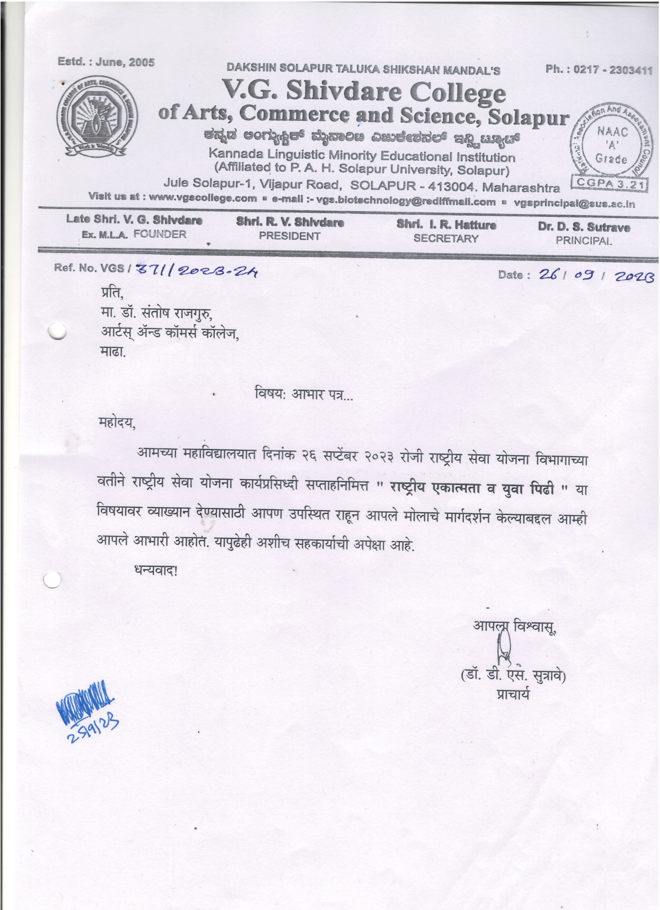Guest lecture on Stri shikshanachya Agradut Savitribai Fule by Dr. Rajani Dalavi 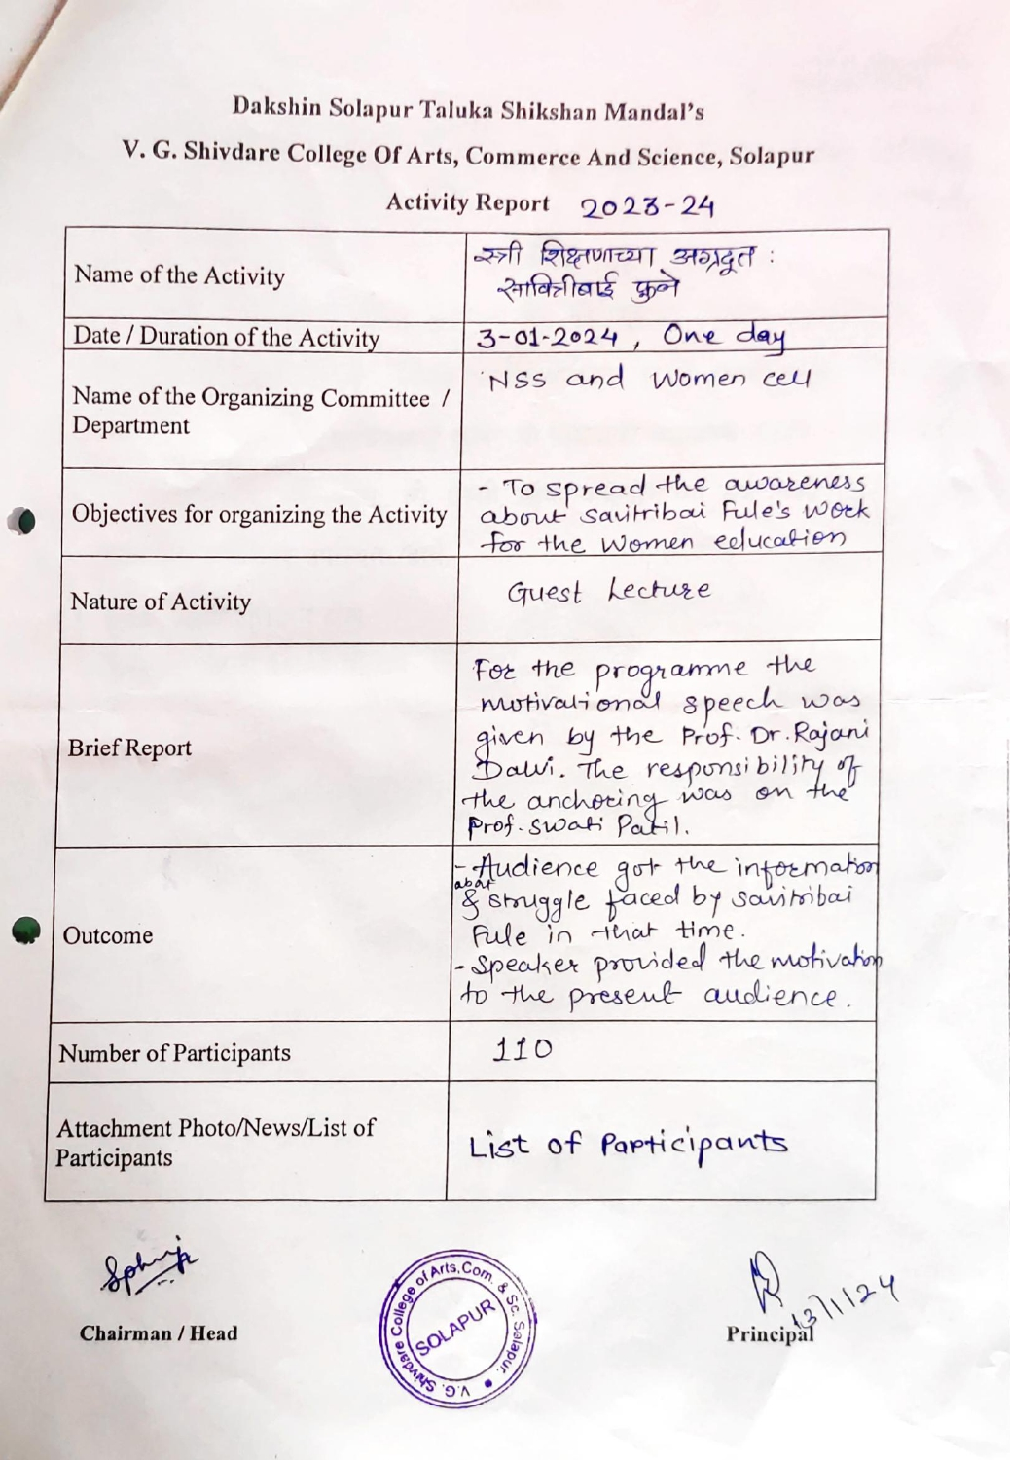
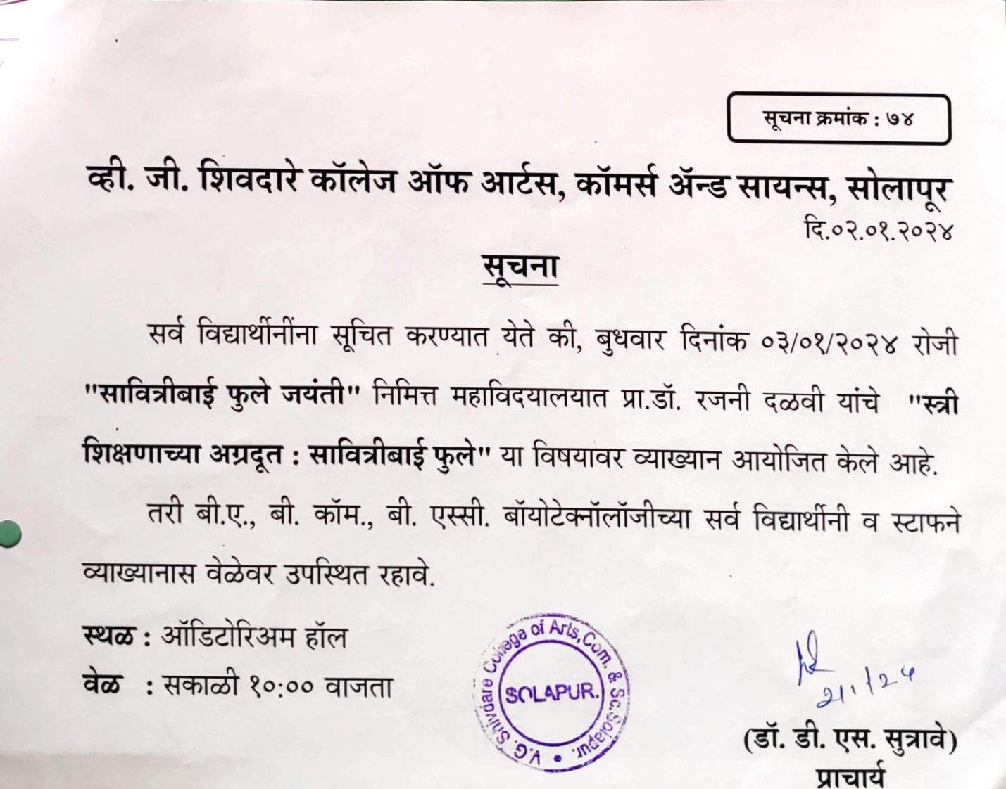

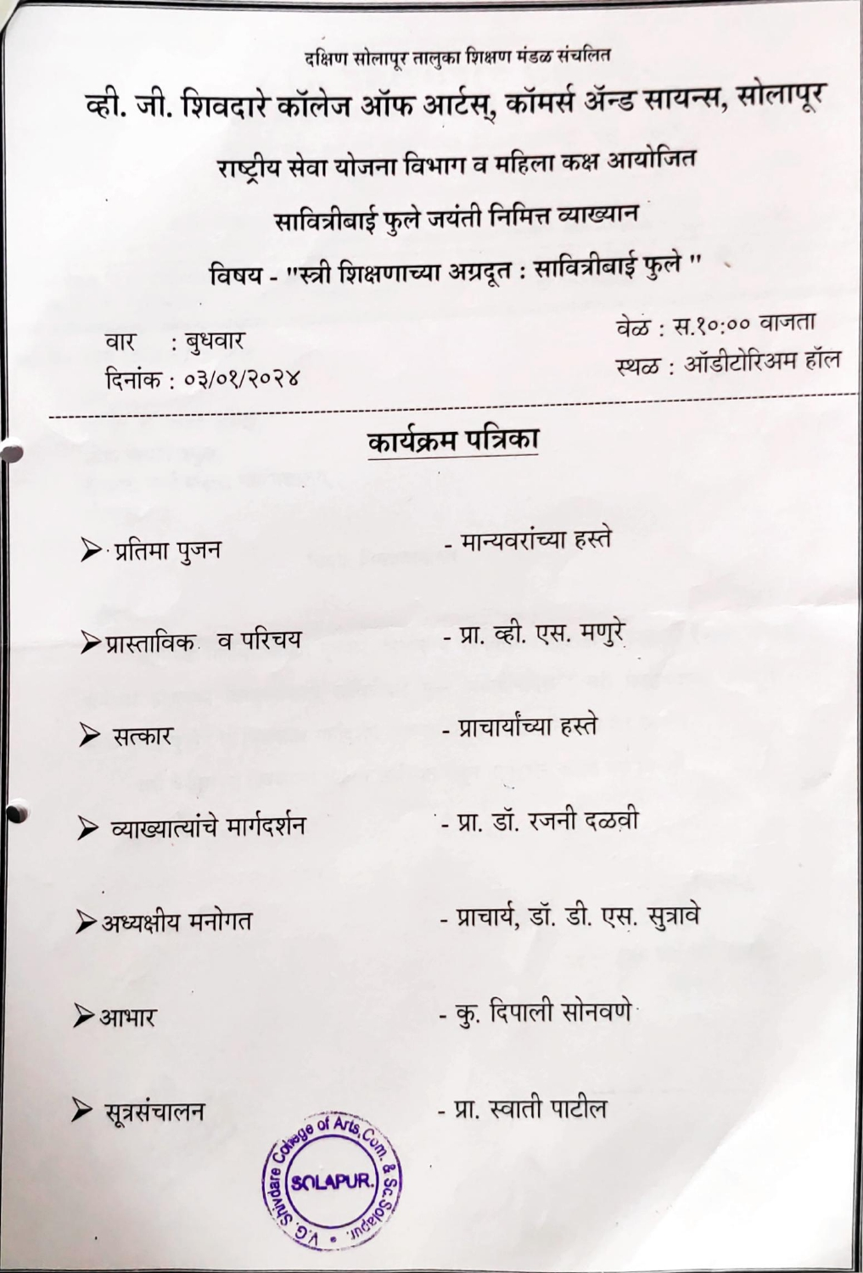
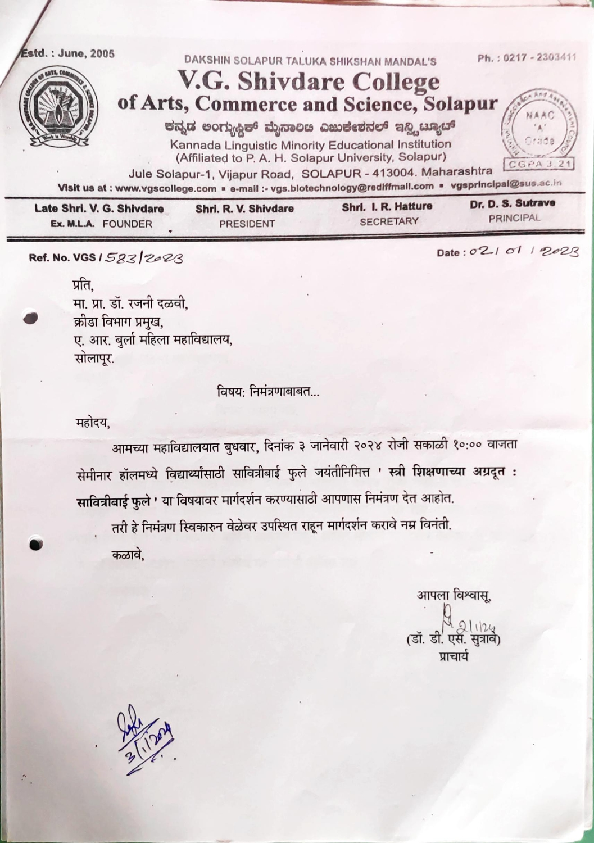
Guest lecture on Stri shikshanachya Agradut Savitribai Fule by Dr. Rajani Dalavi
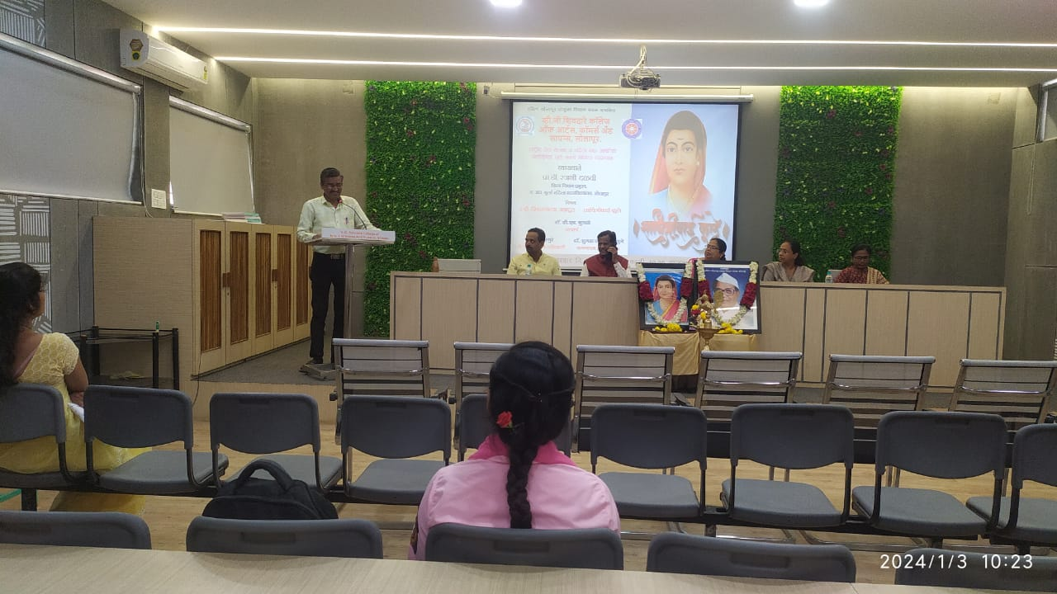

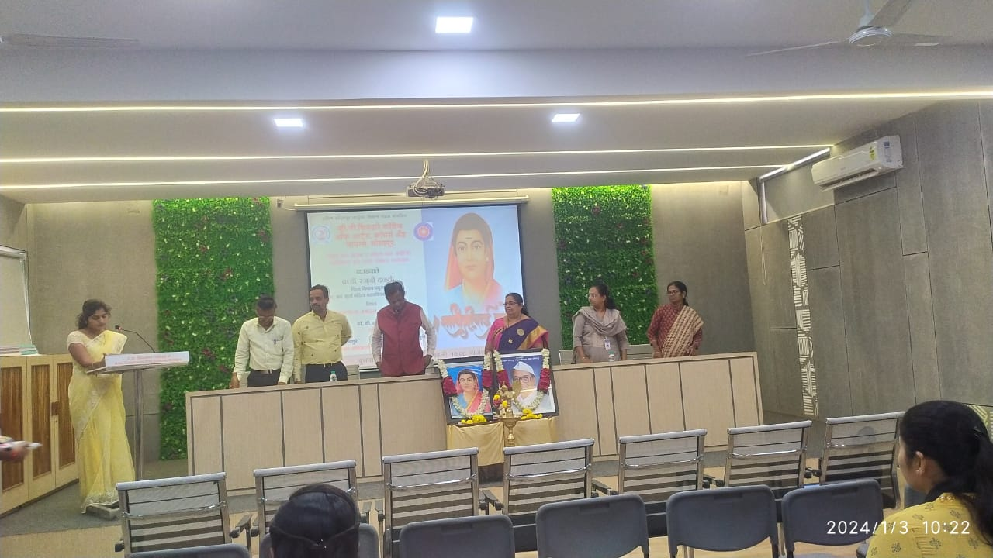
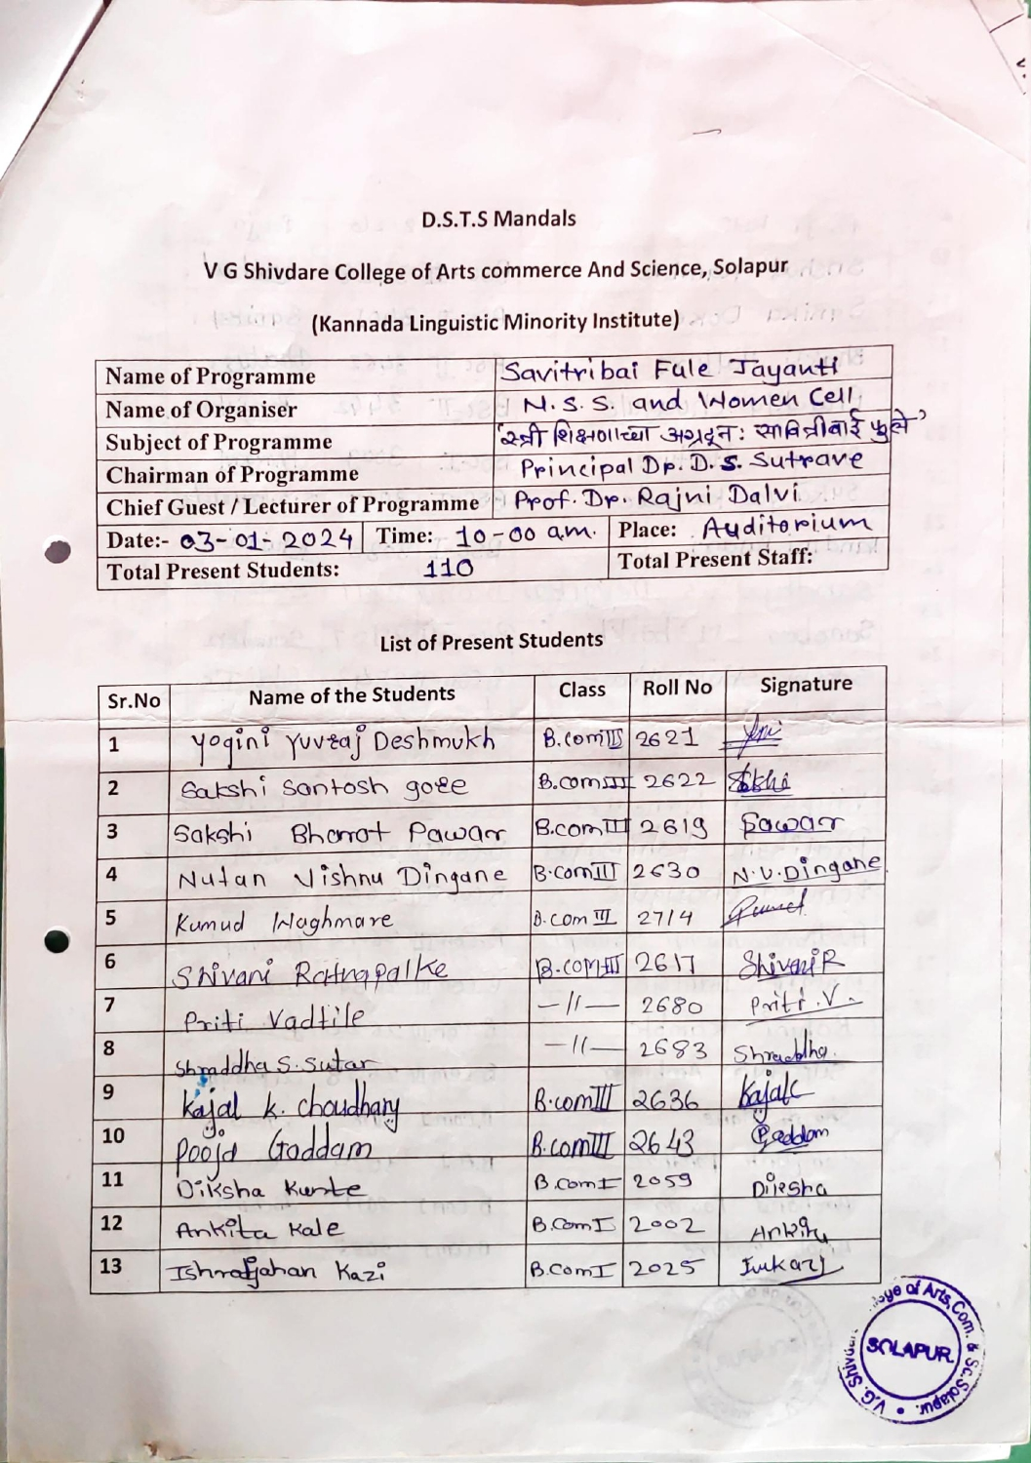
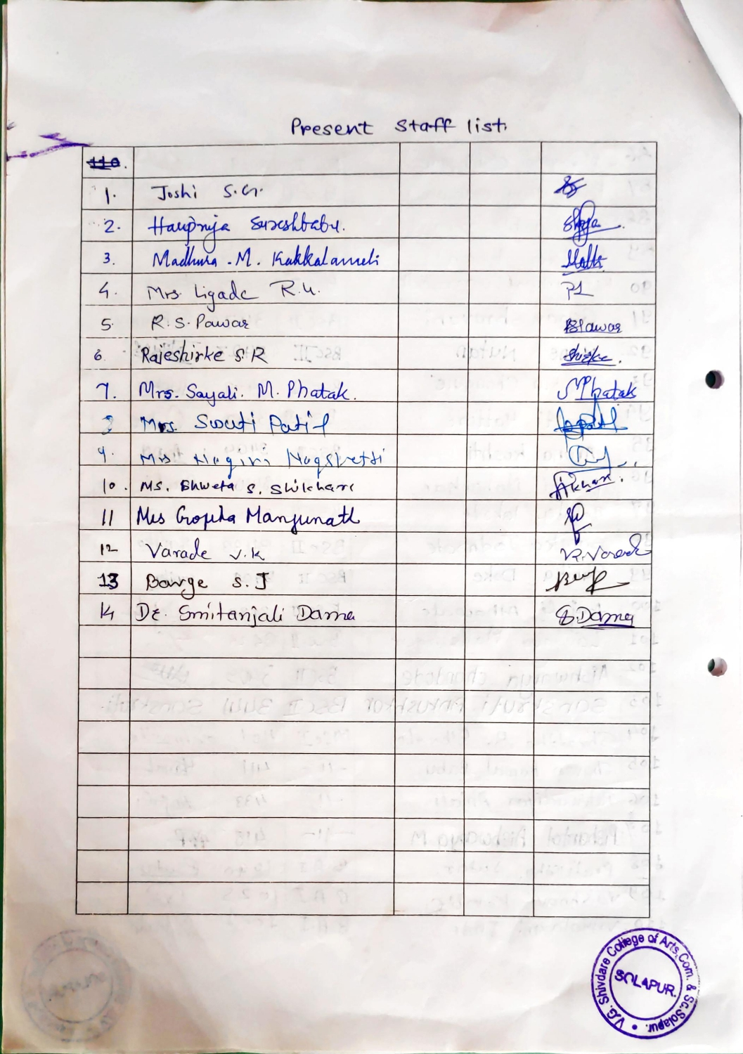
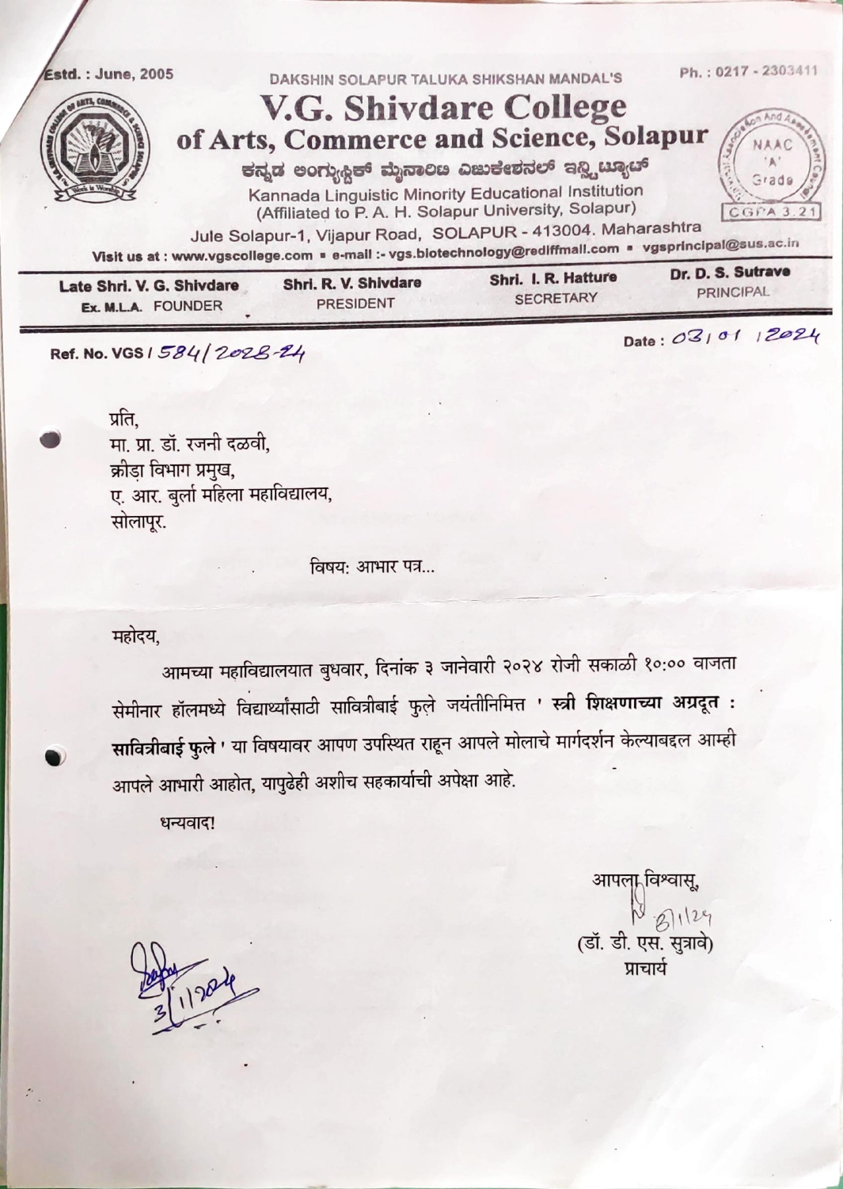
Guest lecture on Life Skill by Shri Virendra Pardesh, Project Manager Family Plaining Association Solapur 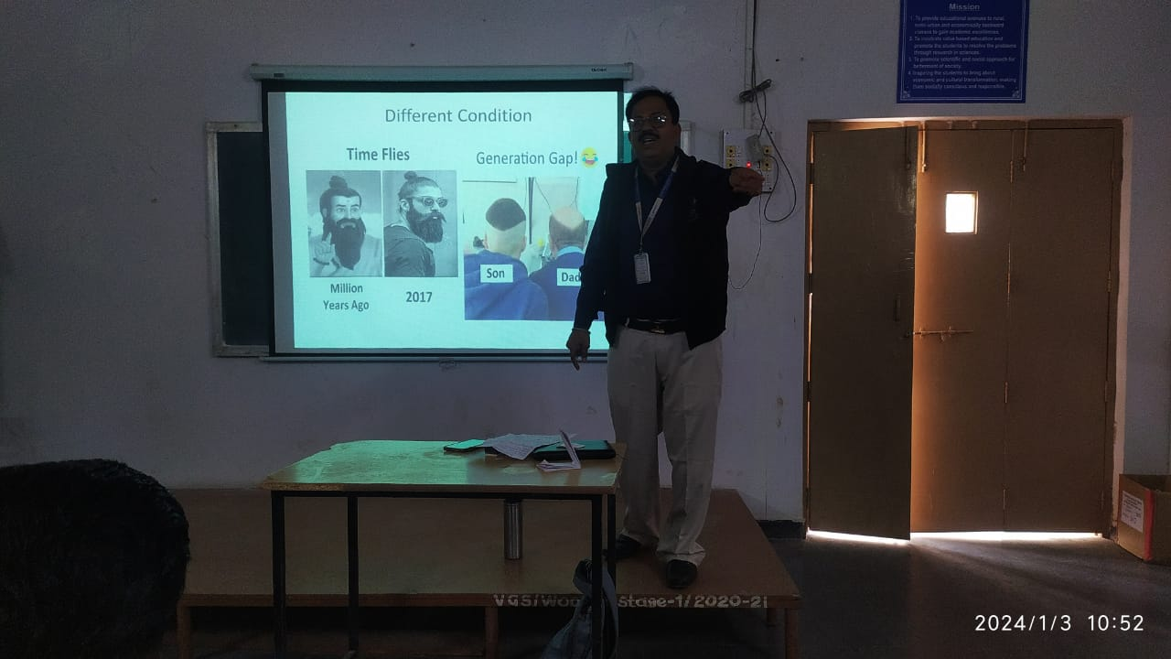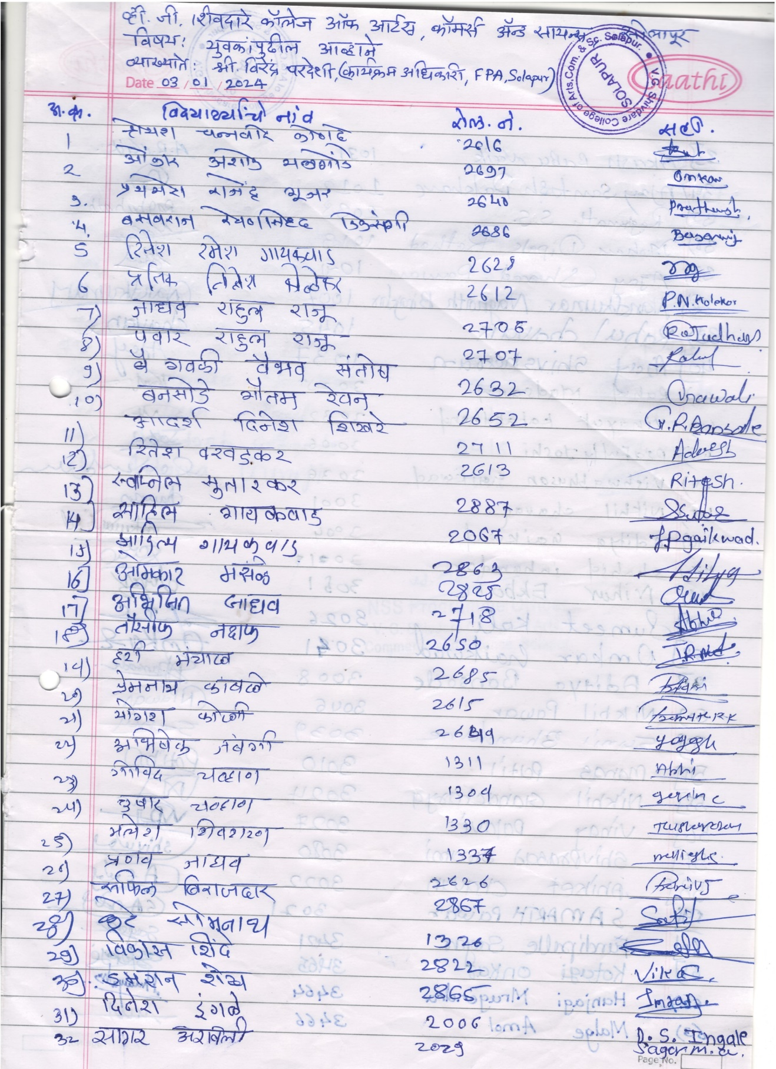
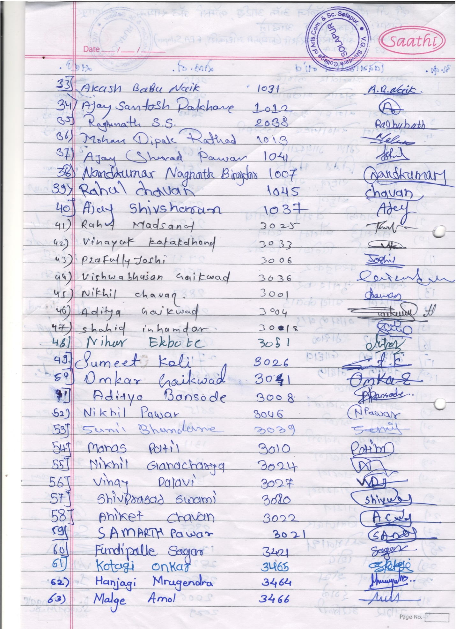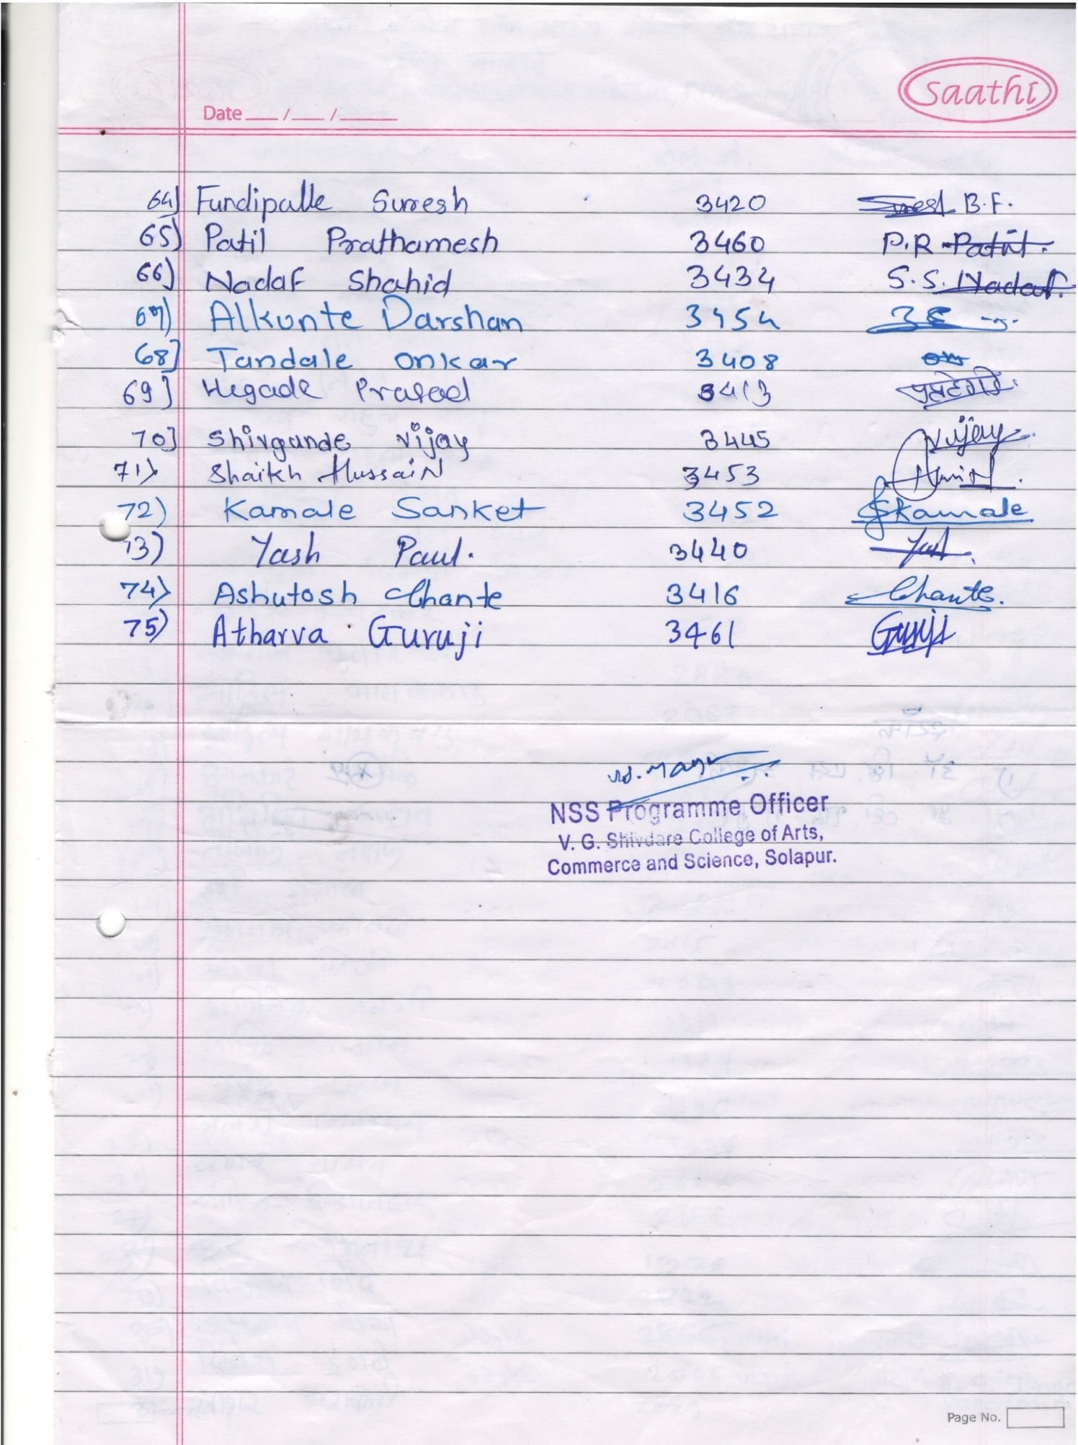
National Voters Day: Voter Awareness and Registration Programme by Prof. C.P.Umarajkar
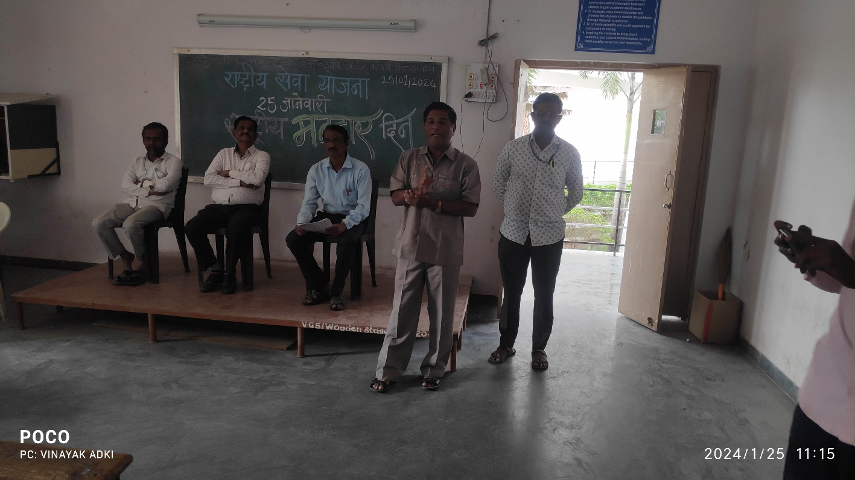
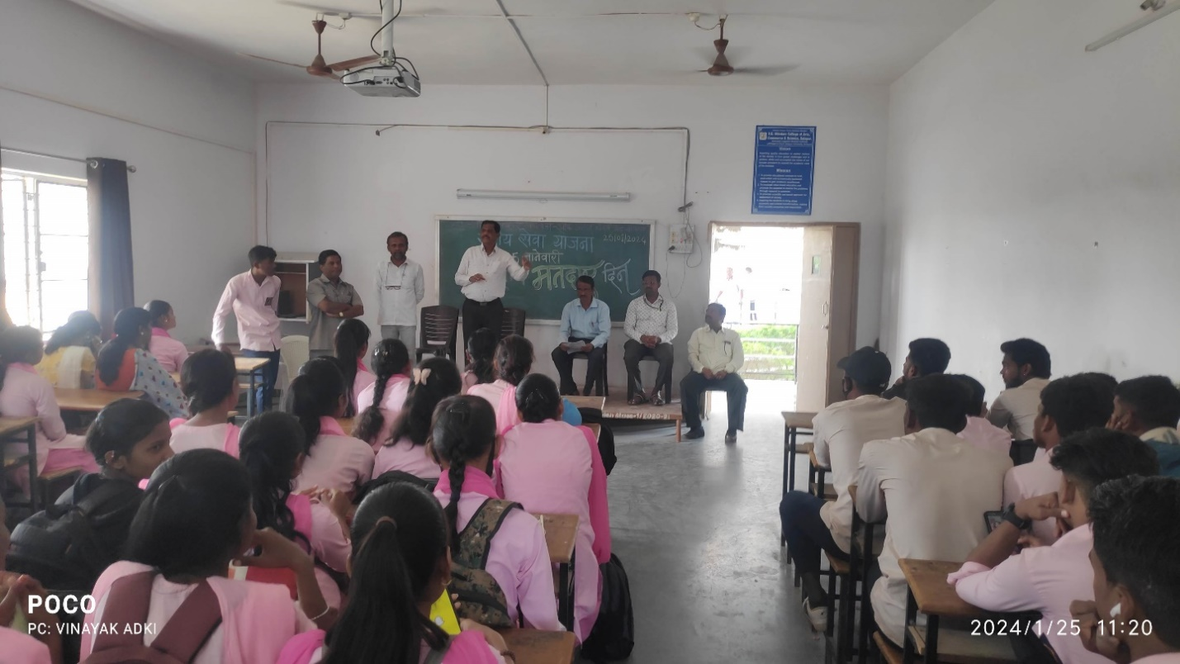
Blood Donation Camp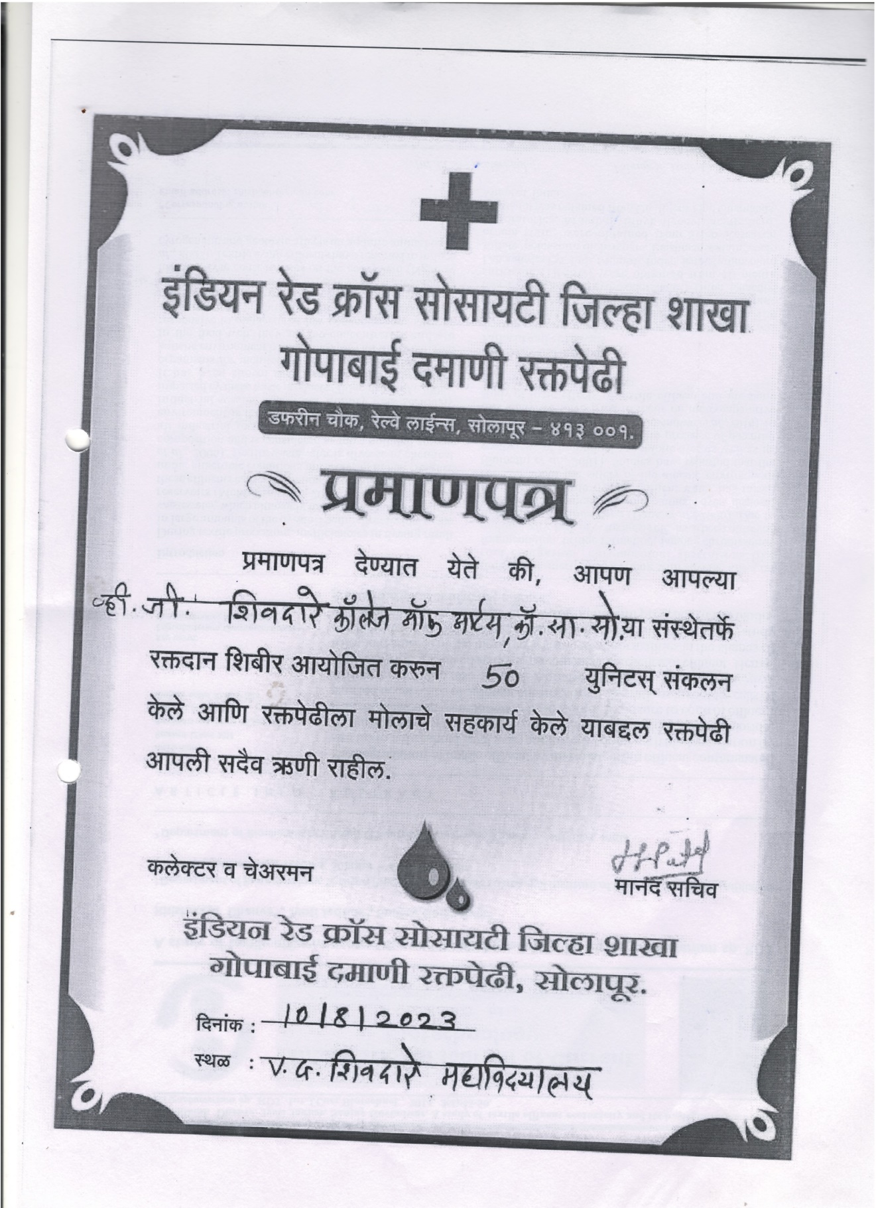
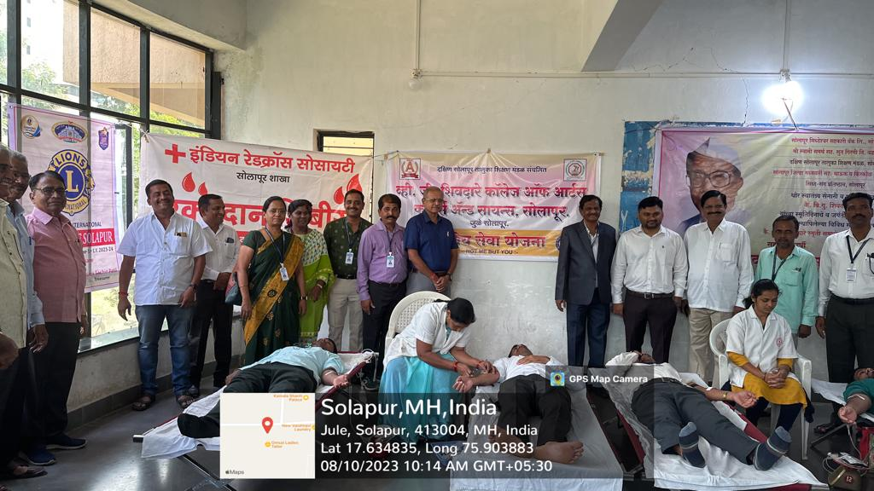

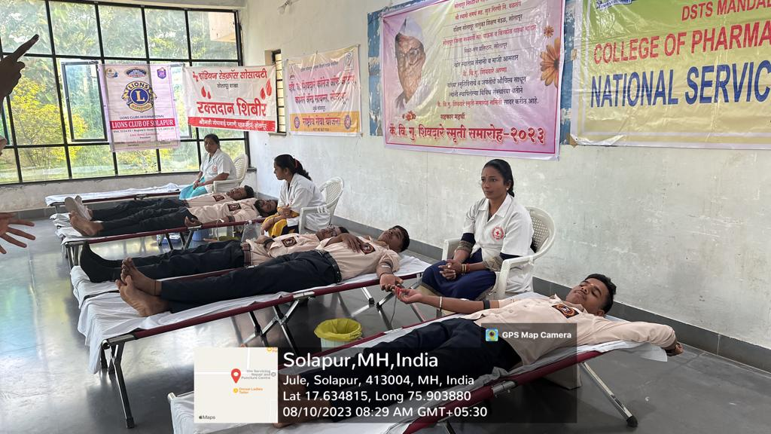

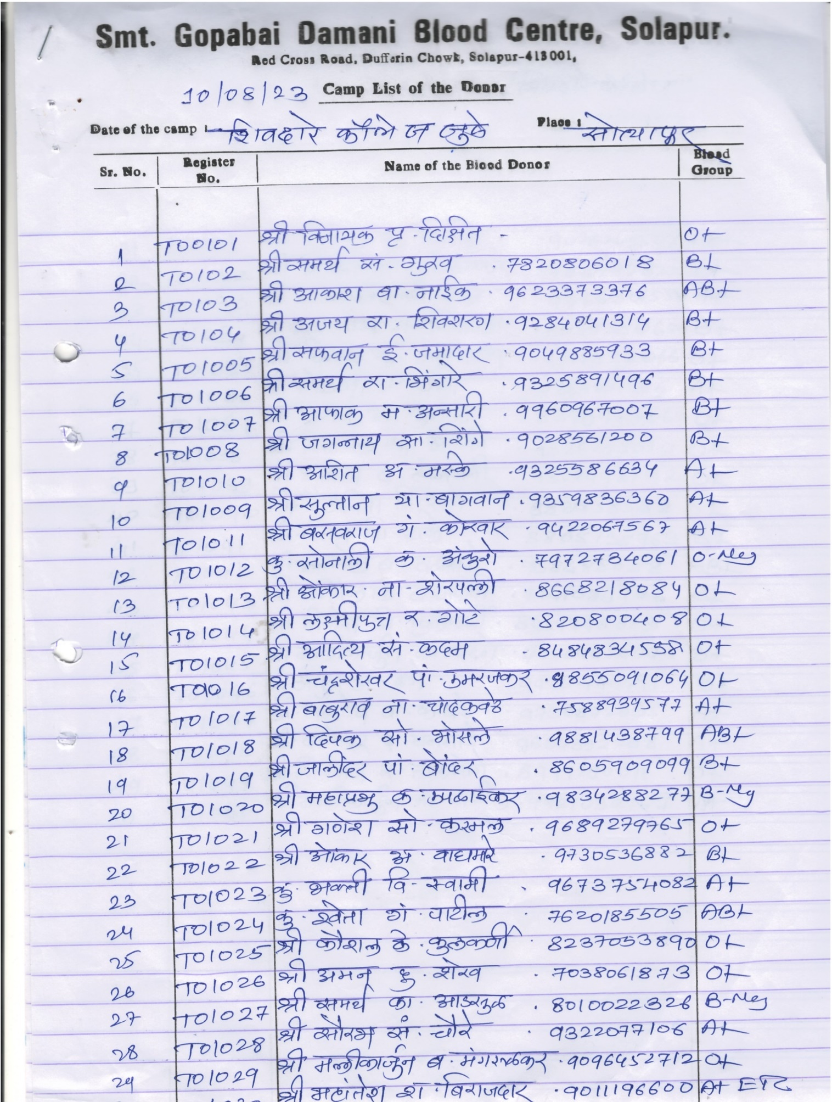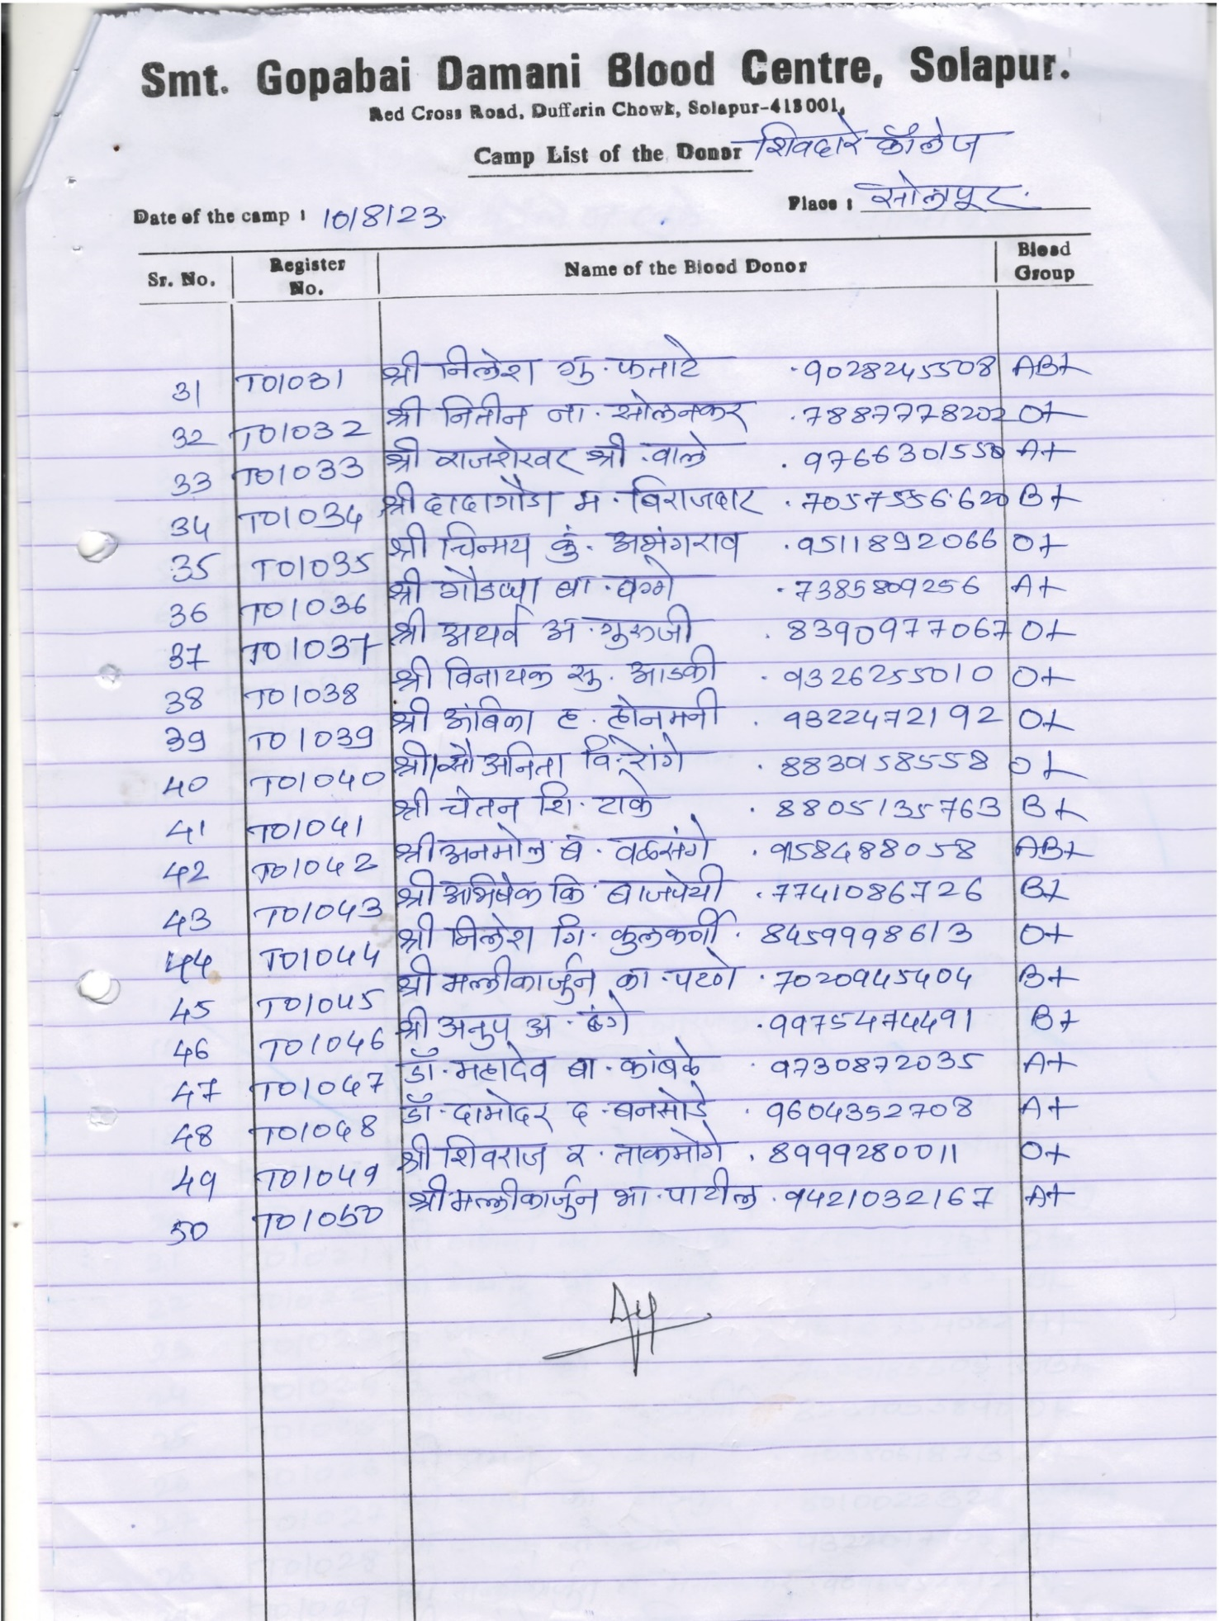
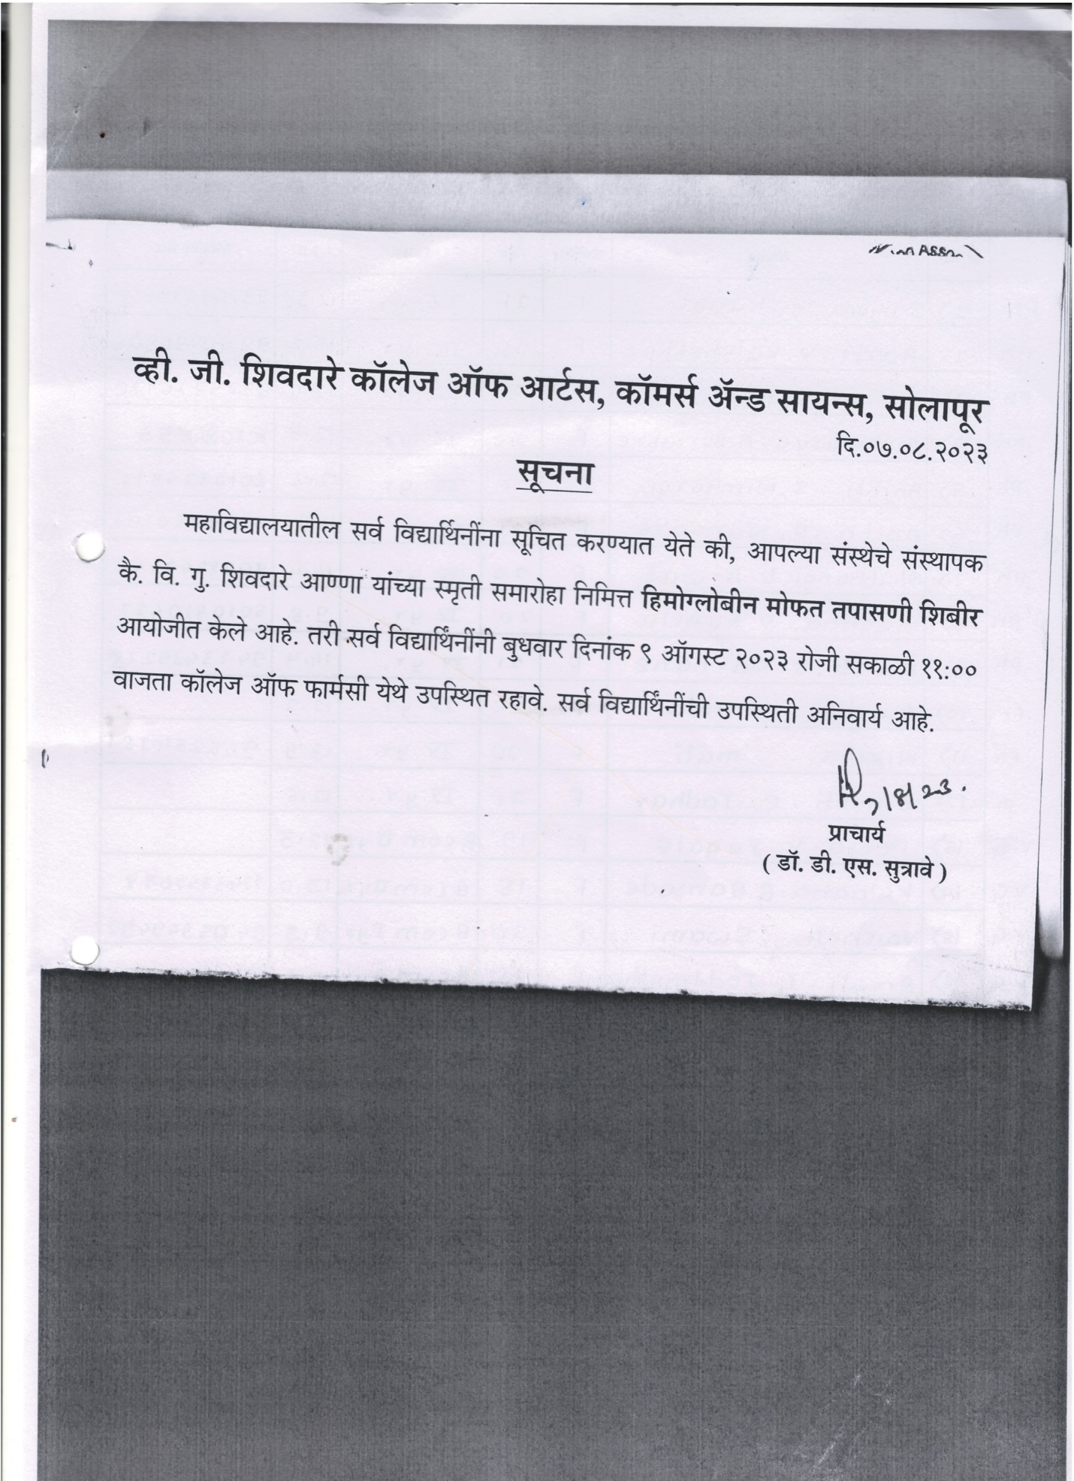
HB check up camp
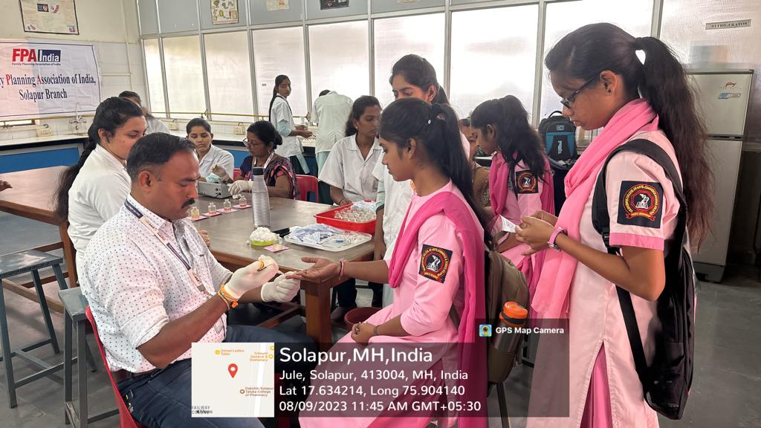

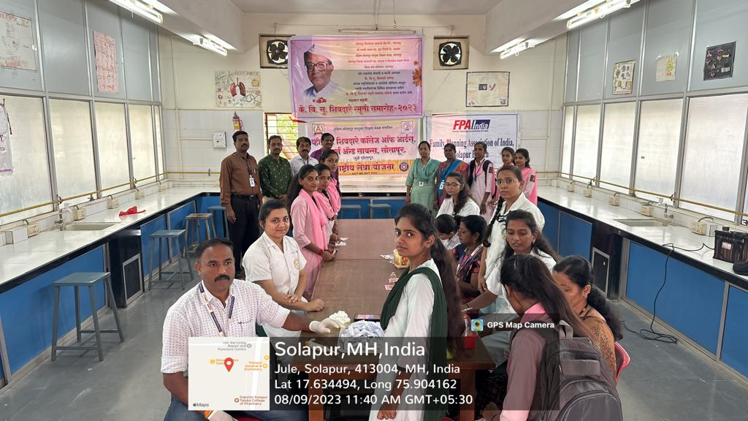

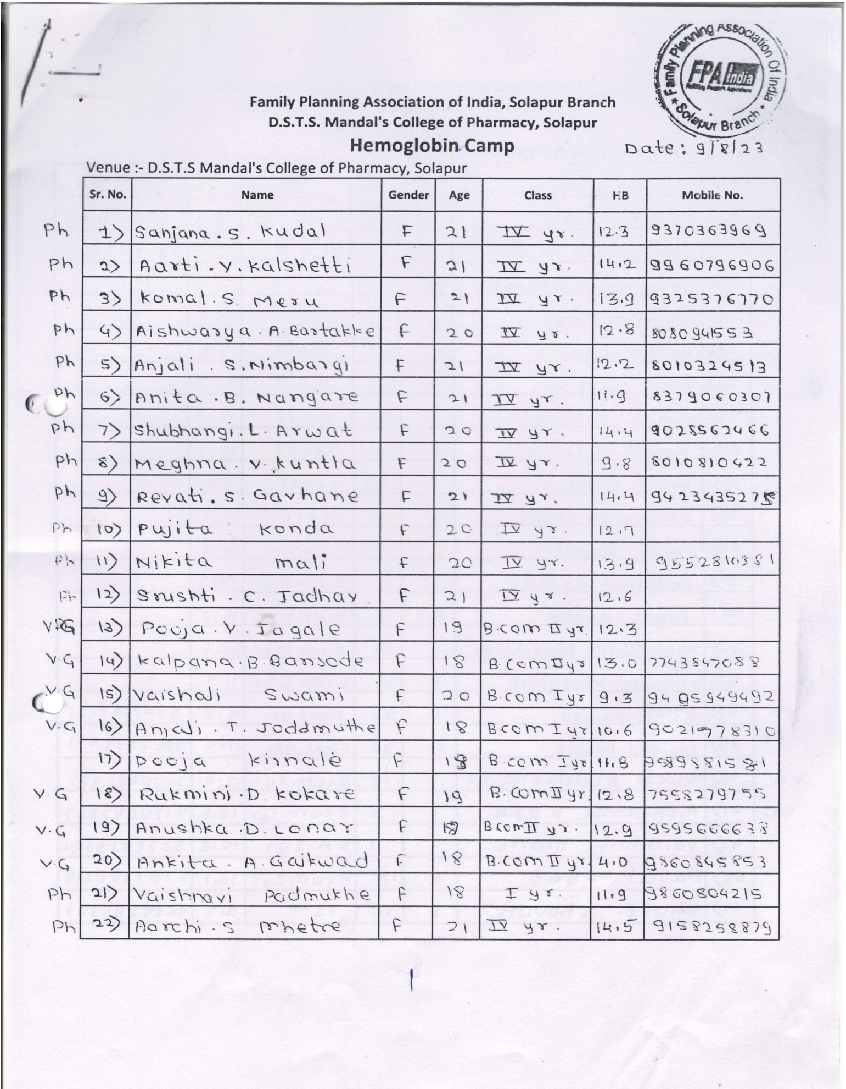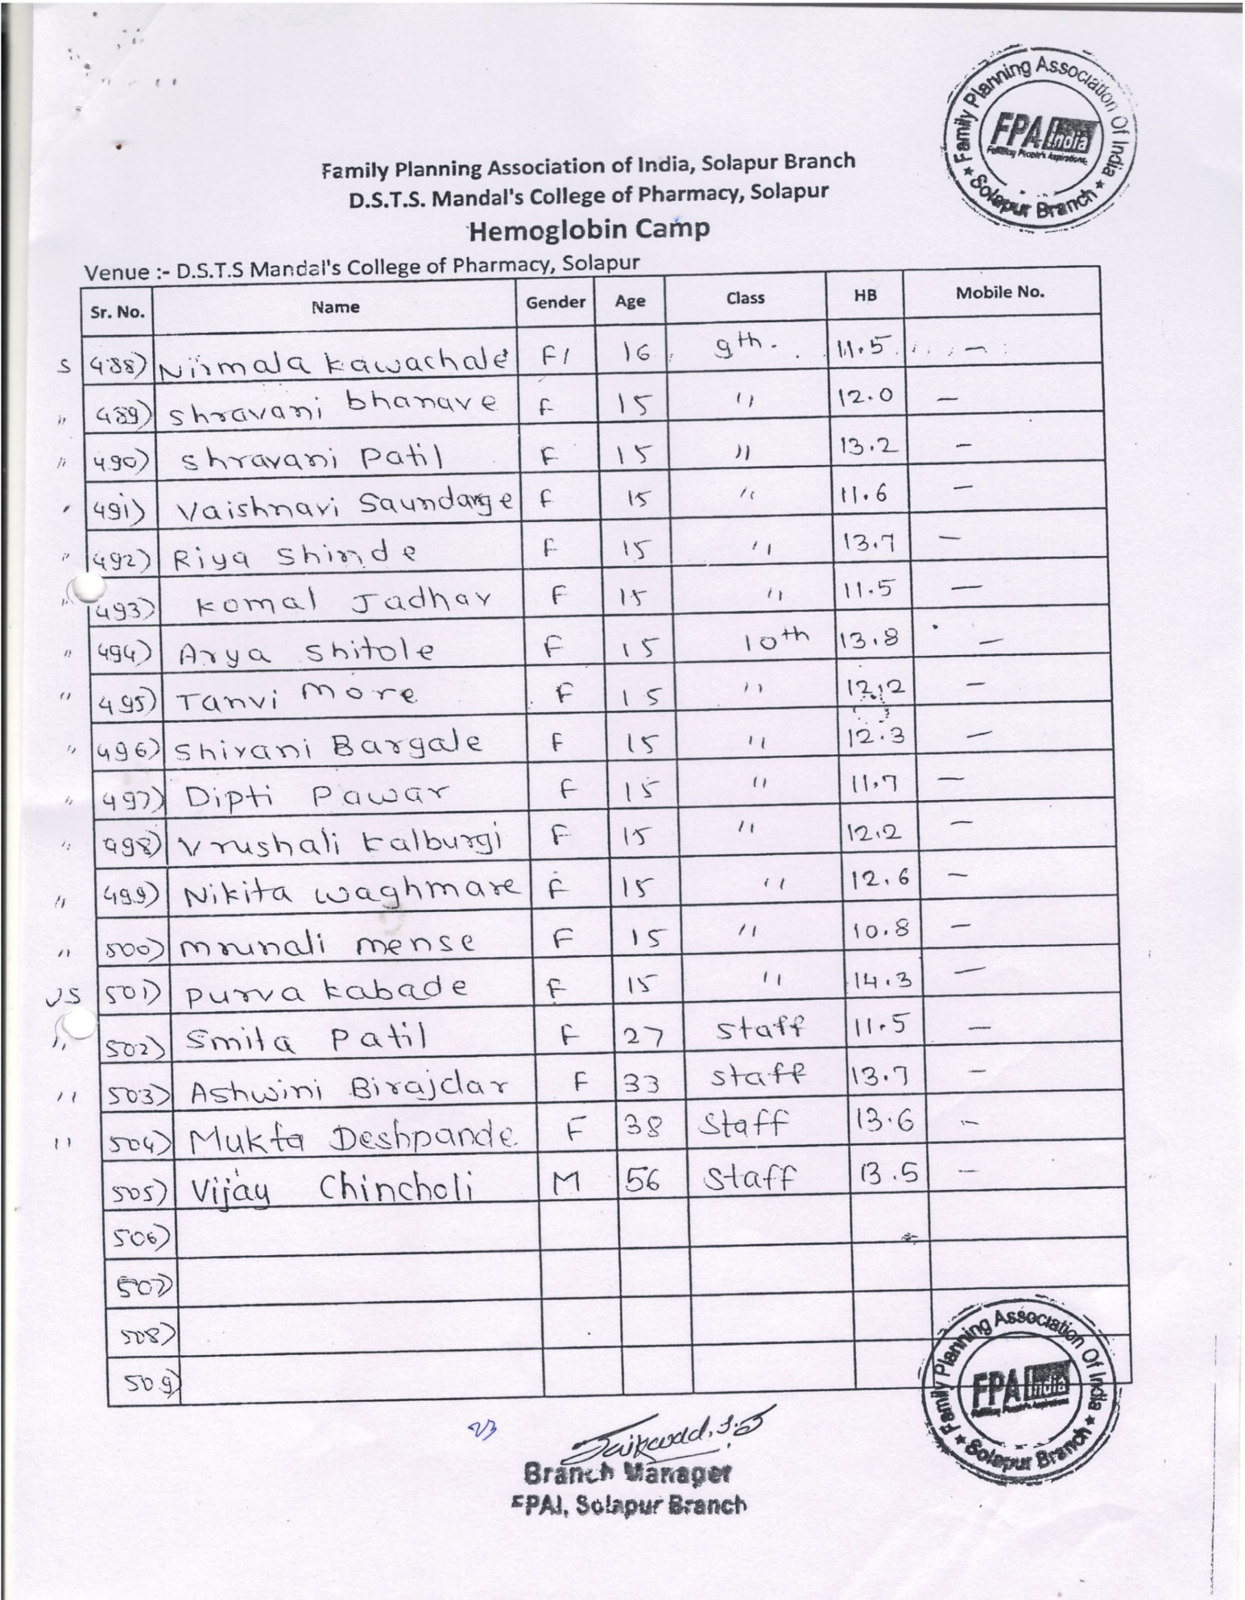
Health Checkup Camp in Unique Eglish Medium School, Solapur
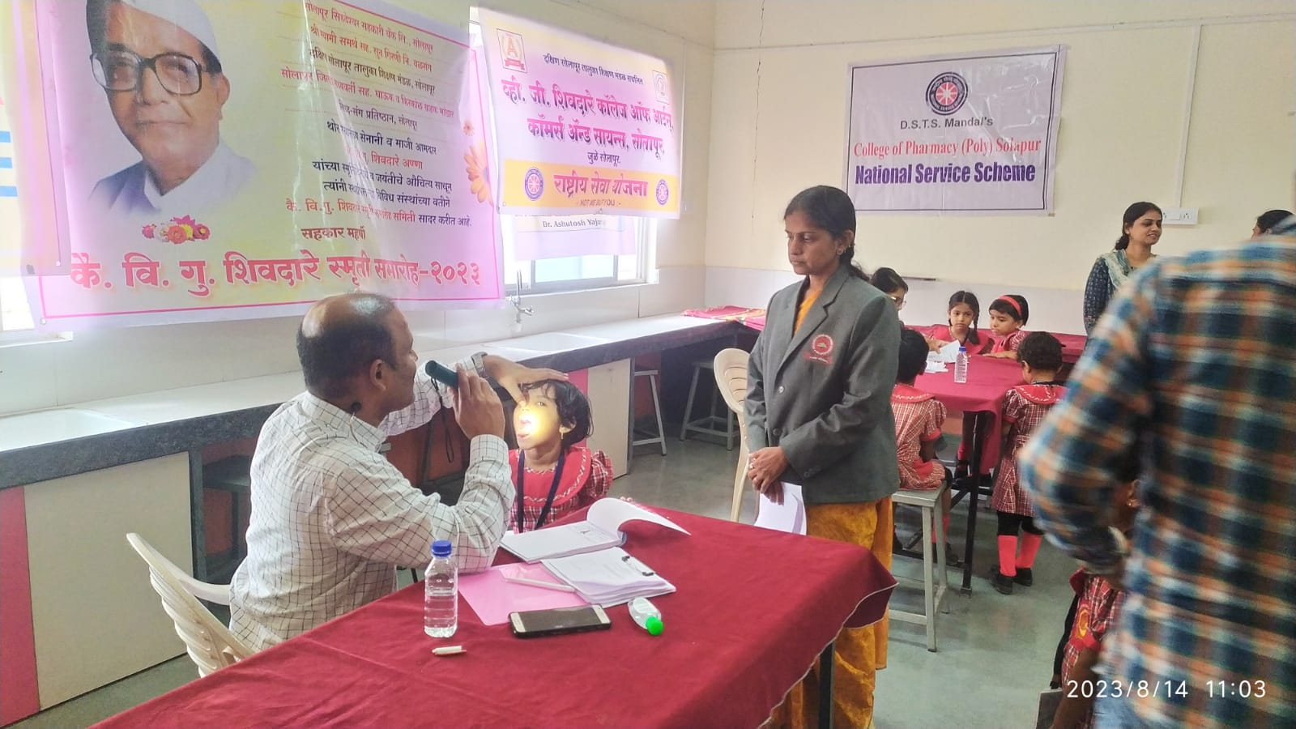

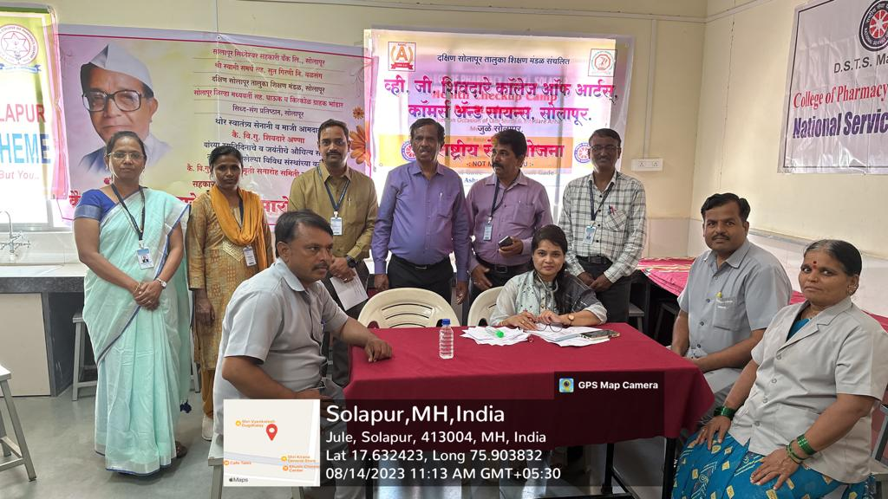

World Organ Donation awareness rally
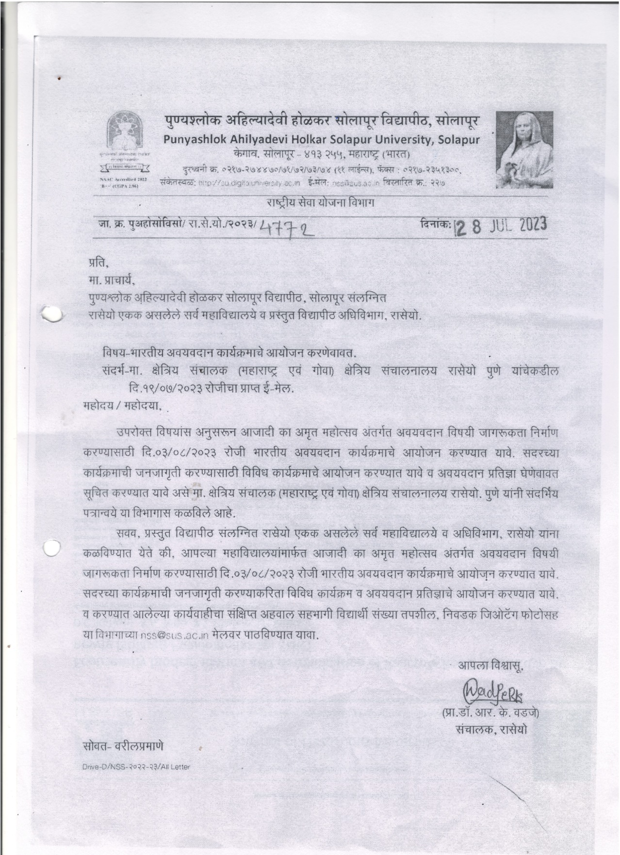
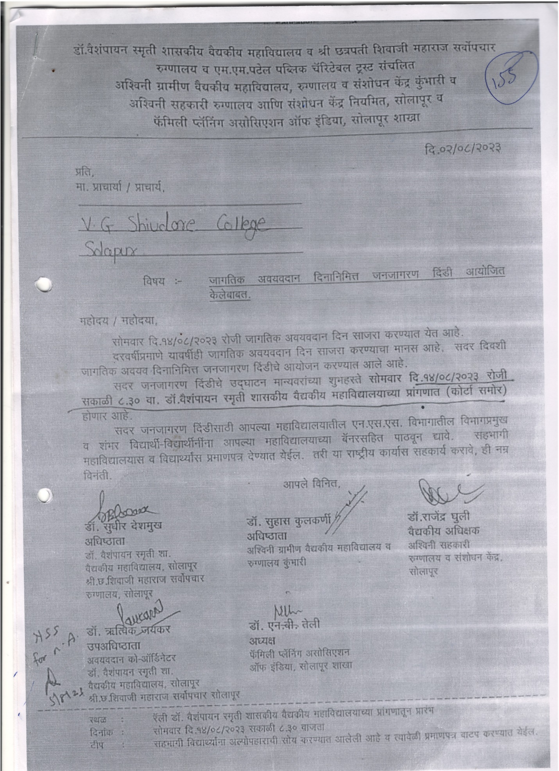
World Organ Donation awareness rally
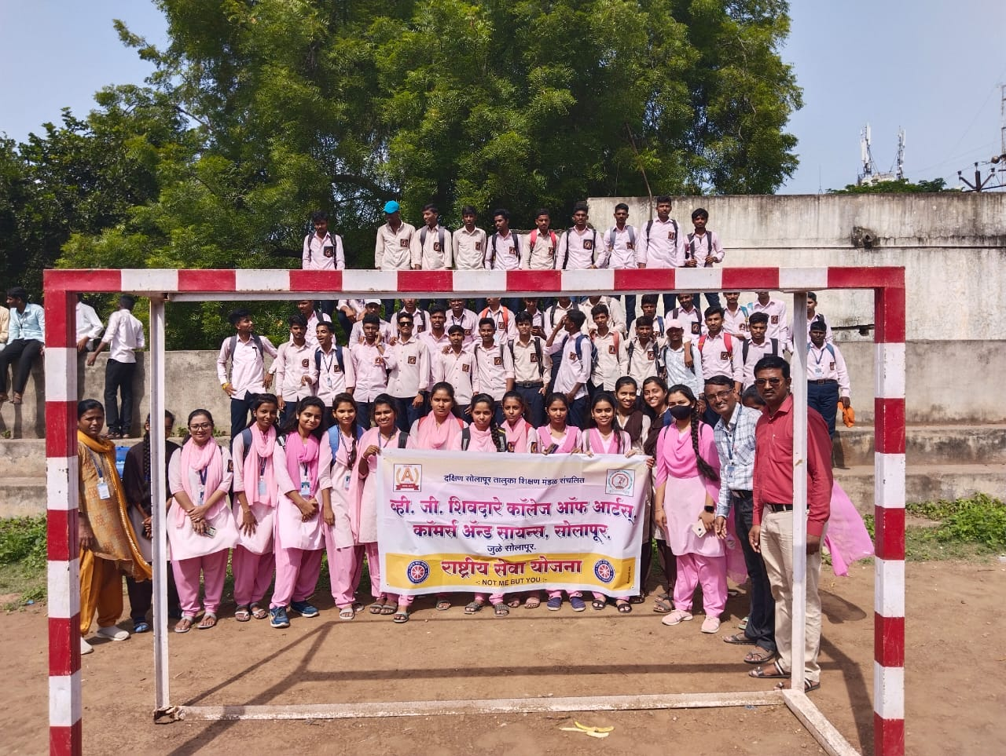

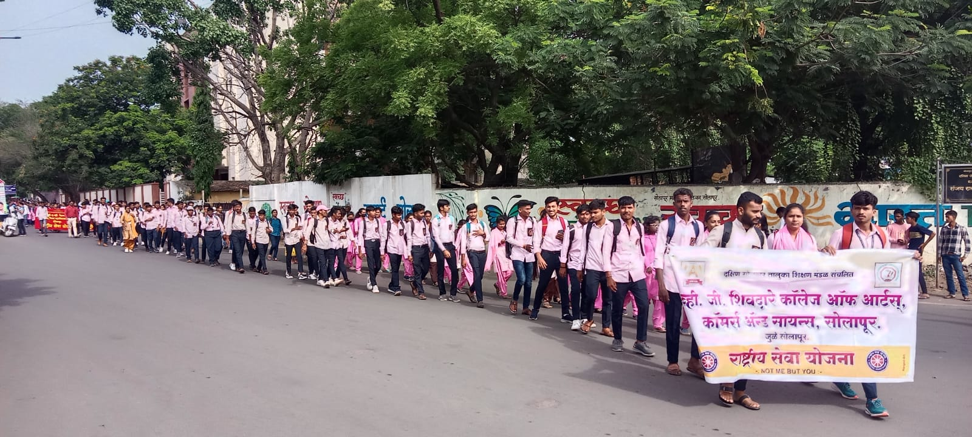

AIDS awareness rally
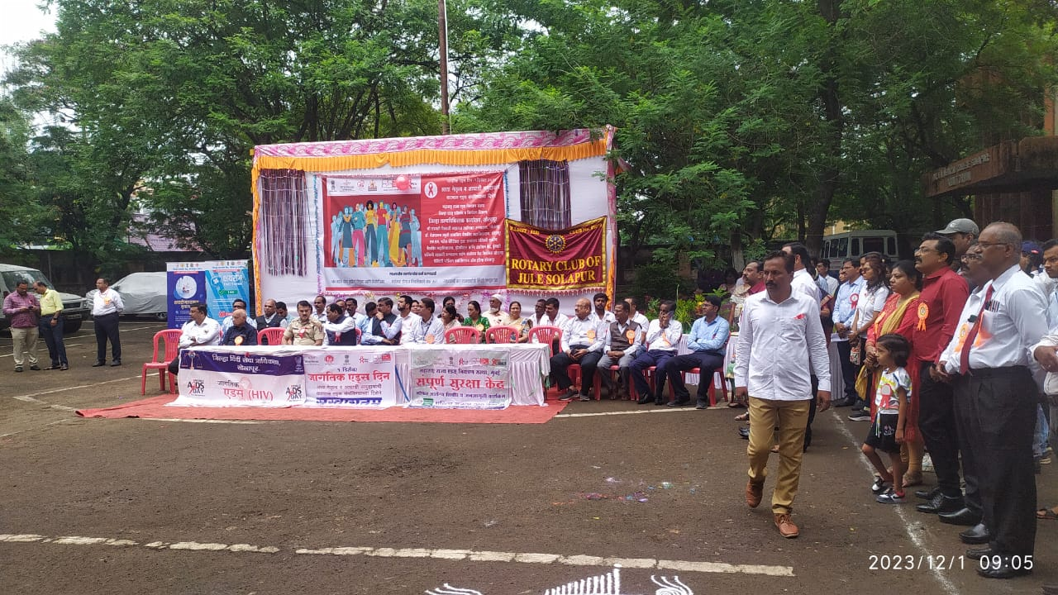

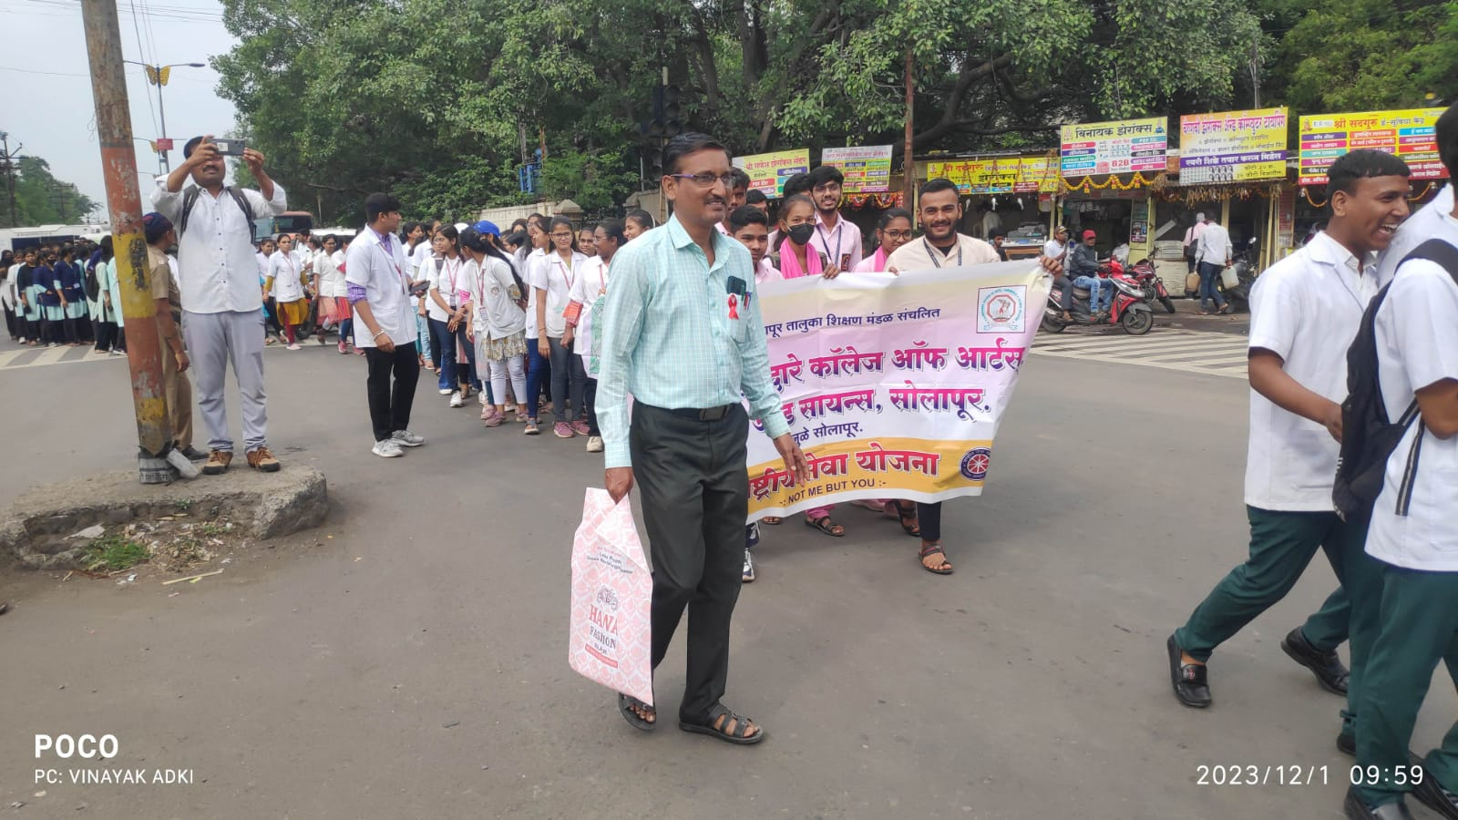

work shop on Disaster Management and Leadership Development
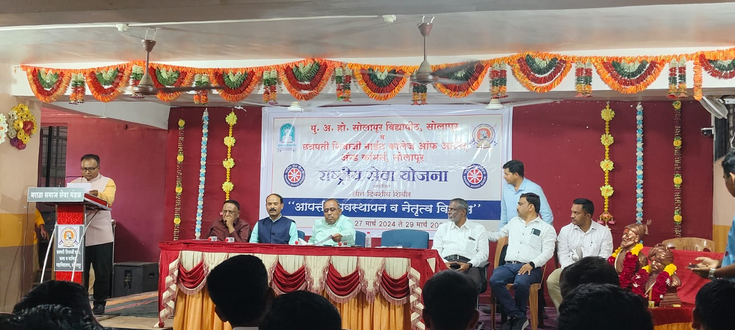

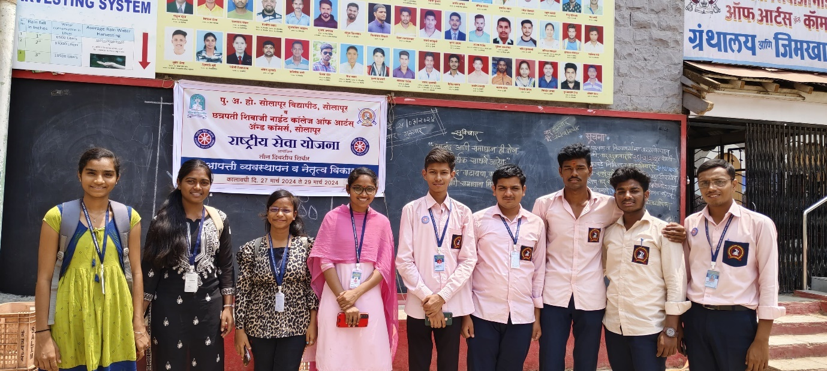

Health Awareness Workshop for Girls: Dr. Bharat Mule
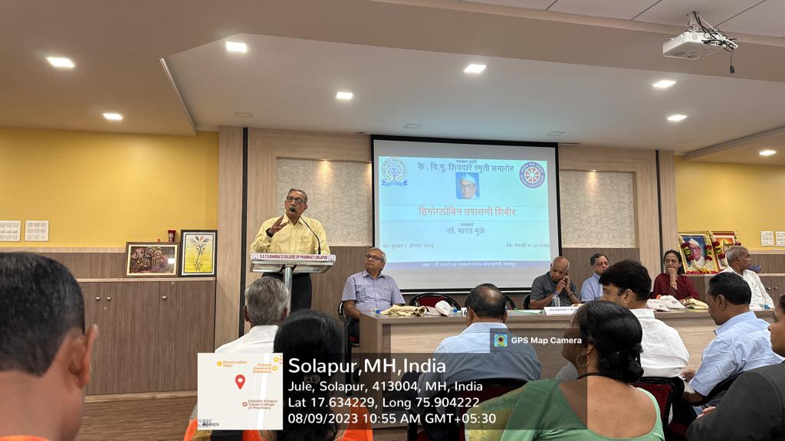

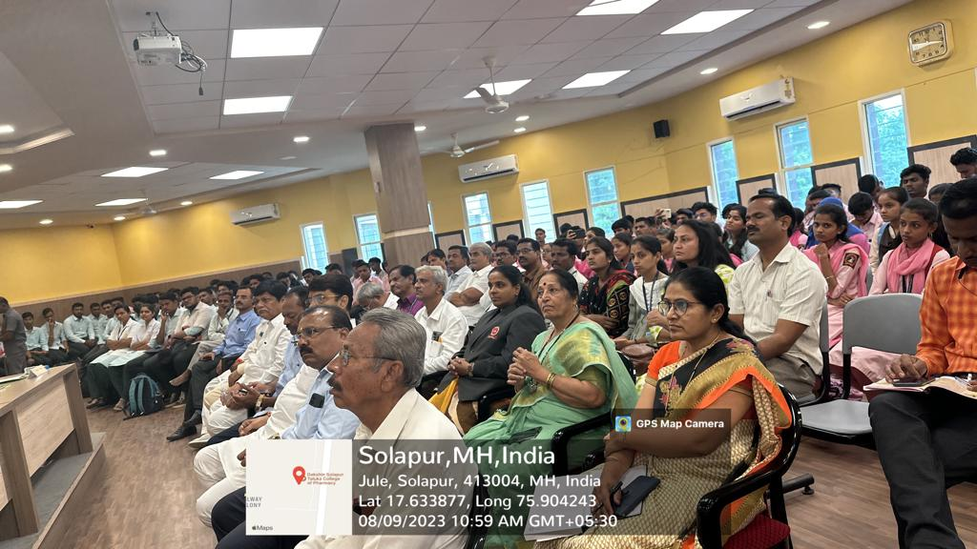

Swachha Bharat Abhiyan: Cleanliness activity
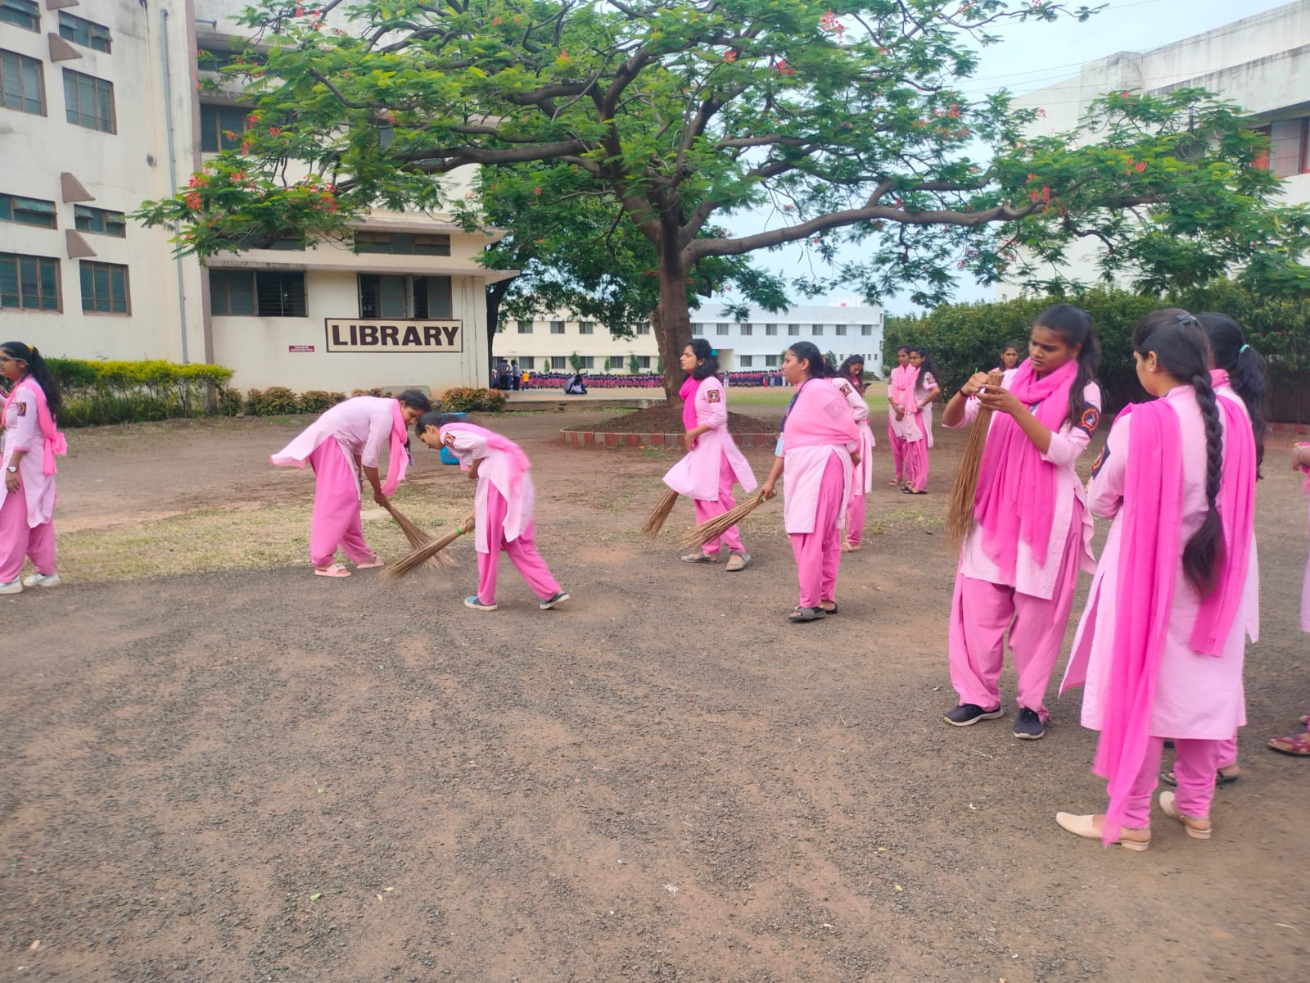
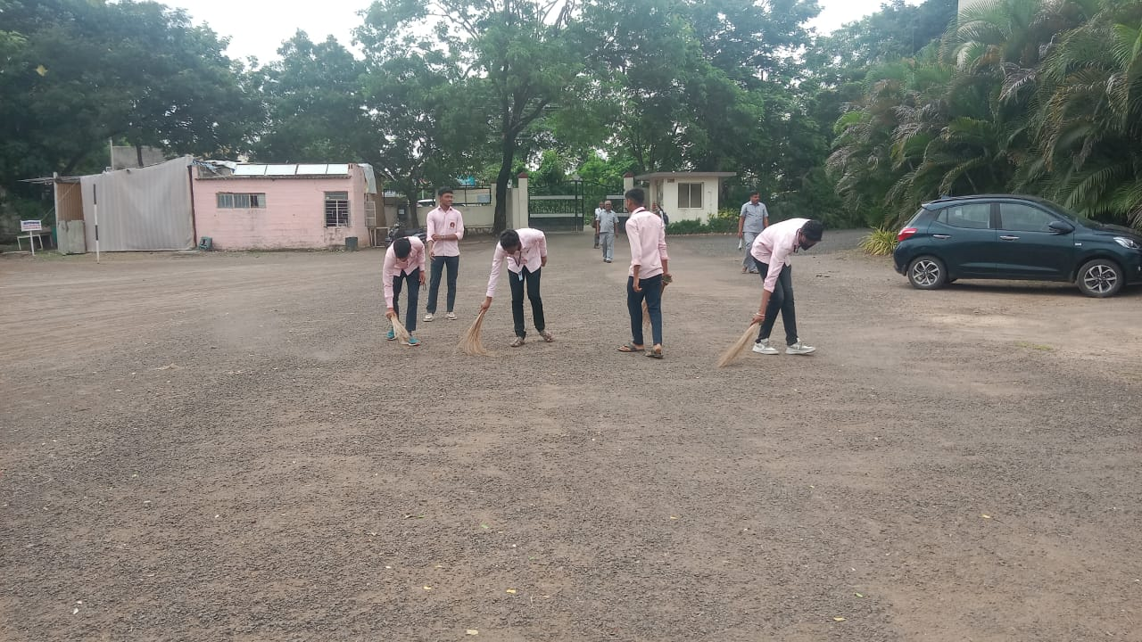

International Yoga Day
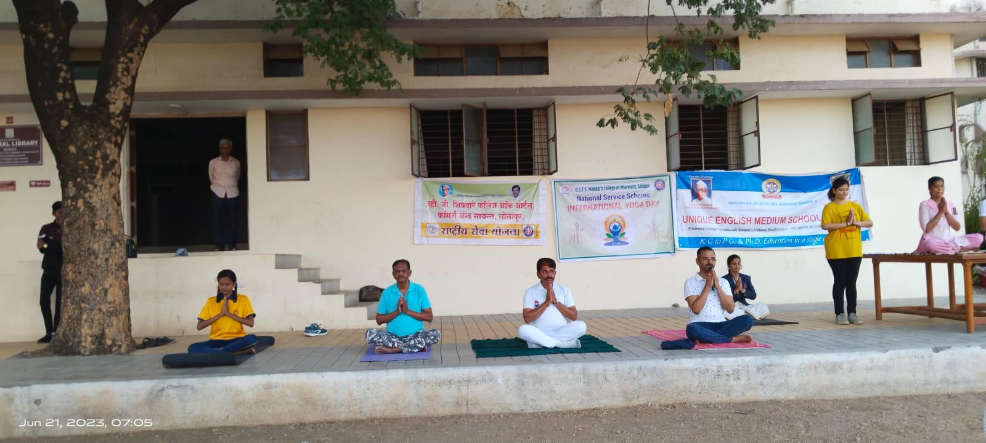
Vigilance Awareness Week : Guest Lecture by Mr. Vikas Goutam Manager Indian Oil Corporation
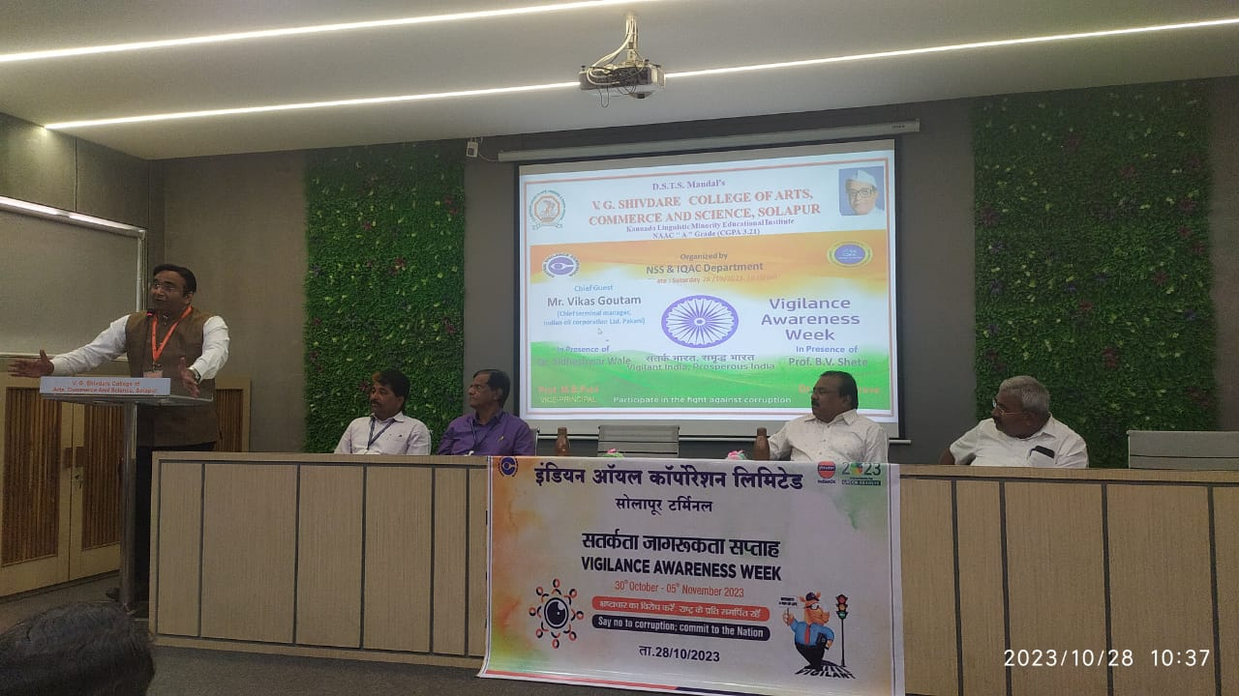
NSS Camp at Hattur, South Solapur.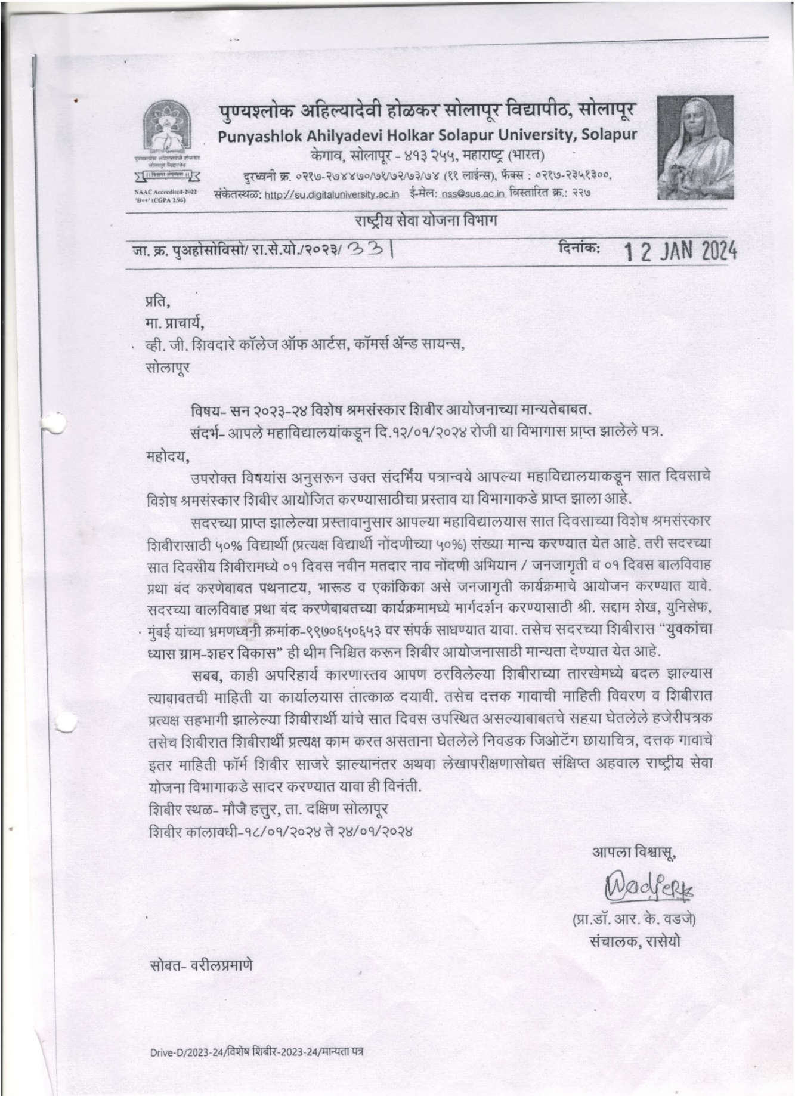
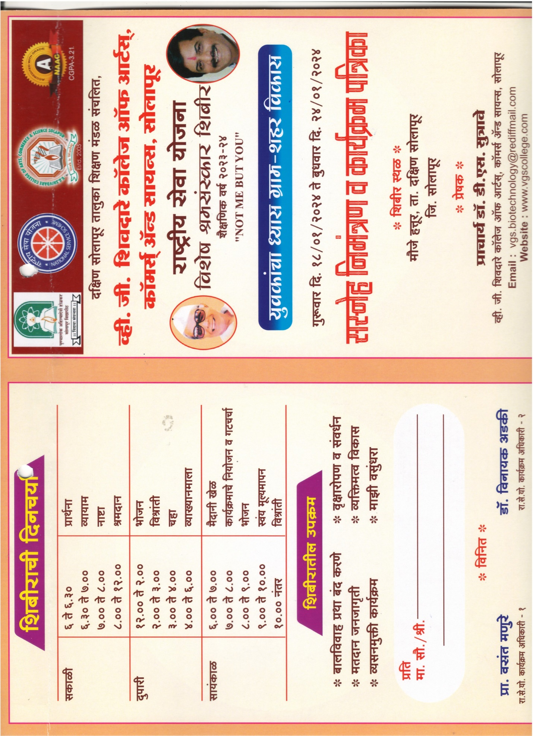
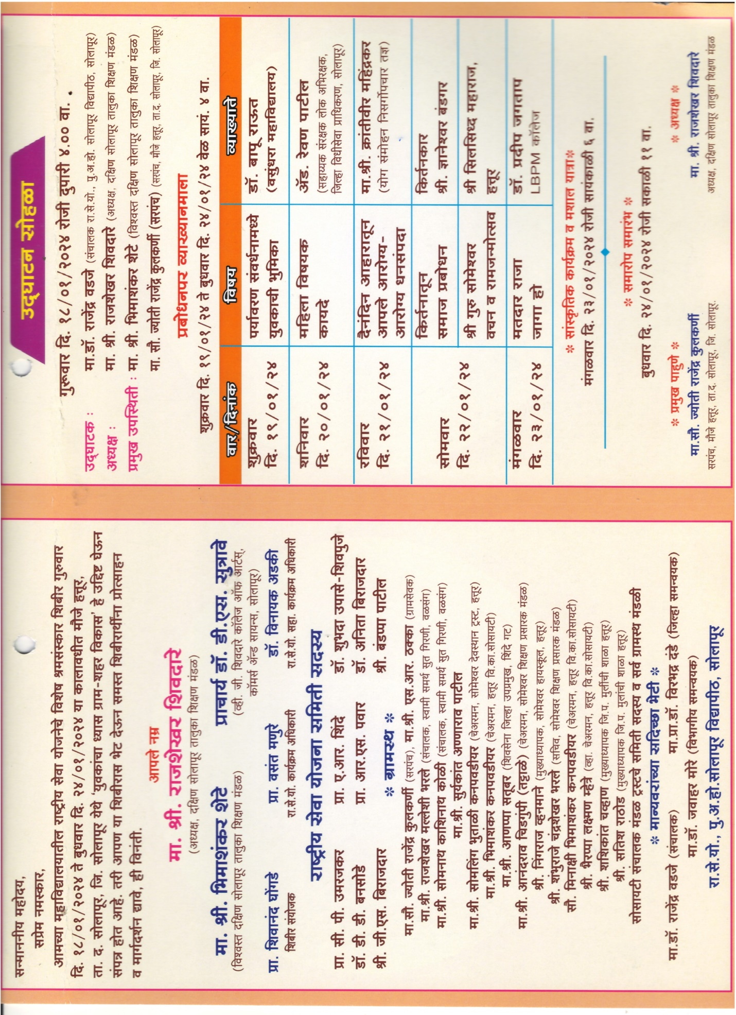
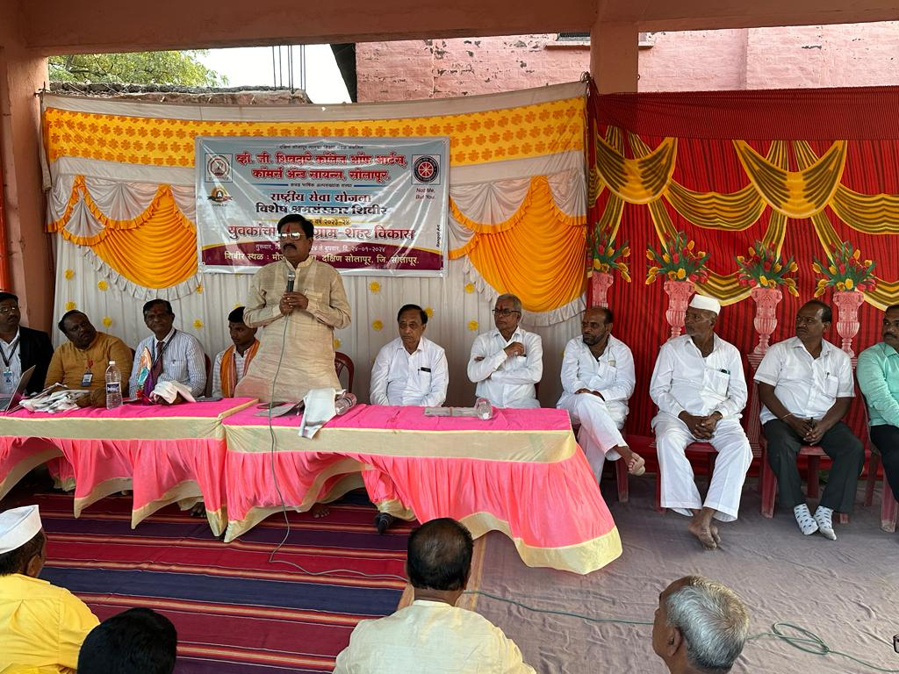
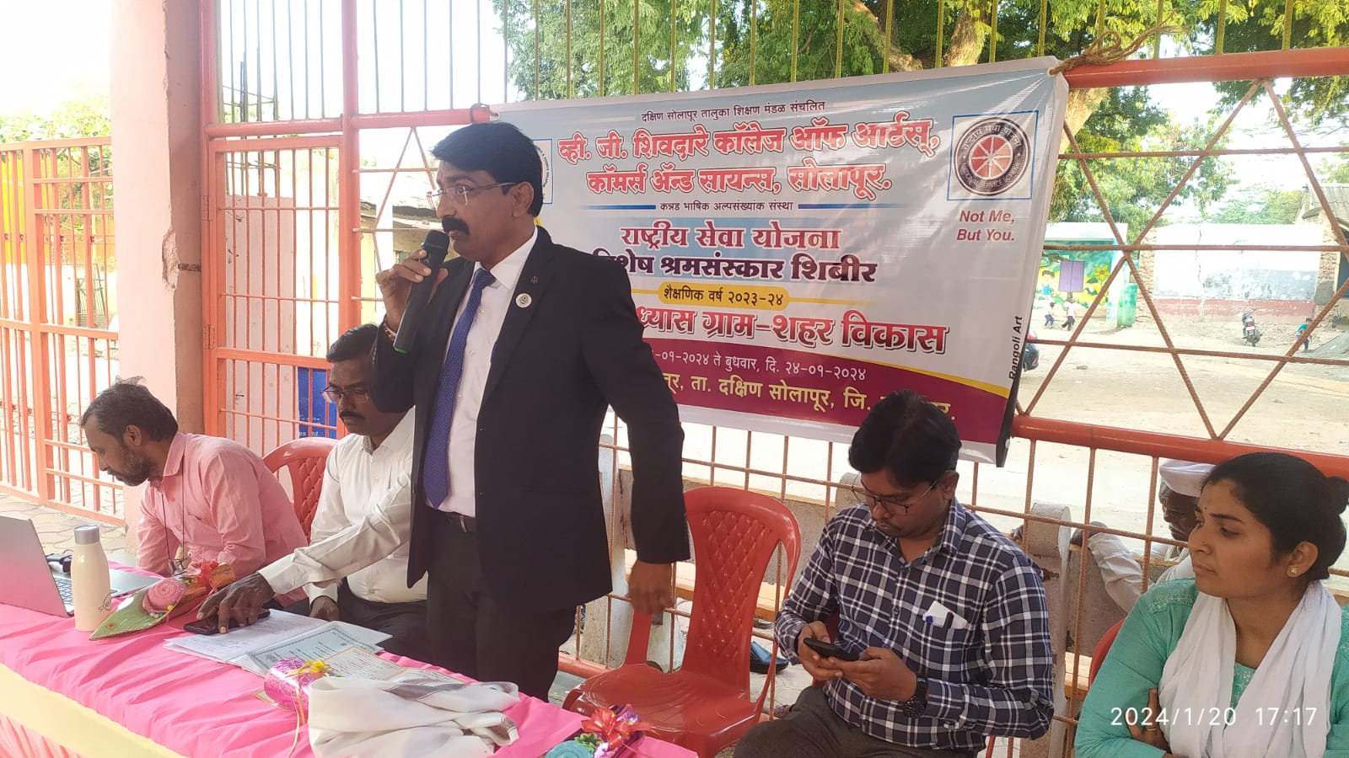

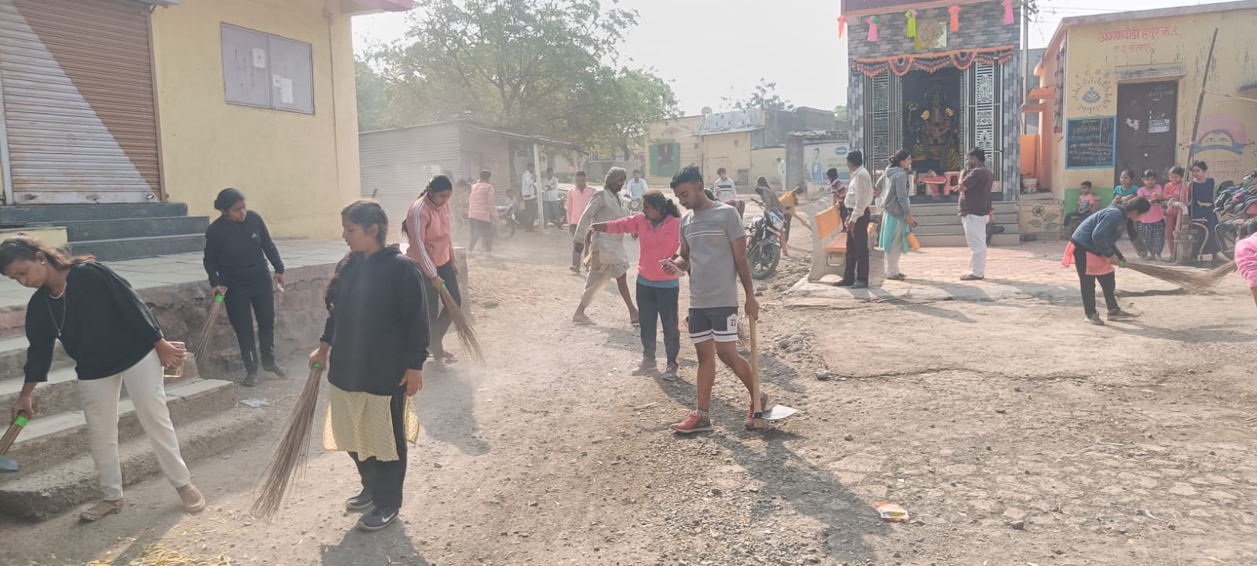

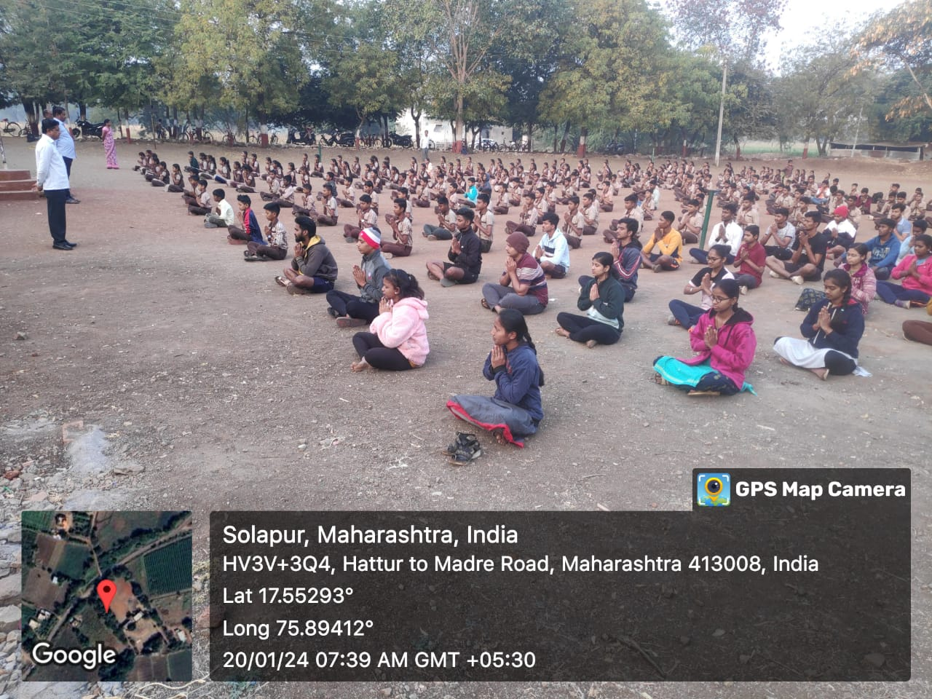

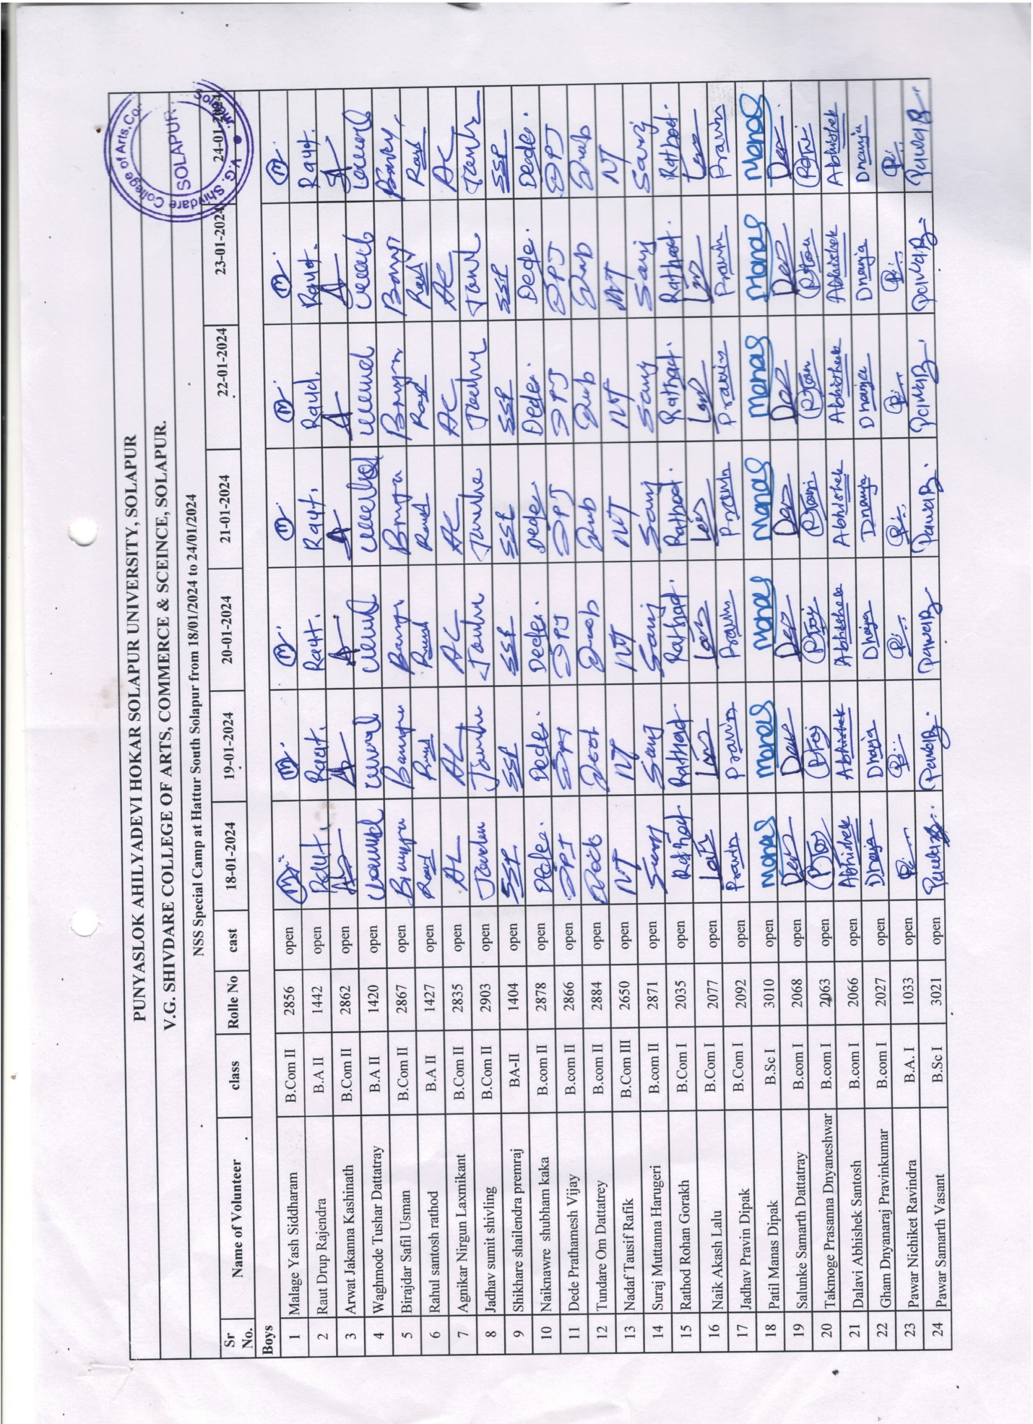
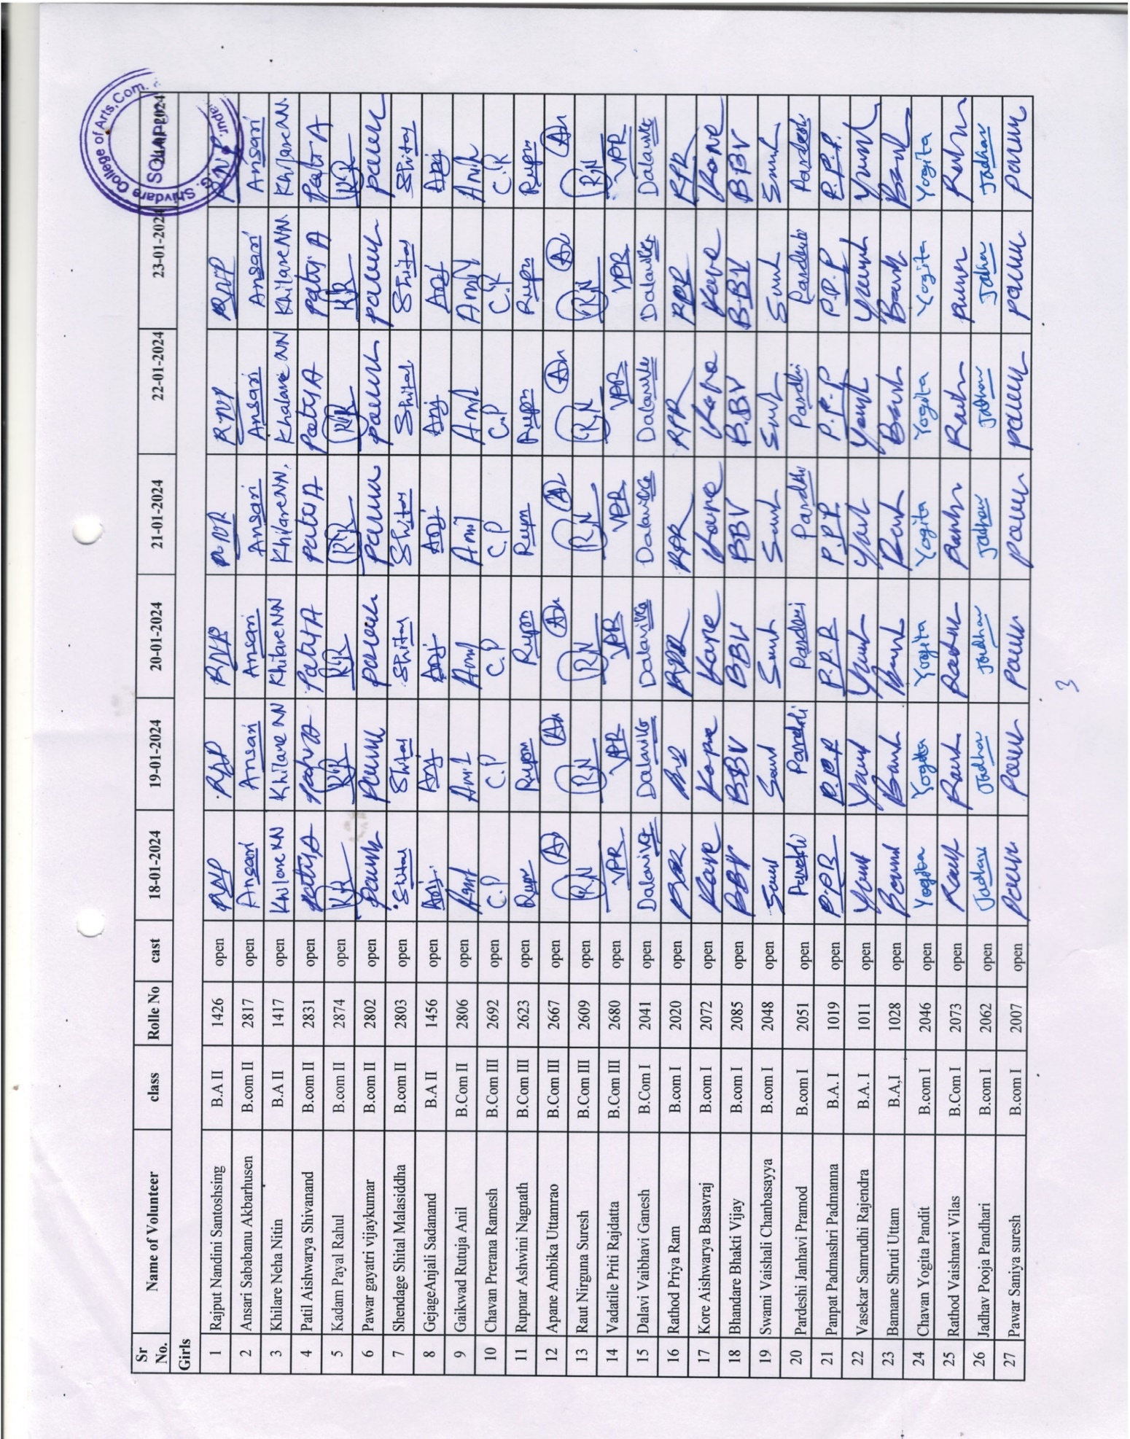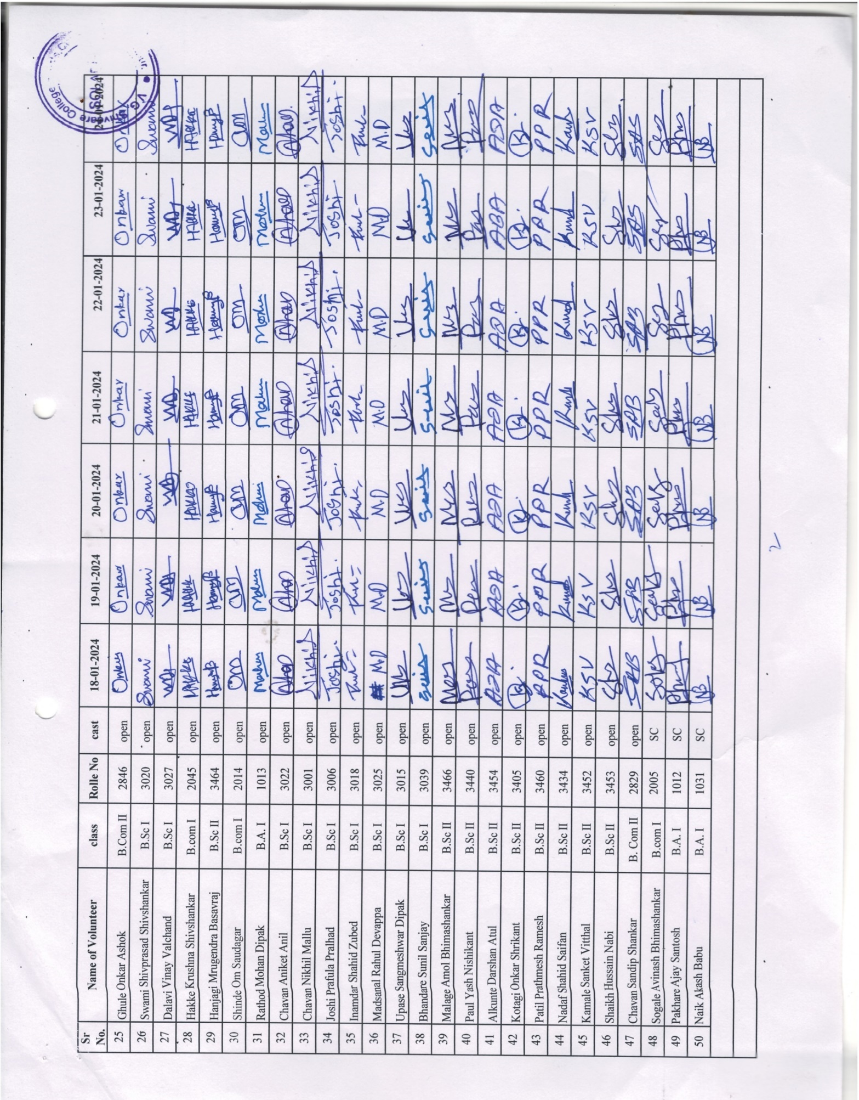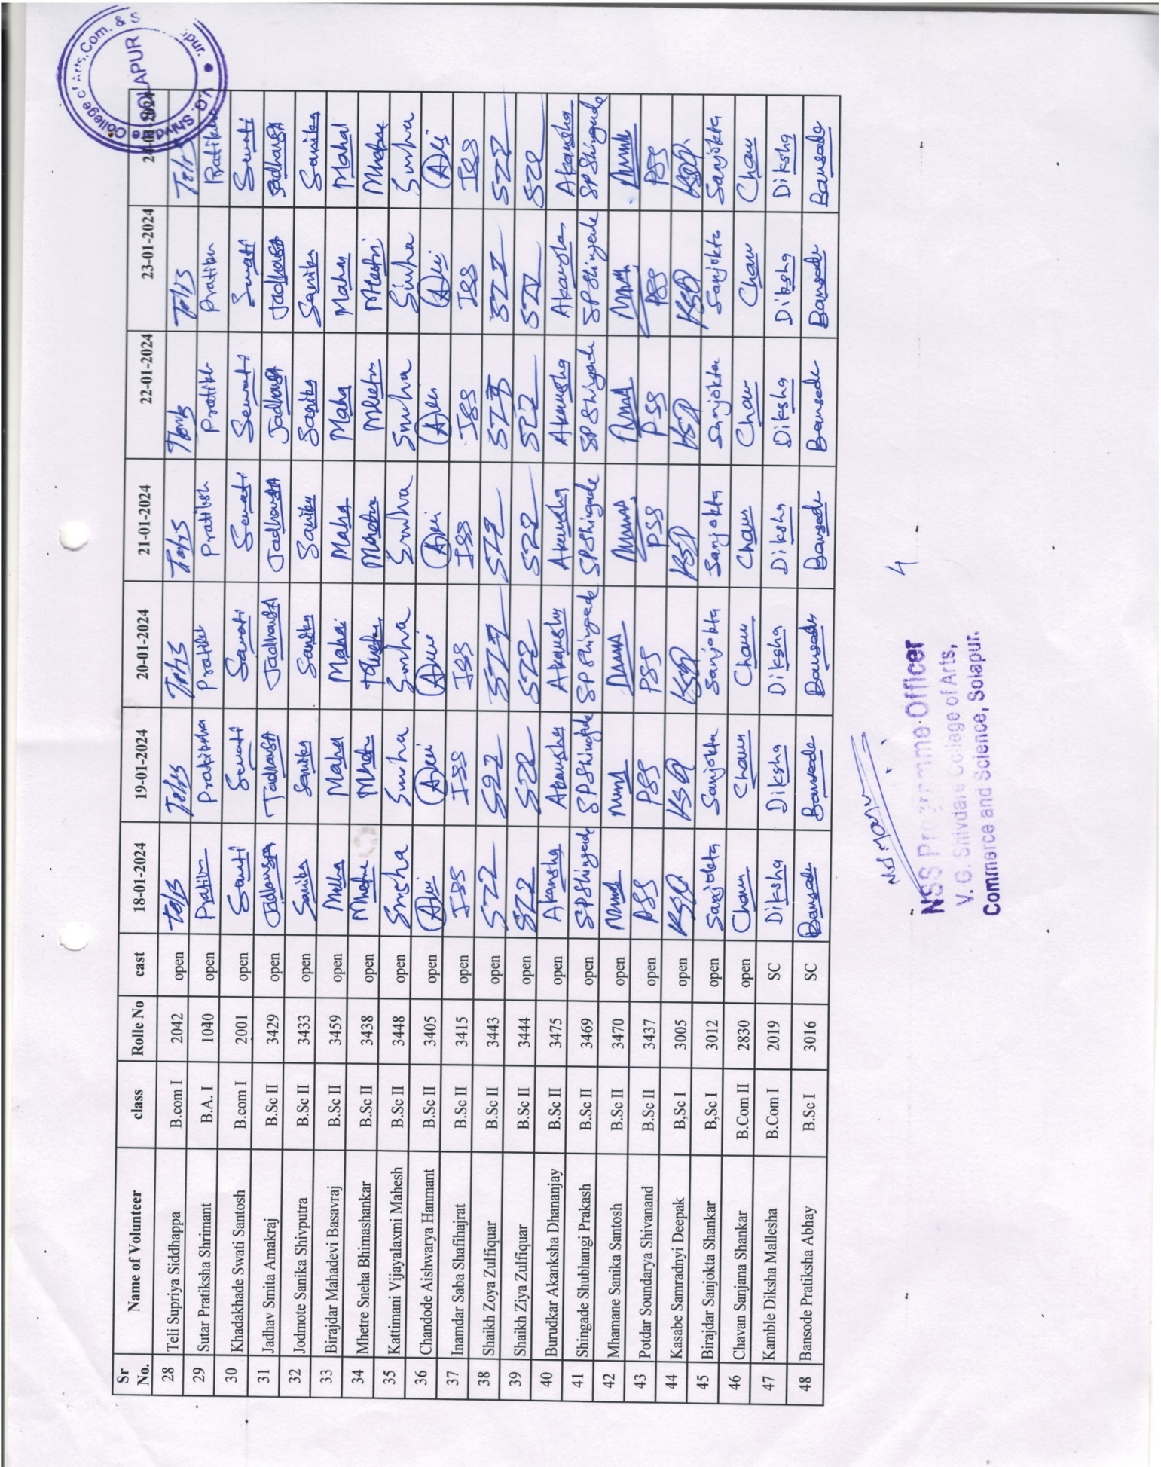
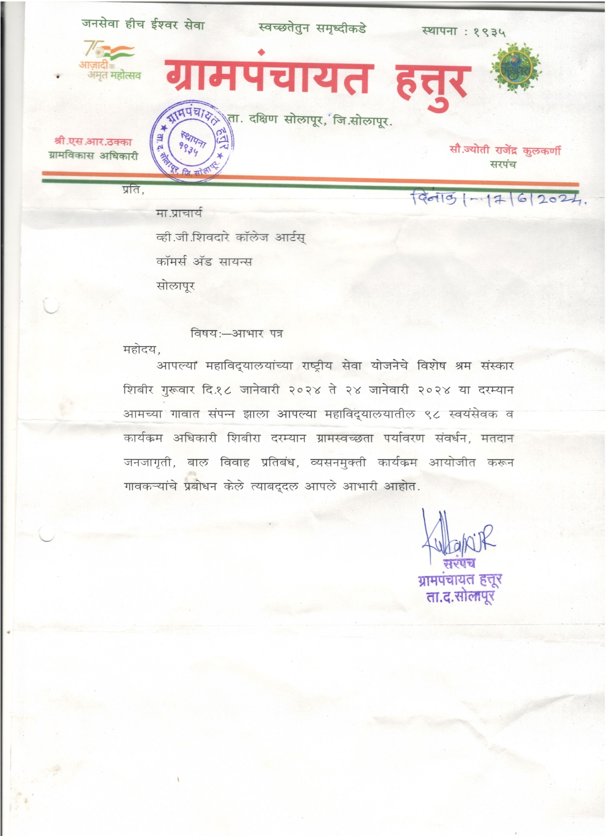

Participation of NSS Volunteer Miss Kajal Choudhari in National Integration camp, Mangaluru
