3.5.1 Number of Collaborative activities for research, Faculty exchange, Student exchange/ internship during the year
Sl. No. | Title of the collaborative activity | Name of the collaborating agency with contact details | Name of the participant | Year of collaboration | Duration | Nature of the activity | Link to the relavant document
1 | BajajFiserv certificate course | Bajajfinserv Ltd | Commerce department B.com III | 2023-24 | 01 year | Training Programme related ot Banking, Insurance and Finance
2 | Kavya sanmelan | Marathi Sahitya Parishad, Jule Solapur | Marthi Department Students | 2023-24 | 05 years | Kavya Sanmelan in occasion of marathi Rajya Bhasha Din

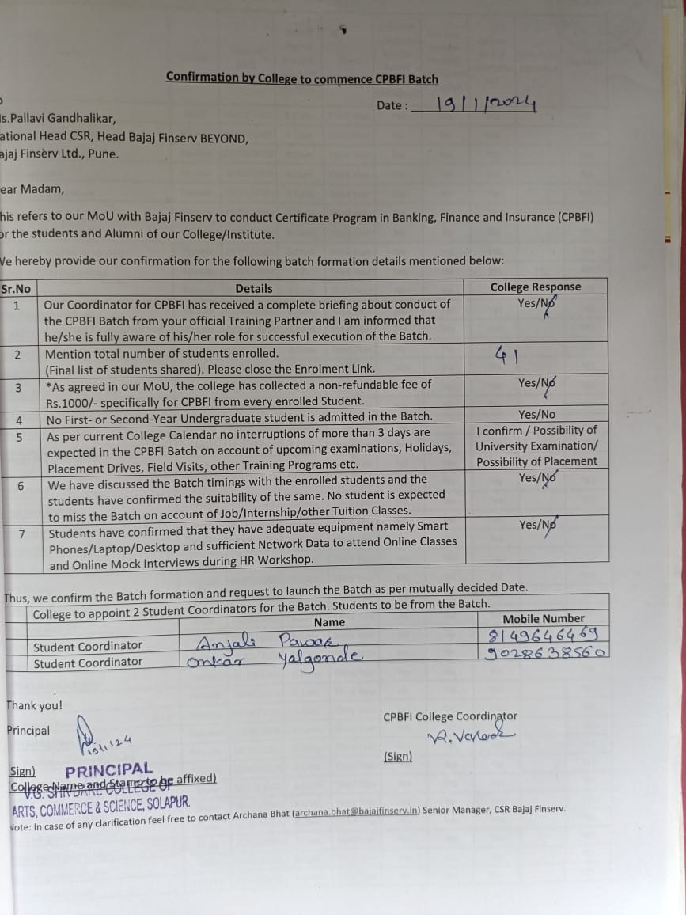
Inaugural function of Bajaj finserv CERTIFICATE PROGRAMME ON BANKING, FINANCE AND INSURANCE” Date: 1/2/24
