3.5.2 Number of functional MoUs with institutions, other universities, industries, corporate houses etc. during the year
Organisation with which MoU is signed | Name of the institution/ industry/ corporate house | Year of signing MoU | Duration | List the actual activities under each MOU year wise | Number of students/teachers participated under MoUs
Siddharth Salunke corporate Director BioEra Life Science Pvt. Ltd. | BioEra Life Science Pvt. Ltd. | Oct-23 | 3 Year | 1 | 75
Principal, Laxmibai Bharat Patil Mahila Mahavidyalaya, Solapur | Rayat Shikshan Sanstha | 21st September 2022 | 5 Year | 1 | 100
Pallavi Gandhalikar Head Bajajfinserv Ltd | Baja Finserv Ltd. | 19th January 2024 | 1 Year | 32 lectures | 41
Director Marathi Sahitya Parishad, Jule Solapur | Marathi Sahitya Parishad, Jule Solapur | 05th January 2023 | 5 Year | 1 | 140

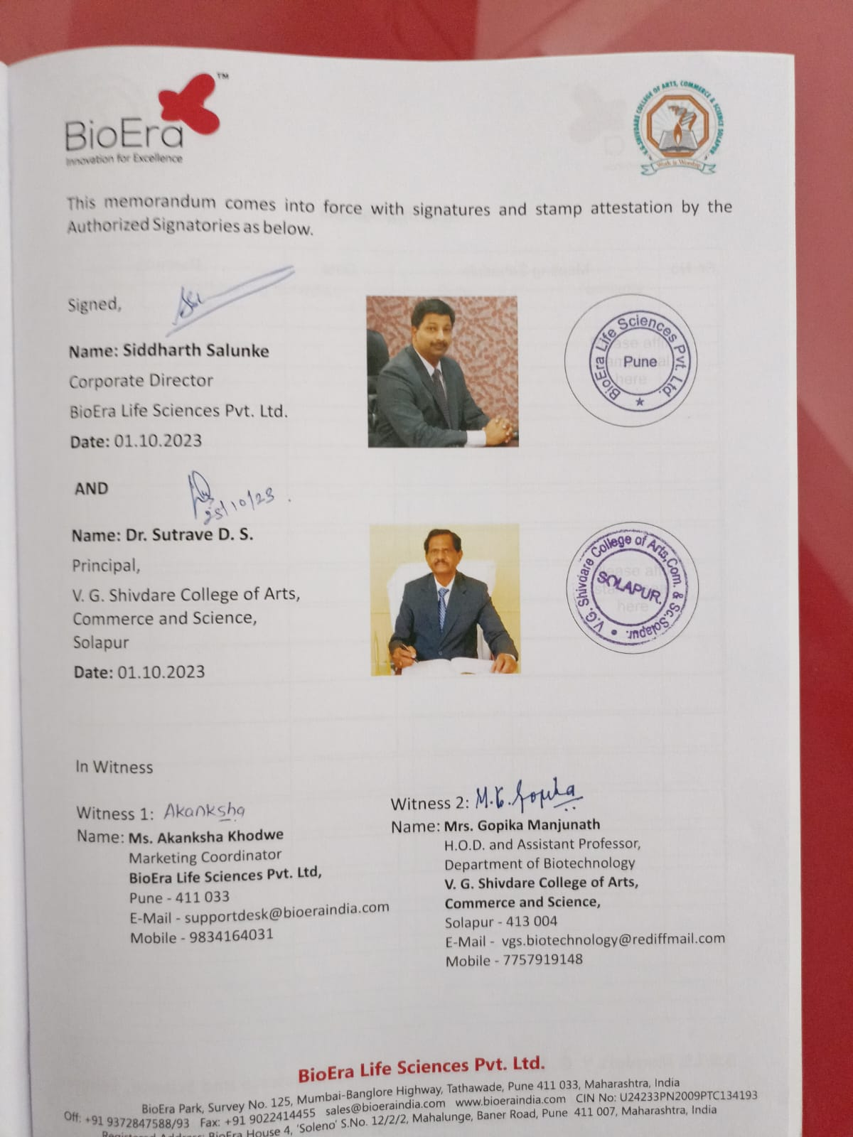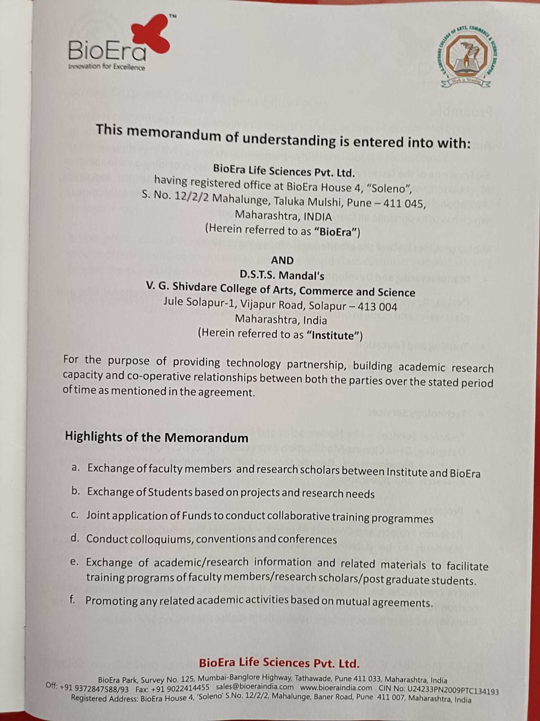
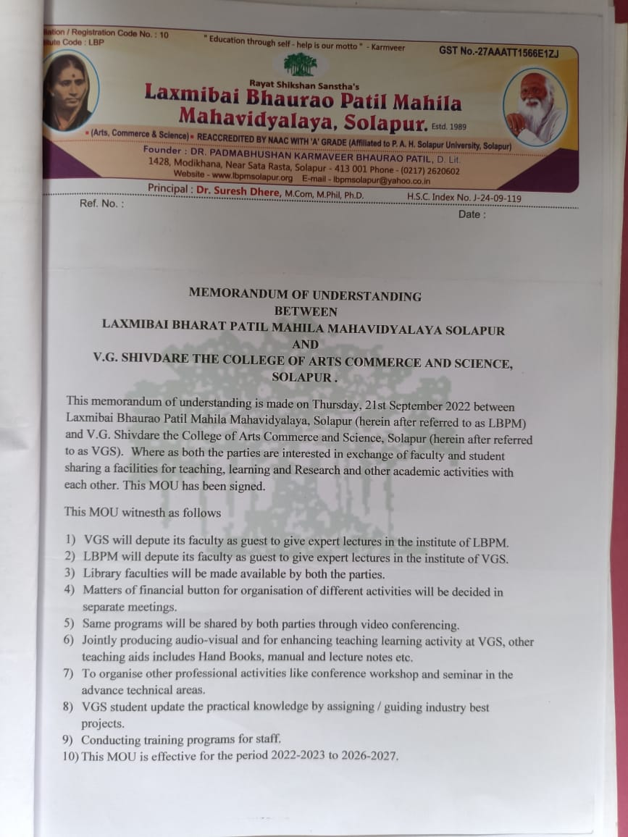
Lecture under MoU by Prof. Hanamgaon P.B. at LBPM college
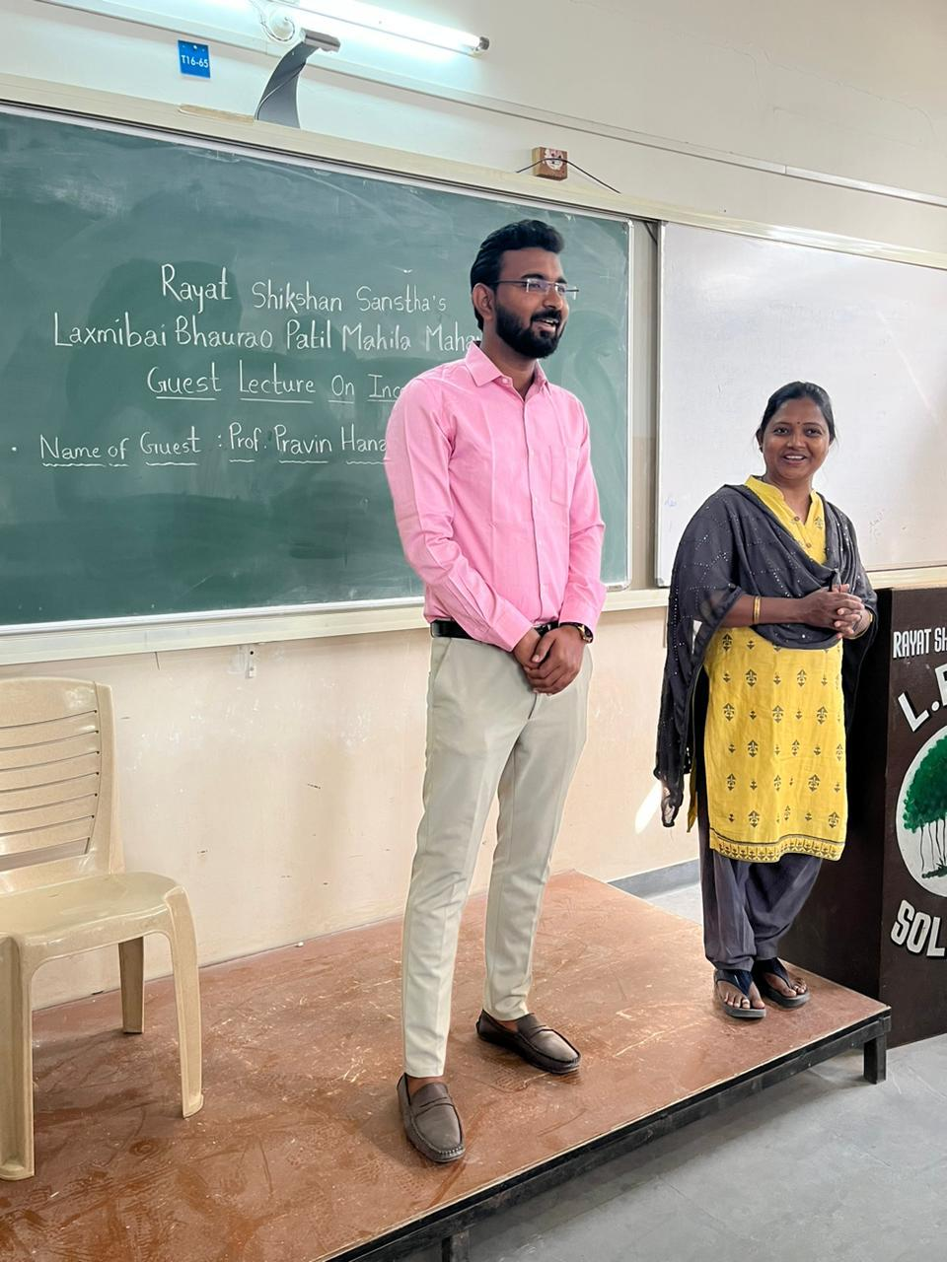
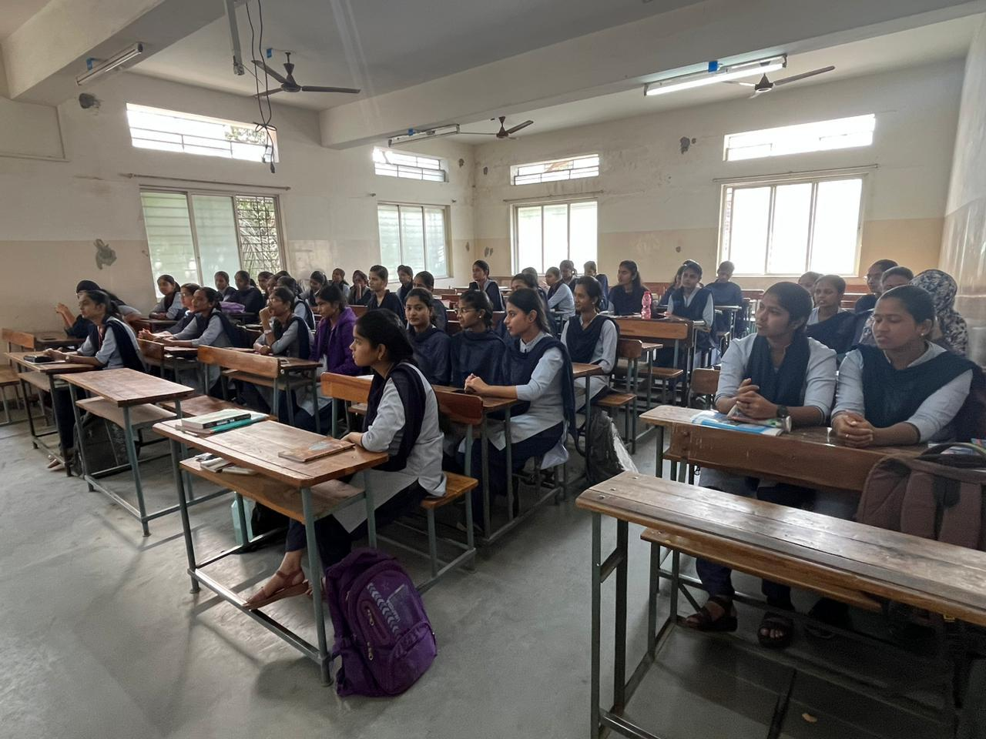
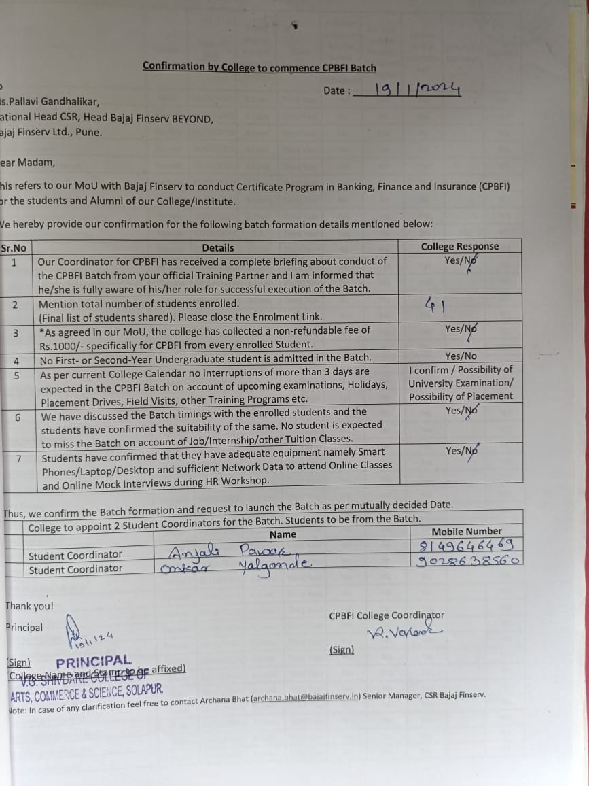
Inaugural function of Bajaj finserv CERTIFICATE PROGRAMME ON BANKING, FINANCE AND INSURANCE” Date: 1/2/24
