4.1.2 - The Institution has adequate facilities for cultural activities, sports, games (indoor, outdoor), gymnasium, yoga centre etc.
1. http://vgscollege.com/updatedweb/septoctnov23/Sports%20Achievment%20In%20YOGA.pdf
2. http://vgscollege.com/updatedweb/septoctnov23/Sports%20%20Coaching%20Camp.pdf
3.http://vgscollege.com/updatedweb/septoctnov23/Sports%20University%20Level%20Achievment%203.pdf
4. http://vgscollege.com/updatedweb/septoctnov23/Youth%20Festival%202023.pdf

Measures initiated by the Institution for the promotion of gender equity during the
year
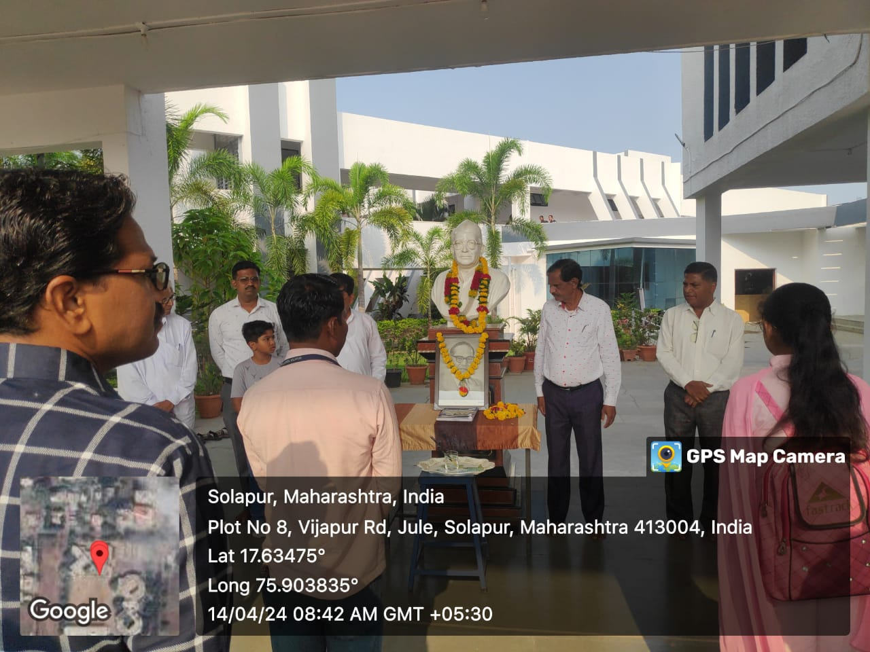
Celebration of birth anniversary Dr.Baba Saheb Ambedker

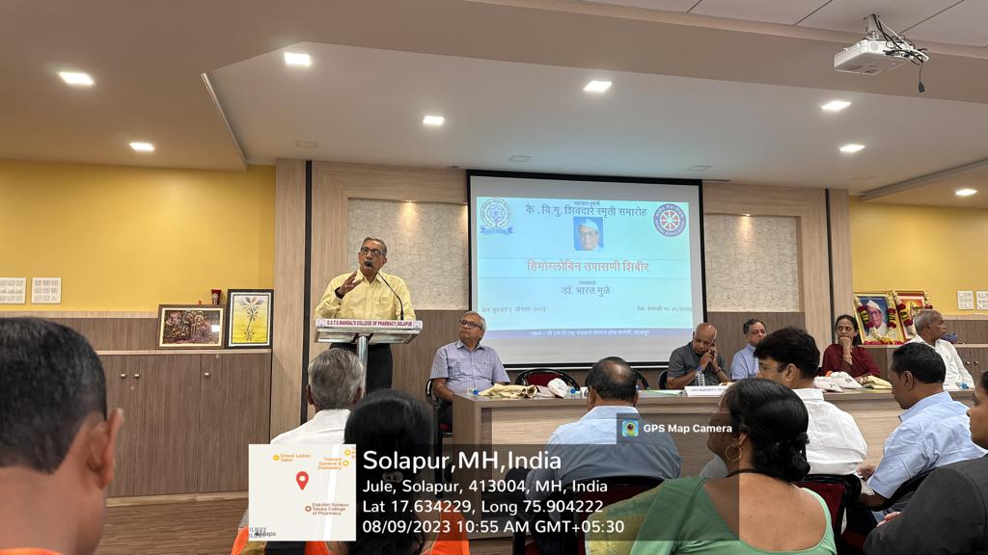
- Haemoglobin and Thalassemia awareness check-up camp for girls

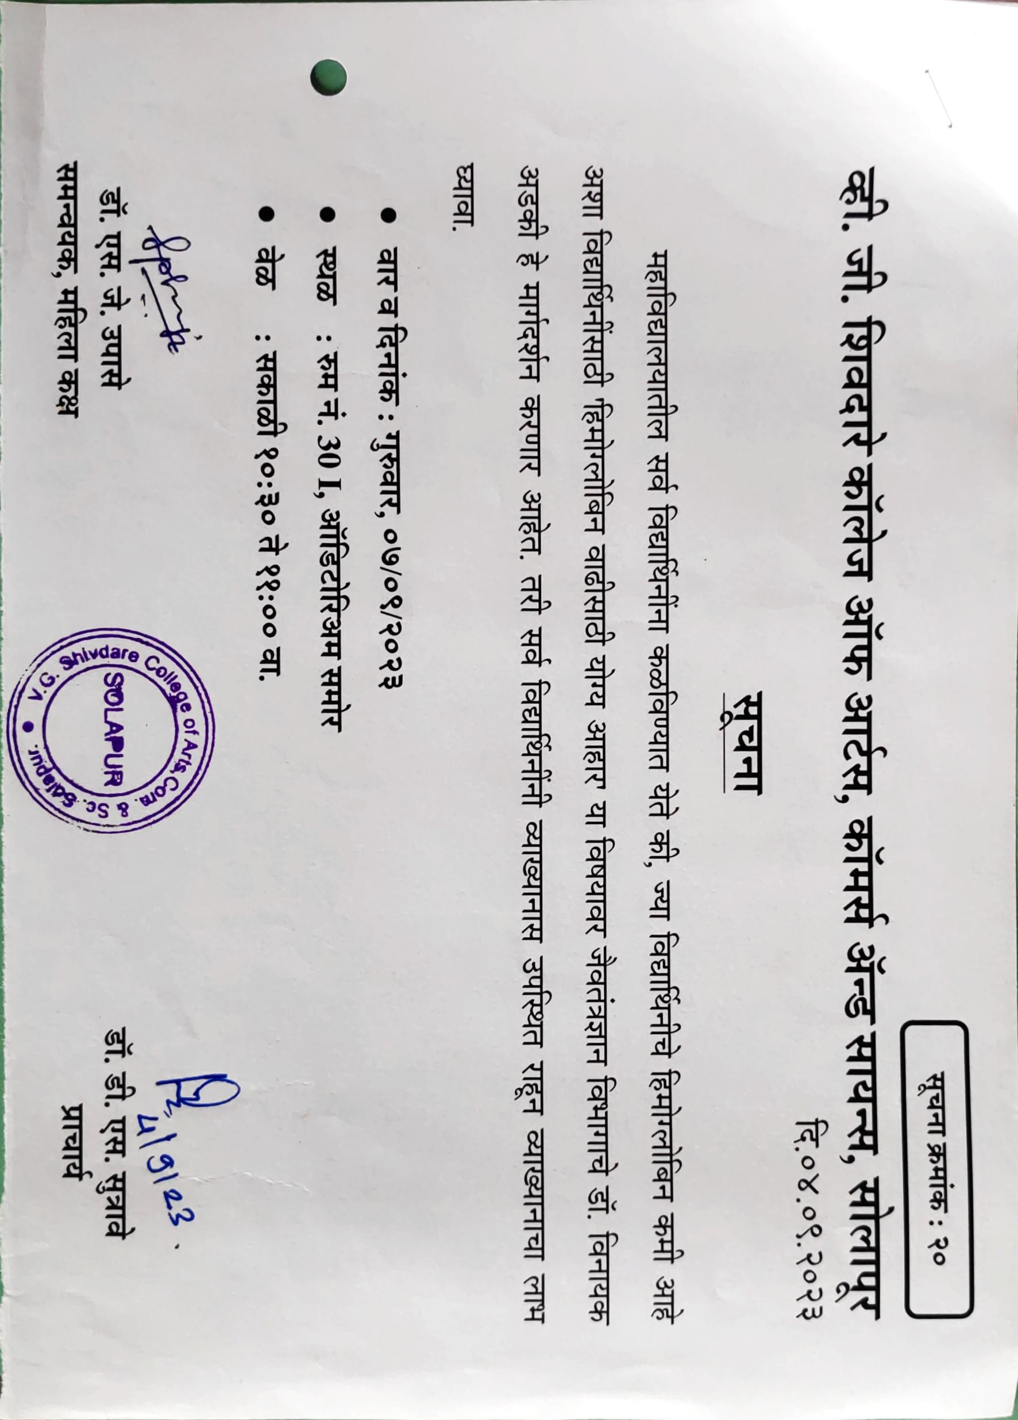
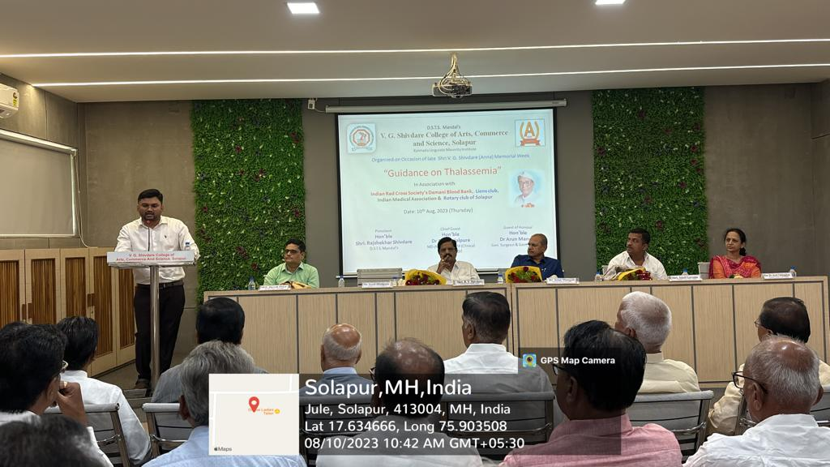
- Haemoglobin and Thalassemia awareness check-up camp for girls

- Principal Notice Haemoglobin and Thalassemia awareness check-up camp

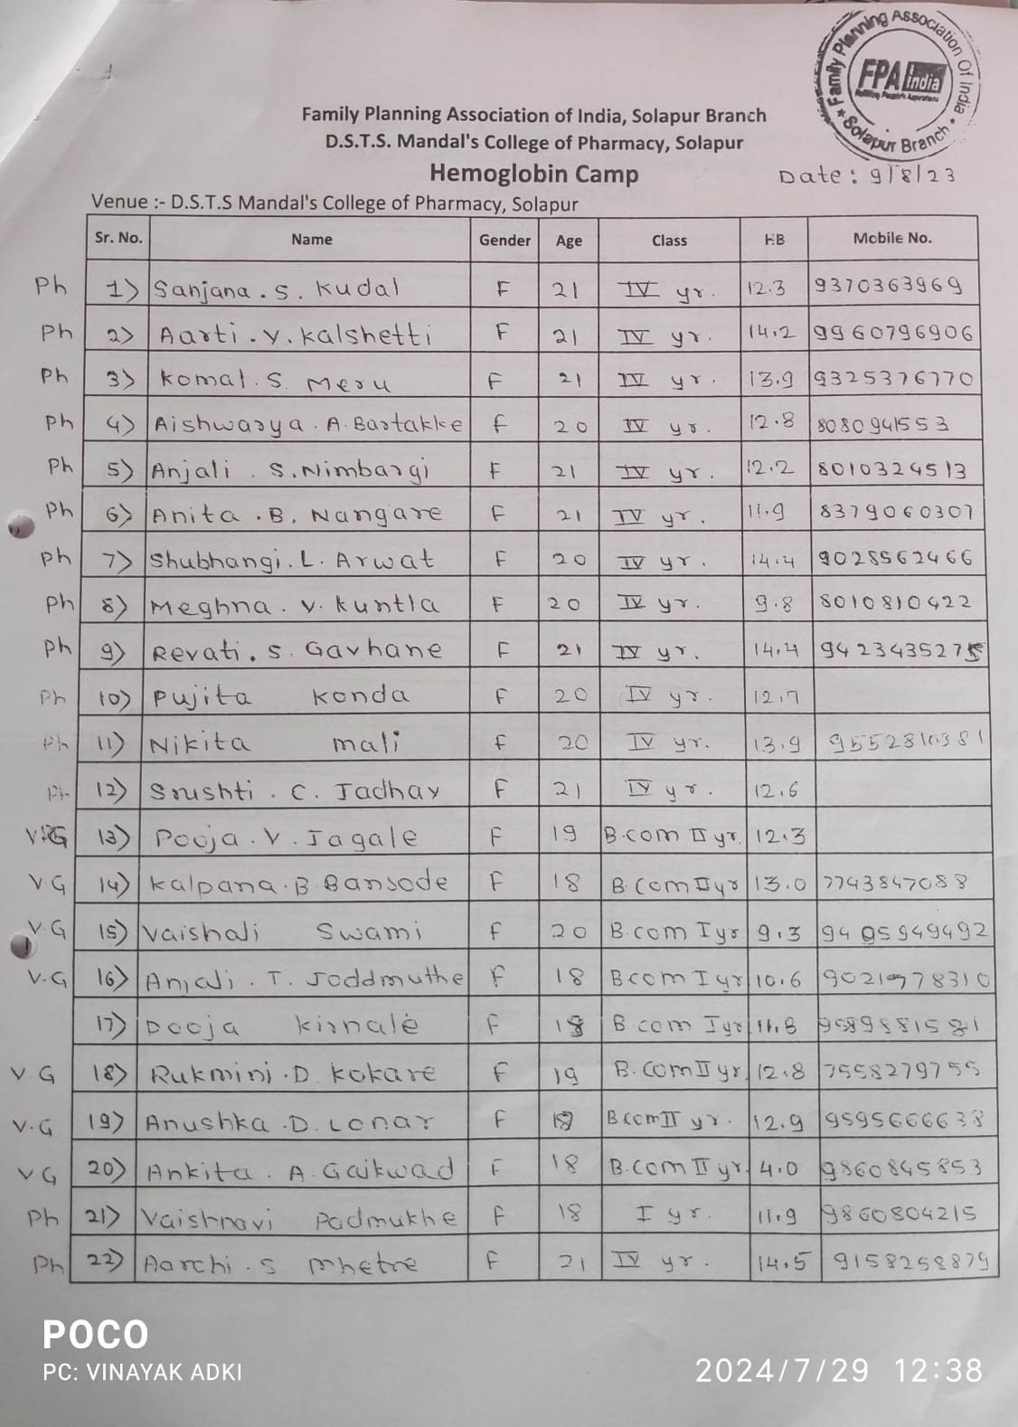
- List of Students enrolled for Check up

V.G.Shivdare college of Art, Commerce and Science
Self defence Program For girls- 2023

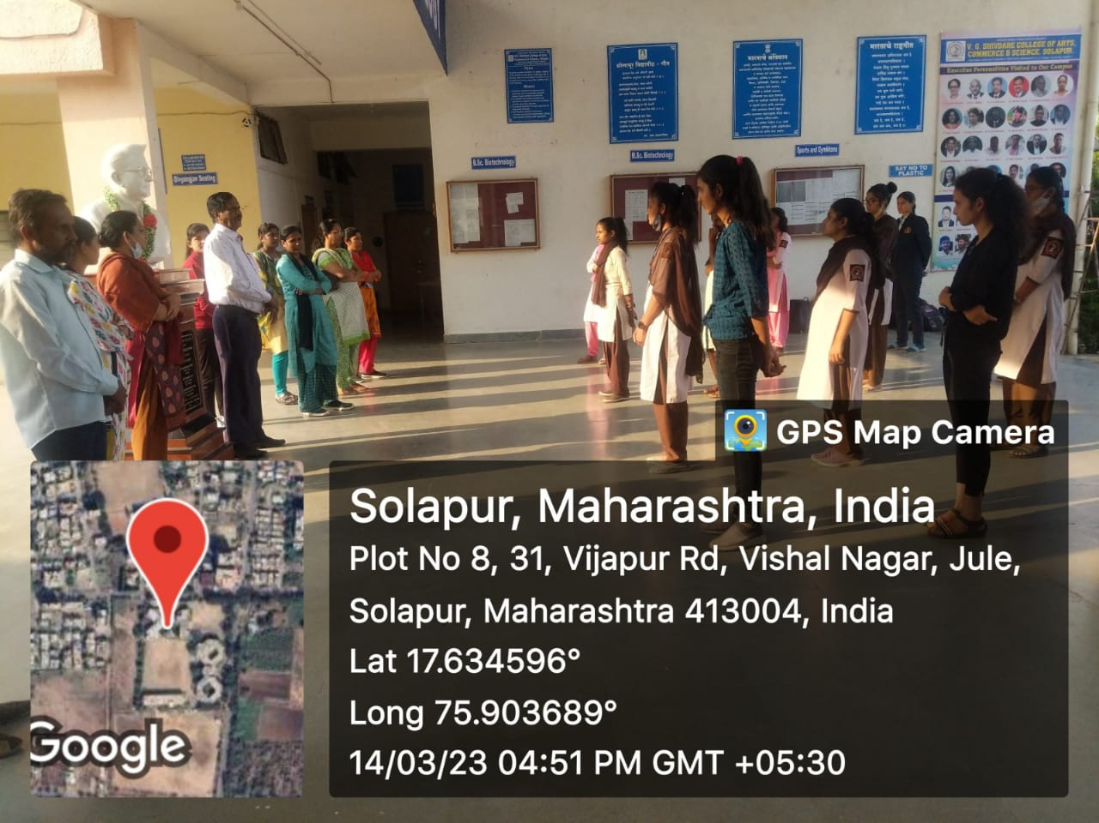
- Self defence Program For girls- 2023

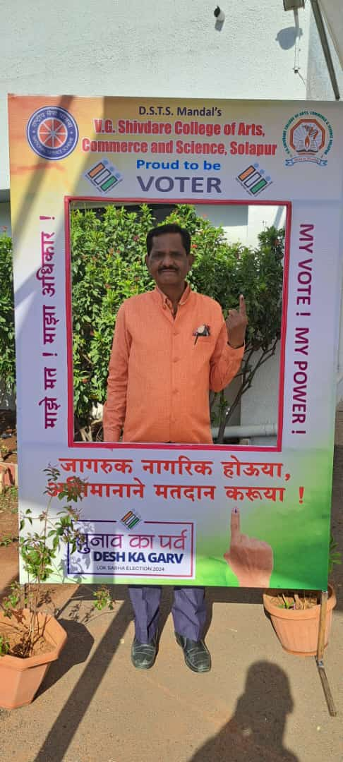
- Principal Dr. Sutrave D.S in ‘Voters awareness programm’

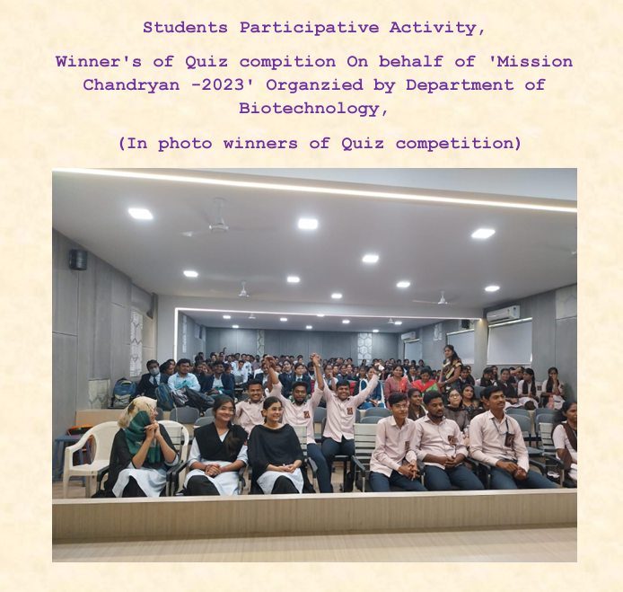
Measures initiated by the Institution for the promotion of gender equity during the
year
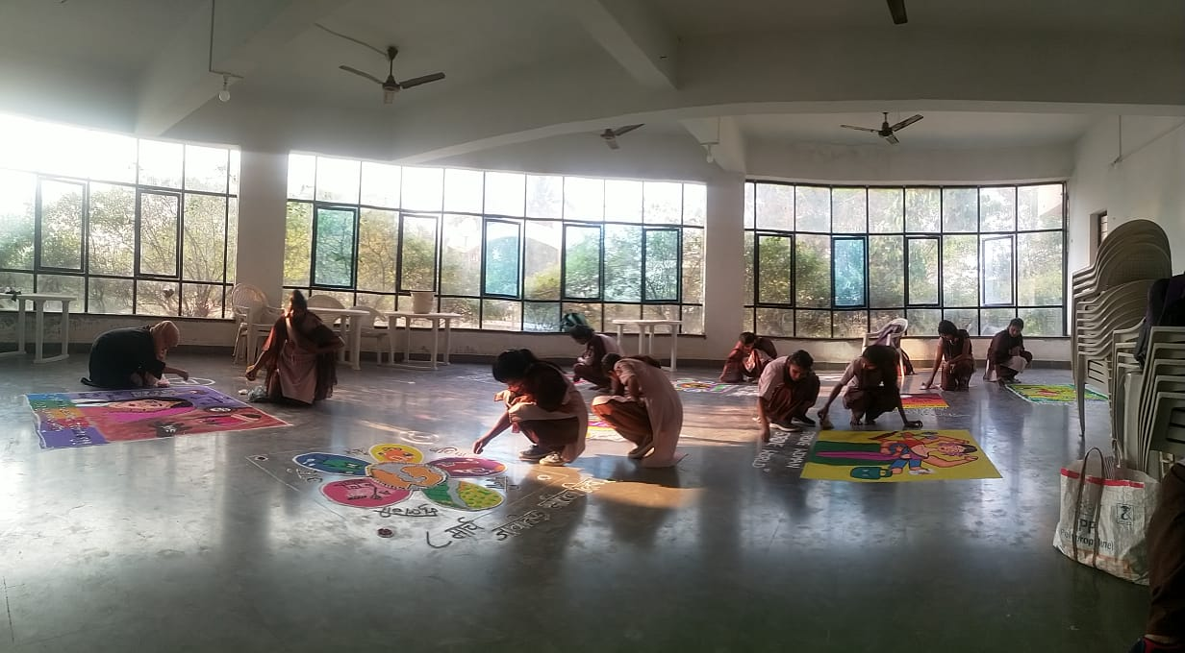

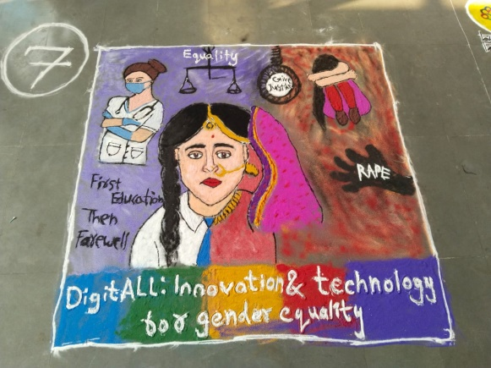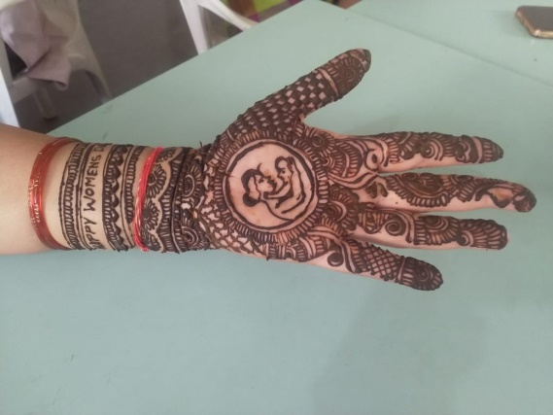

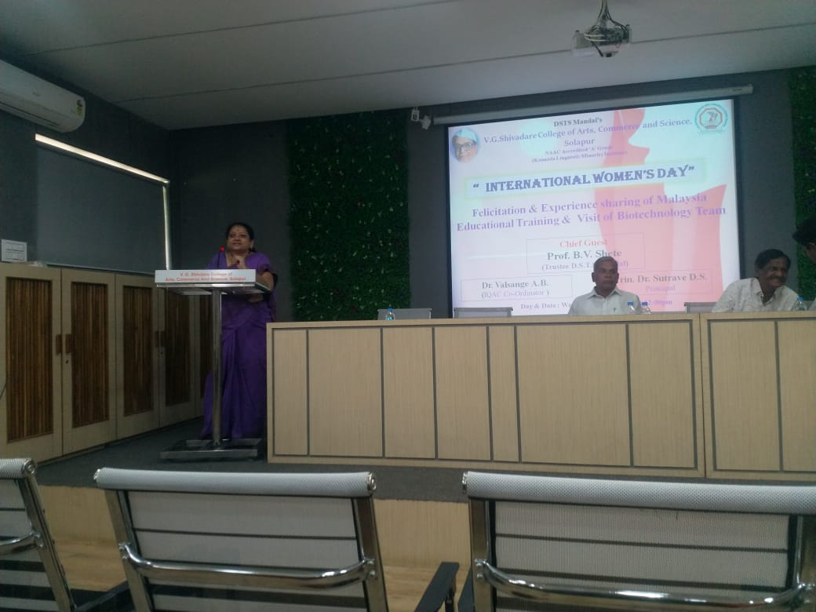
8th March 2023-Department of Biotechnology
International Womens day celebtration
Chief guest Mr. B.V Shete sir (Trustee D.S.T.S Mandal)

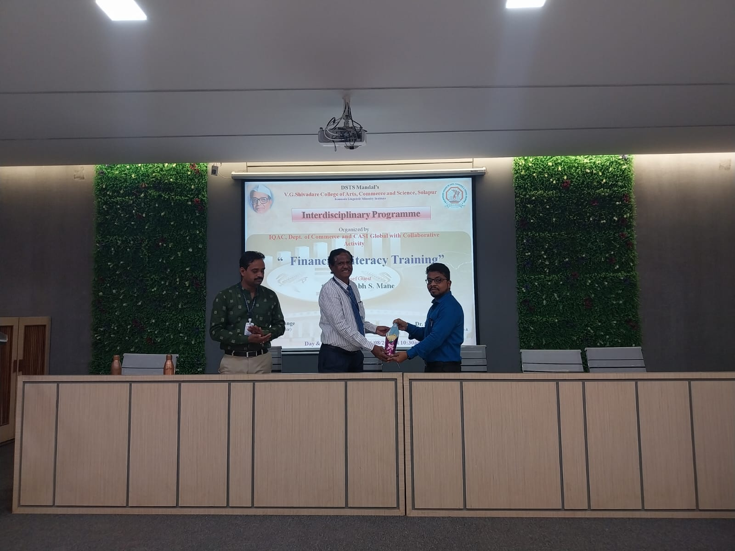
February 13 - 17, 2023 Financial Literacy week celebration
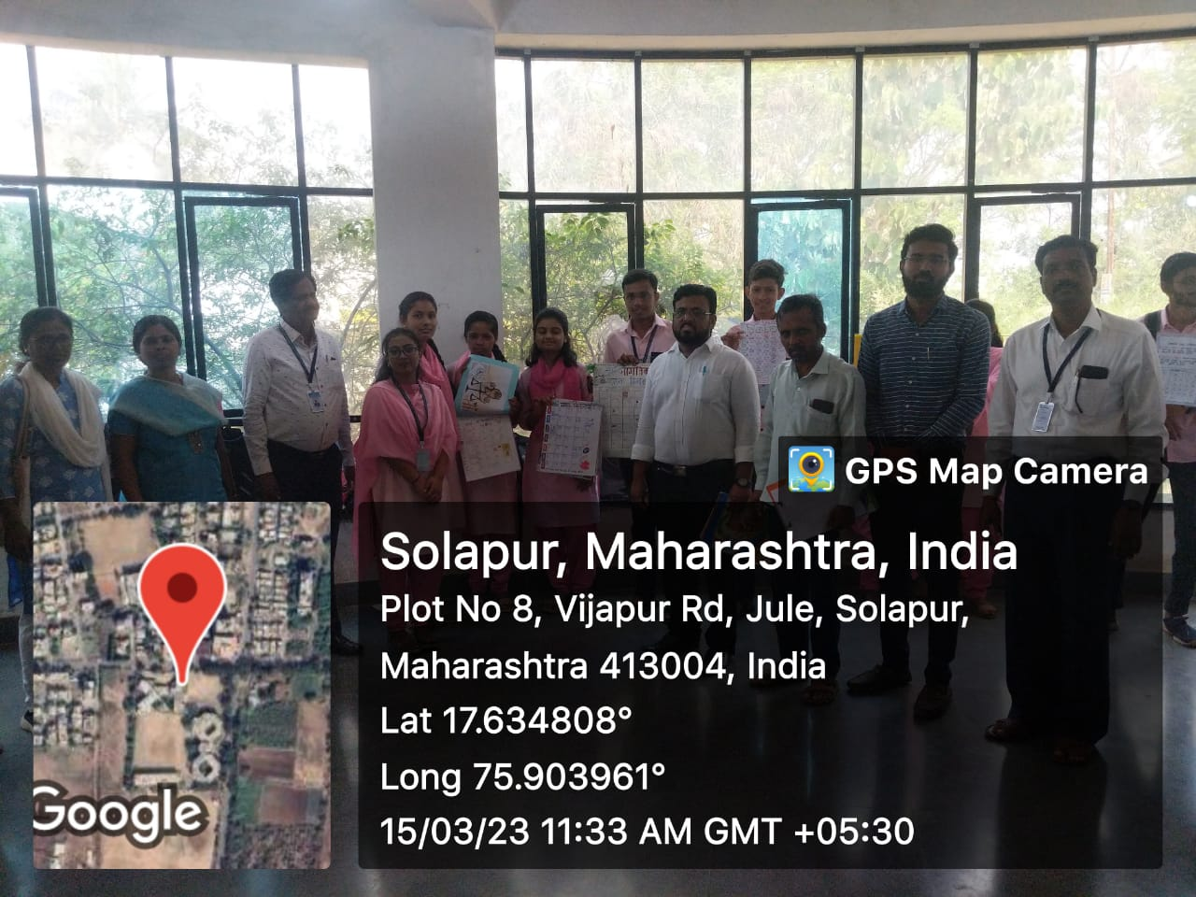
Rangoli & Mehandi Competition Occasion on International Women’s Day

