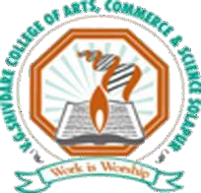

Estd. : June 2005
DAKSHIN SOLAPUR TALUKA SHIKSHANMANDAL’S
V. G. Shivdare College of
Arts, Commerce and Science, Solapur
(Kannada Linguistic Minority Institute)
(Affiliated to P. A. H. Solapur University)

Phone :0217 -2303411
Fax : 0217- 2341380

Jule Solapur-1, Vijapur Road, Solapur – 413004 Maharashtra Visit us at :www.vgshivdarecollege.com
e-mail :vgs.biotechnology@rediffmail.com / vgsprincipal@sus.ac.in

Late Shri. V. G. Shivdare  Ex. M. L. A.  FOUNDER | Shri. R. V. Shivdare  PRESIDENT | Shri. I. R. Hatture  SECRETARY | Dr. D. S. Sutrave  PRINCIPAL

6.2.1 - The institutional Strategic/ perspective plan is effectively deployed

Perspective/Strategic plan and Deployment

Perspective plan | Compliance
1. Curricular Aspects
Introduction of new certificates courses in college | During academic year college has applied for new UG/ PG certificate course program.
Introduction of free carrier guidance and prashikshan kendra center to the needy student. | Free carrier guidance and prashikshan kendra center to needy enrolled students
To seek permanent affiliation for university | Final proposal to seek permanent affiliation is sent to the university
To organize various programs in relation with NEP program | Eminent personalities were invited and various workshops were organized by all departments.
To start NEP syllabus for PG course (M.Sc Biotechnology) | As per government and university NEP syllabus  has been implemented to PG course during academic year

Perspective plan | Compliance
2. Teaching-Learning and Evaluation
Updating of computers and ICT Facility | New projectors and computers were purchased
Purchase of new library books, New laboratory equipment’s and chemicals | As per NEP 2020 new books and recent equipment’s and chemicals were purchased.
Reforms in continuous internal evaluation (CIE) for better results | Students continuous internal evaluation is carried through Various periodical tests, assignments, tutorials, seminars,  internal examinations etc.
Use of different software’s in teaching-learning process as well as in administration | During academic year 2014-2015, Licensed Educare software in administration work was introduced. During academic year 2022- 2023 windows compatible licensed software are purchased
Recruitment of qualified teaching and non- teaching staff | As per requirement, all Positions are recruited.
Implementation Mentor-Mentee system | Mentor-Mentee system was implemented in 2011 till date it is effective.
Encouragement to teaching as well as non- teaching faculty for updation of knowledge  through participation in various courses (Orientation/ Refresher/ Short term/FDP). | All teaching and non-teaching faculty memebrs are motivated for participating in various courses such as FDP, Refresher ,Short term.

3. Research, Innovation and Extension | Compliance
To achieve the excellence in research by considering local problems | Different projects considering local as well as  global problems were undertaken by UG and PG students
Establishment of Incubation center for creativity and knowledge transfer | Incubation center was established during academic year 2017. Jewamarut, Different plant growth enhancers were produced and  sold in common society by biotechnology students.
To organize conferences/ Seminars/ Workshops etc. | Different workshops, conferences, international conferences are being arranged by college.
To motivate and encourage students as well as faculty to participate in various research activities through Avishkar Research Committee | Students and staff from all the departments are motivated and allowed to participate in college level Avishkar research festivals. Awardee from such festivals and conferences are further allowed to proceed to complete their research.
To organize IPR workshop | IQAC of college ensures organization of IPR workshops, Conferences related topic periodically.
To arrange various research competitions for students | In remembrances of great scientist G.Mendel every year various debates, poster competitions are arranged. In addition to this for UG Biotechnology students a special  Certificate course in research methodology is also undertaken by Biotechnology department.
To start NCC - NSS extra unit | An extra NSS unit was stared from 2020
To encourage students for participation in various co-curricular and extension activities like NSS, DLLE, WDC, Sports, Cultural, etc. | All students are encouraged to participate in various co-curricular and extension activities like NSS, Sports, Cultural, etc.  College has received college level state level, national level in culture and sports.
To conduct various extension programs for community engagement Participation of students in administration | Meritorious and extra talented students from all the departments are motivated to take participation in different college and university  level committee.
MOU and linkages with other institutes, research institutes, industries and other bodies like NGO | College has active MOUS at national and local levels.

4. Infrastructure and Learning  Resources | Compliance
Total computerization of college central library with INFLIBNET and Delnet | Institution has a common completely atomized central library with INFLIBNET for academic year (2010-2015). Onwards SOUL  2.0 and DELNET was purchased in the A.Y 2017.

Enhancement of infrastructure facilities/ new college building (Class room, seminar hall, open theatre, auditorium hall, library, girls and boys common room, washrooms, etc.) | As per need infrastructure is upgraded periodically.
Modification in CCTV in college premises. | College premise is secured through CCTV.  Upgradation is undertaken during A.Y 2019 - 2020
Upgradation and extension of science laboratory. | As per syllabi and research orientation all laboratory were extended and modified.
Introduction of botanical garden in unused area. | College premise has medicinal and botanical garden in unused areas
Upgradation of administrative office, guest house, principal cabin, vice principle cabin and IQAC room | All needy area of administration were well furnished as per need, and full automated with modern recent computers.  IQAC documentation room is updated with separate cupboards for record keepings.
Enhancement of sport facility through indoor stadium, open ground, etc. | College has separate multipurpose hall for indoor games, as well as ground for outdoor games.
Development of college canteen Development of parking shade Modification of drinking water  facility To develop the physical facility for differently abled students (Ramp facility) | College has well developed infrastructure especially for differently abled students. There is a separate parking for boys and girls.

5. Students support and progression | Compliances
To provide scholarship of various government and non- government agencies to students. | Office assistance is provided regarding different scholarships to all students.
To register Alumni Association | Institute has registered alumni association in During academic year 2021-2022
To organize large number of capability enhancement programs such as career | College organizes various capability enhancement programs like soft skill  development, Yoga mediation personality development program, Cam Pro 2019 etc.
Encouragement of students for participation in competitive examination department | Carrier guidance center aware and guide students through about various competitive examinations after UG and PG courses.
To provide free internet and Wi-Fi | For academic purpose college offer free high speed internet through Wi-Fi service to all staff and students
To arrange workshops/ guest lectures regarding preparation of competitive examination | College arranges different workshops and guest lectures on Competitive exams after PG course like SET, NET, and GATE.
To encourage students for higher education | All UG and PG students are guided and motivated for their higher studies.
To arrange campus interview for graduated students | Campus interviews for both PG and UG students are proposed, communication with various agencies has been started from  A.Y 2015.

Book bank scheme for all students | Book bank scheme for all students is provided at department level.
To organize various camps for students (PAN card/ Bank account opening) | College organized different activities like Voter registration etc.
Renovation in first AID facility for students as well as faculty | College renovates first AID facility every year.

6. Governance, Leadership and  Management | Compliance
Development of youth and nation by providing quality education using institutes vision and mission. | College has effective deployment method in providing its own vision and mission to all needy students and to the society as well.
Implementation of E- governance in academic and in administrative work | Safe e- governance is started in all  departments of college by the from A.Y 2014
Organization of different training program for teaching and non-teaching faculty members. | Various training programs like Modi- Leepi, Faculty developments, Personality development, up gradation of E- governance and e- content developments, Laboratory safety programs, Environment cleanliness,  were undertaken for teaching and non-teaching faculty members
Felicitation of teaching and non-teaching for their extra-ordinary work | Every year, during prize distribution program teachers and non-teaching staff members are felicitated for their extra ordinary work.  Their achievements are published annually in ‘Biotalent’
To encourage students and faculty by providing funds for participation in various activities like conference/ seminars/ workshops, etc. | To inculcate recent knowledge faculty members are continuously funded to  participate in various international and national level conferences and workshops
To take quality initiatives through IQAC for academic development as well as promoting quality culture of institute | College IQAC ensures academic excellence by undertaking various programs like feedback on syllabi, teacher performances and organizing state level, national and international level workshops and seminars.  Student, staff requirements about academic  and other related co-curricular are provided as per need

7. Institutional Values and Best Practices | Compliance
Create awareness about Human rights, Women constitutional rights, voter’s right. Parliament of  religions, minority’s rules and rights and gender | College creates awareness about Human rights, Women constitutional rights, voter’s right.  Parliament of religions, minority’s rules and
equity programmes in students, staffs and local commnity. | rights and gender equity programs in students, staffs  and local community.
To celebrate the national, state, District as well as institutional importance days | National, state, district as well as important days  are renowned by arranging different program with students, staff and local community
Installation of solar energy in college campus | 10KV capacity solar systems has been installed  during A.Y 2014-2015
To impart Human values and professional ethics | Institute has conducted different Human values and professional ethics seminars and created awareness among staff and students.
To maintain clean and green campus through green practices | Clean and green practices and their maintenance of green campus, is been monitored and audited by Internal and external environmental auditor
To create ‘Lab to Land culture’ | New hydrophonic, vermicompost, organic acid production has been started. And effectively run the department o biotechnology

Syllabus of the Tissue culture certificate course

. 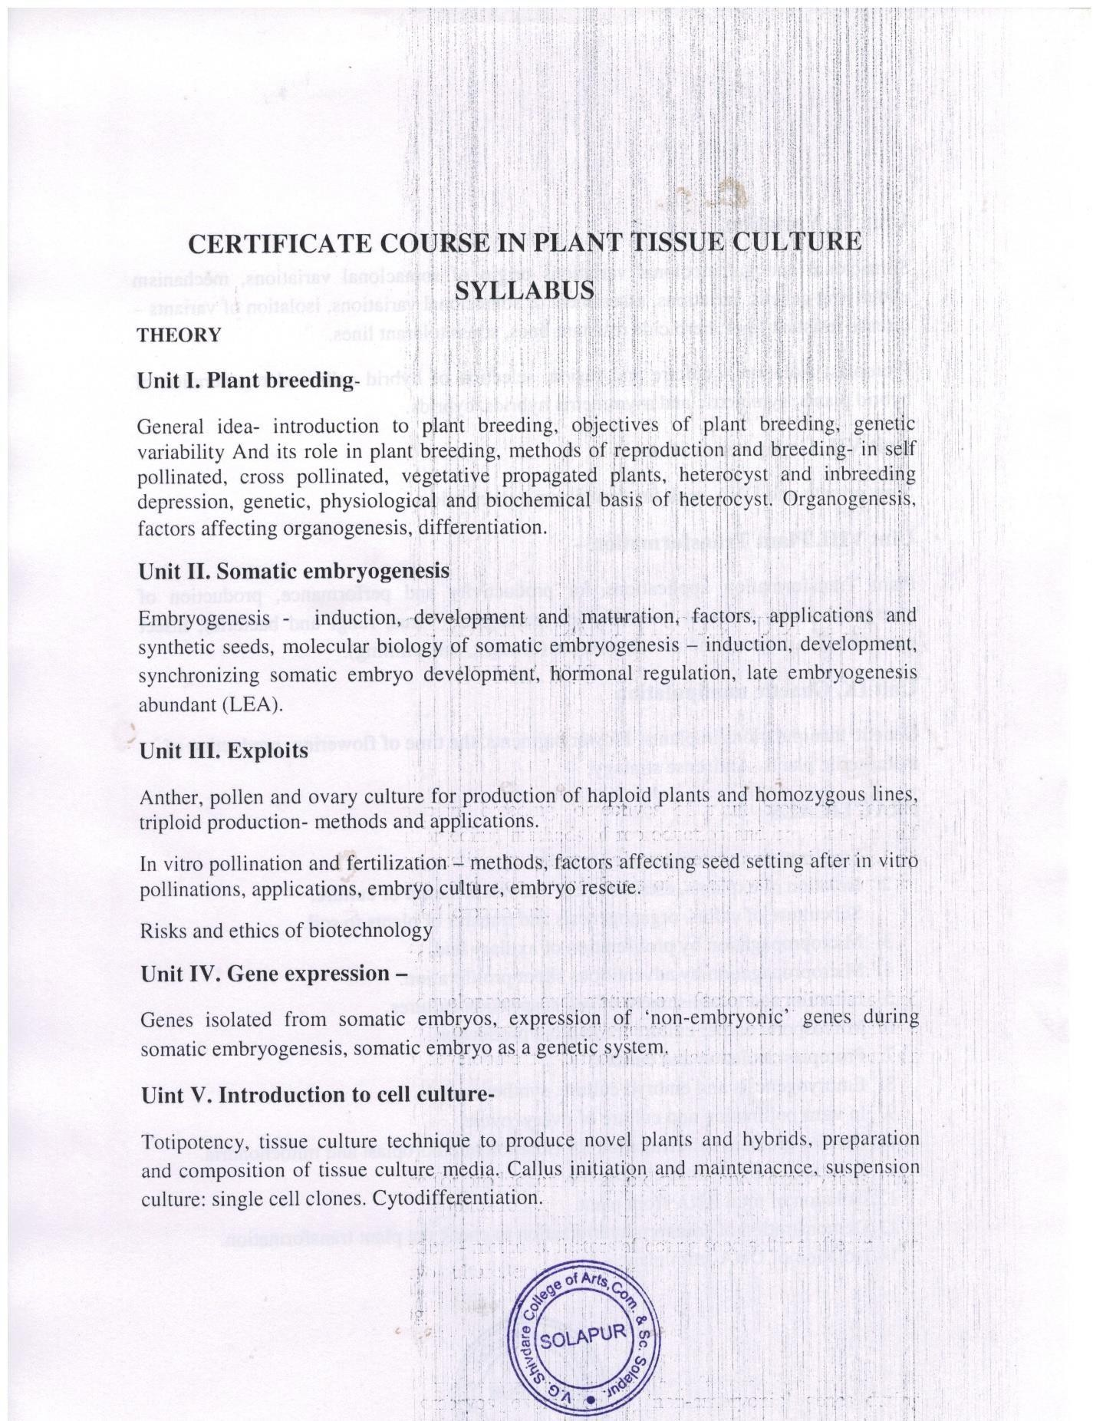

Result of the Tissue culture certificate course
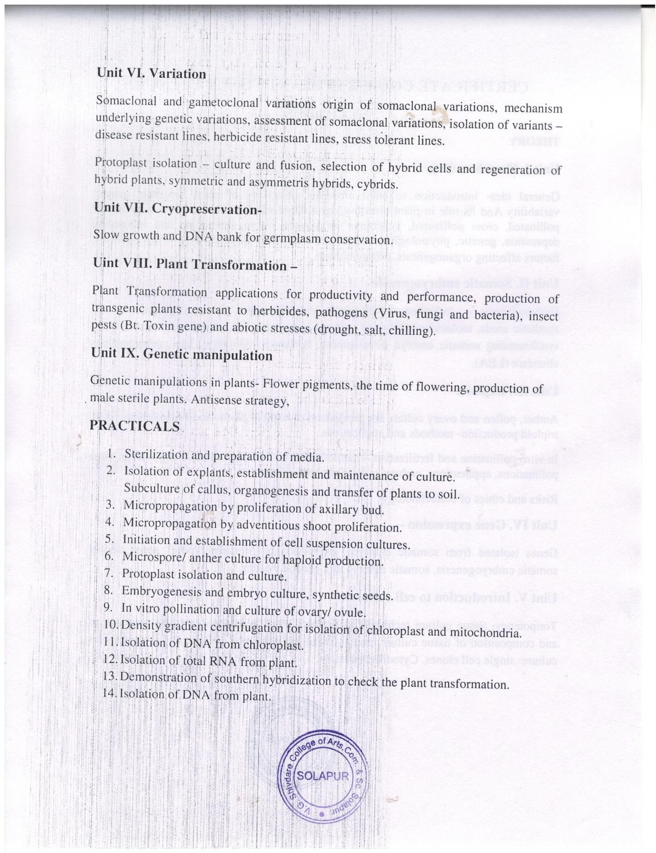

Marklist of the Tissue culture certificate course
Teacher’s appointment letter

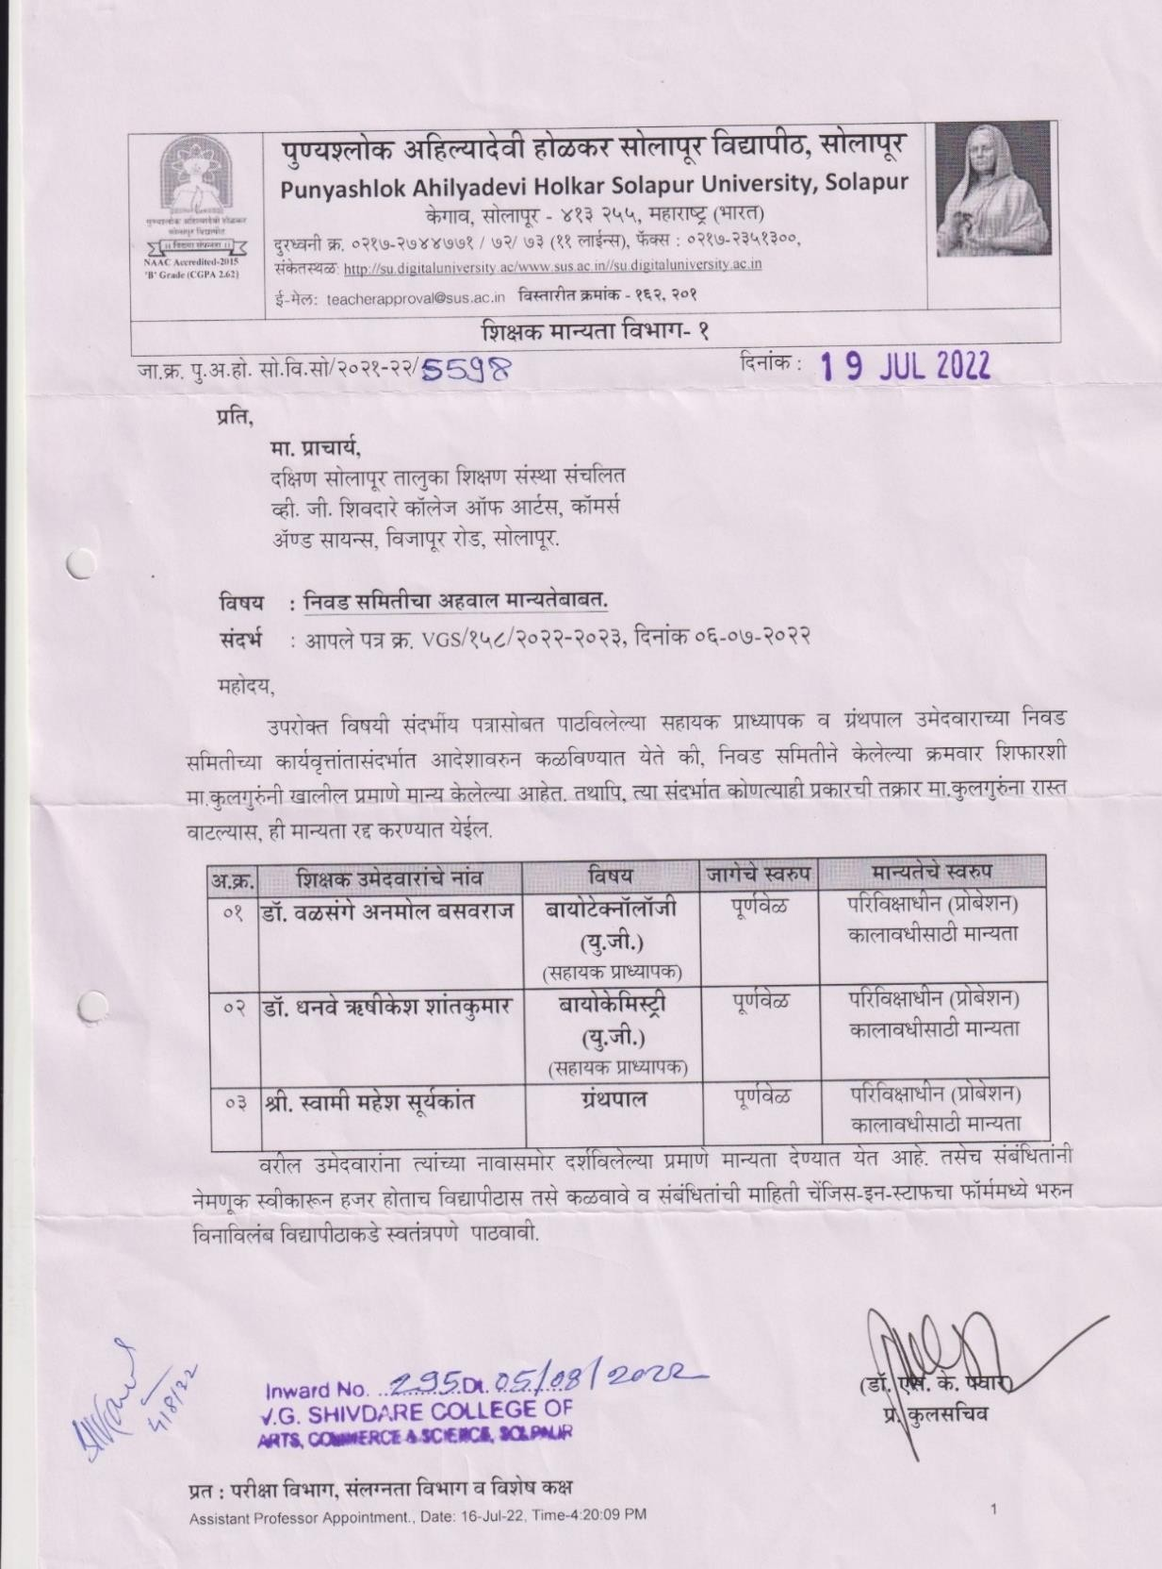

Universities’ letter of post approval

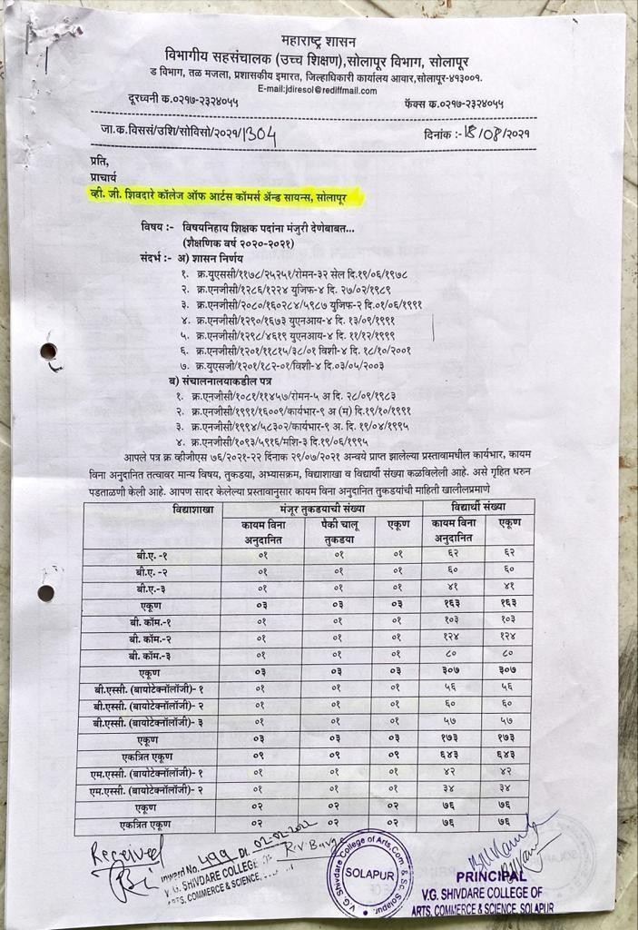

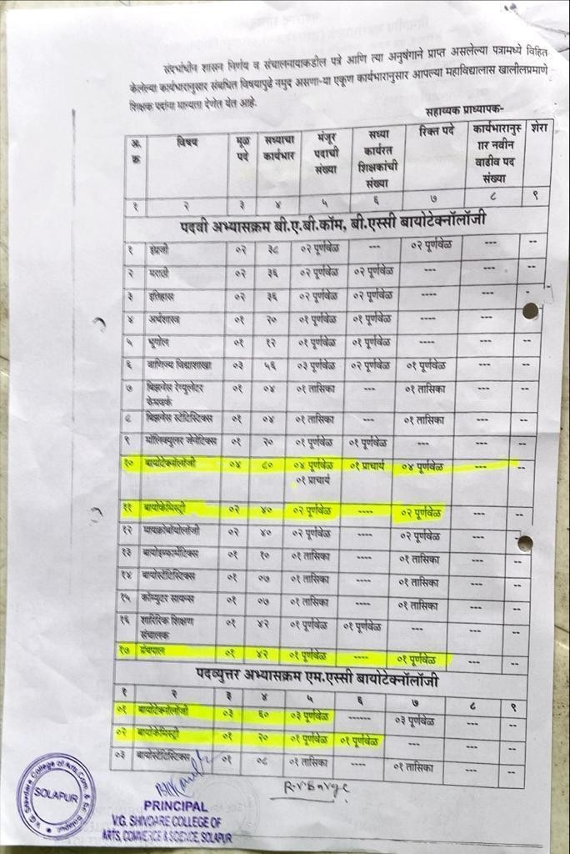

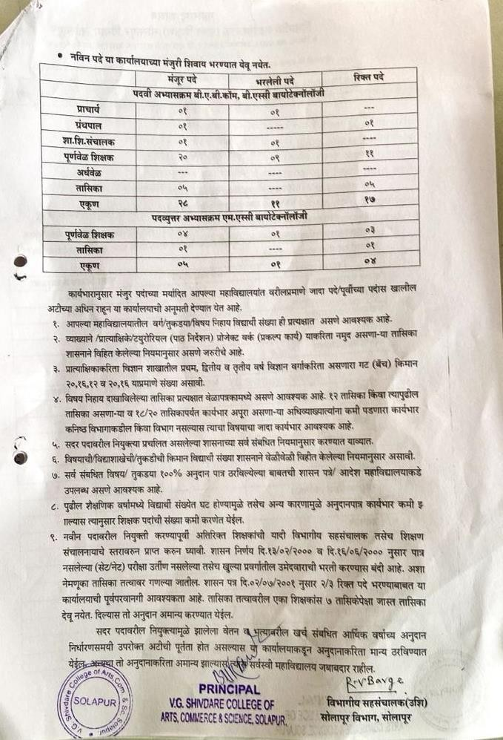

Perspective/Strategic plan and Deployment Example: Tissue culture certificate course
The short term courses will make additional values in student’s academics so college
decided to introduce short term certificate course which will be beneficial for students. This circular was initially introduced by Solapur University dated 22 June 2018. With that reference college decided to start such courses in campus. Principal and various staff members decided to start 2 certificate course in Tally (for commerce student) and Plant Tissue culture (for Biotechnology student). Various meeting were conducted to finalize the certificate course designing syllabus structure time table adjustment. Two separate co- coordinator were appointed for smooth working of course which communicate with university for fess certificate and examination. The certificate course in Plant tissue culture and Tally was started on July 2018. Total 7 students were admitted for Plant tissue culture and total 28 students admitted for Tally course.
The institutional Strategic/ perspective plan is effectively deployed Example – Certificate course in Plant Tissue culture

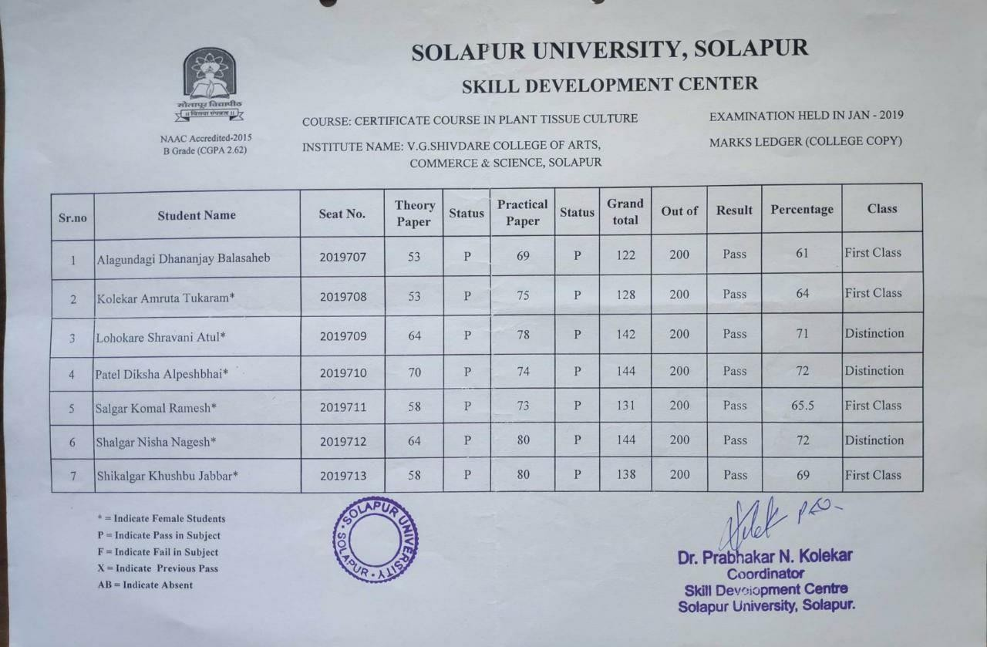

Certificate of the FDP and tissue culture

