7.1.10 The Intitution hasaprescribed code of conduct for students ,teaches , administration

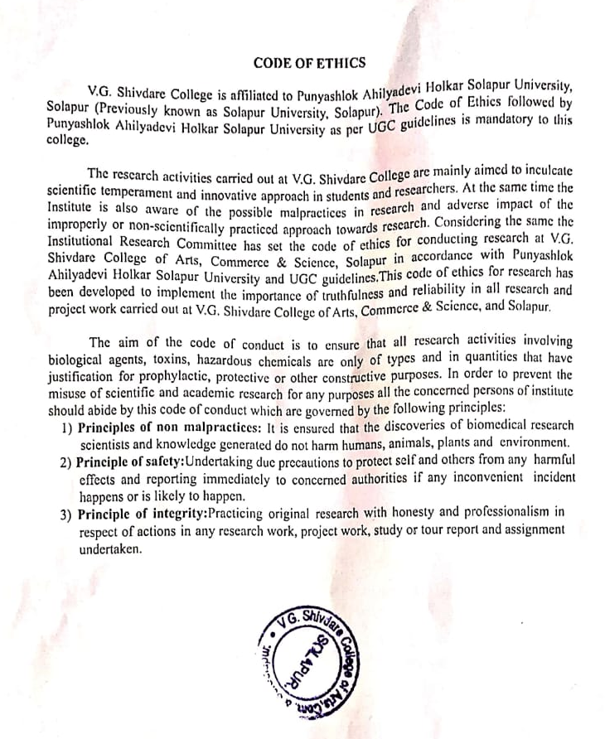

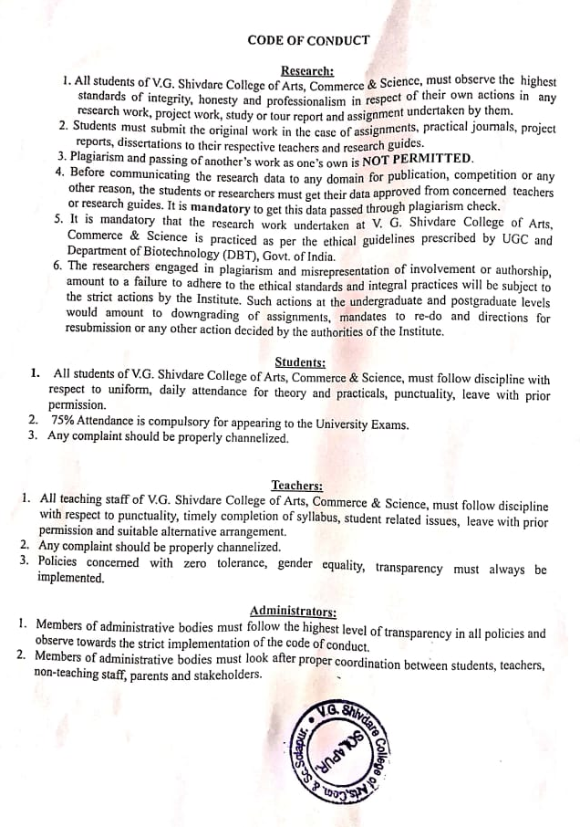

CODE OF ETHICS

V.G. Shivdare College is affiliated to Punyashlok Ahilyadevi Holkar Solapur University, Solapur (Previously known as Solapur University, Solapur). The Code of Ethics followed by Punyashlok Ahilyadevi Holkar Solapur University as per UGC guidelines is mandatory to this college.

The research activities carried out at V.G. Shivdare College are mainly aimed to inculcate scientific temperament and innovative approach in students and researchers. At the same time the Institute is also aware of the possible malpractices in research and adverse impact of the improperly or non-scientifically practiced approach towards research. Considering the same the Institutional Research Committee has set the code of ethics for conducting research at V.G. Shivdare College of Arts, Commerce & Science, Solapur in accordance with Punyashlok Ahilyadevi Holkar Solapur University and UGC guidelines.This code of ethics for research has been developed to implement the importance of truthfulness and reliability in all research and project work carried out at V.G. Shivdare College of Arts, Commerce & Science, and Solapur.

The aim of the code of conduct is to ensure that all research activities involving biological agents, toxins, hazardous chemicals are only of types and in quantities that have justification for prophylactic, protective or other constructive purposes. In order to prevent the misuse of scientific and academic research for any purposes all the concerned persons of institute should abide by this code of conduct which are governed by the following principles:
- Principles of non malpractices: It is ensured that the discoveries of biomedical research scientists and knowledge generated do not harm humans, animals, plants and environment.
- Principle of safety:Undertaking due precautions to protect self and others from any harmful effects and reporting immediately to concerned authorities if any inconvenient incident happens or is likely to happen.
- Principle of integrity:Practicing original research with honesty and professionalism in respect of actions in any research work, project work, study or tour report and assignment undertaken.

CODE OF CONDUCT

Research:
- All students of V.G. Shivdare College of Arts, Commerce & Science, must observe the highest standards of integrity, honesty and professionalism in respect of their own actions in any research work, project work, study or tour report and assignment undertaken by them.
- Students must submit the original work in the case of assignments, practical journals, project reports, dissertations to their respective teachers and research guides.
- Plagiarism and passing of another’s work as one’s own is NOT PERMITTED.
- Before communicating the research data to any domain for publication, competition or any other reason, the students or researchers must get their data approved from concerned teachers or research guides. It is mandatory to get this data passed through plagiarism check.
- It is mandatory that the research work undertaken at V. G. Shivdare College of Arts, Commerce & Science is practiced as per the ethical guidelines prescribed by UGC and Department of Biotechnology (DBT), Govt. of India.
- The researchers engaged in plagiarism and misrepresentation of involvement or authorship, amount to a failure to adhere to the ethical standards and integral practices will be subject to the strict actions by the Institute. Such actions at the undergraduate and postgraduate levels would amount to downgrading of assignments, mandates to re-do and directions for resubmission or any other action decided by the authorities of the Institute.

Students:
- All students of V.G. Shivdare College of Arts, Commerce & Science, must follow discipline with respect to uniform, daily attendance for theory and practicals, punctuality, leave with prior permission.
- 75% Attendance is compulsory for appearing to the University Exams.
- Any complaint should be properly channelized.

Teachers:
- All teaching staff of V.G. Shivdare College of Arts, Commerce & Science, must follow discipline with respect to punctuality, timely completion of syllabus, student related issues, leave with prior permission and suitable alternative arrangement.
- Any complaint should be properly channelized.
- Policies concerned with zero tolerance, gender equality, transparency must always be implemented.

Administrators:
- Members of administrative bodies must follow the highest level of transparency in all policies and observe towards the strict implementation of the code of conduct.
- Members of administrative bodies must look after proper coordination between students, teachers, non-teaching staff, parents and stakeholders.

