7.1.11 Intitution celebrates/ organises national and international commemorative days , events and festivals
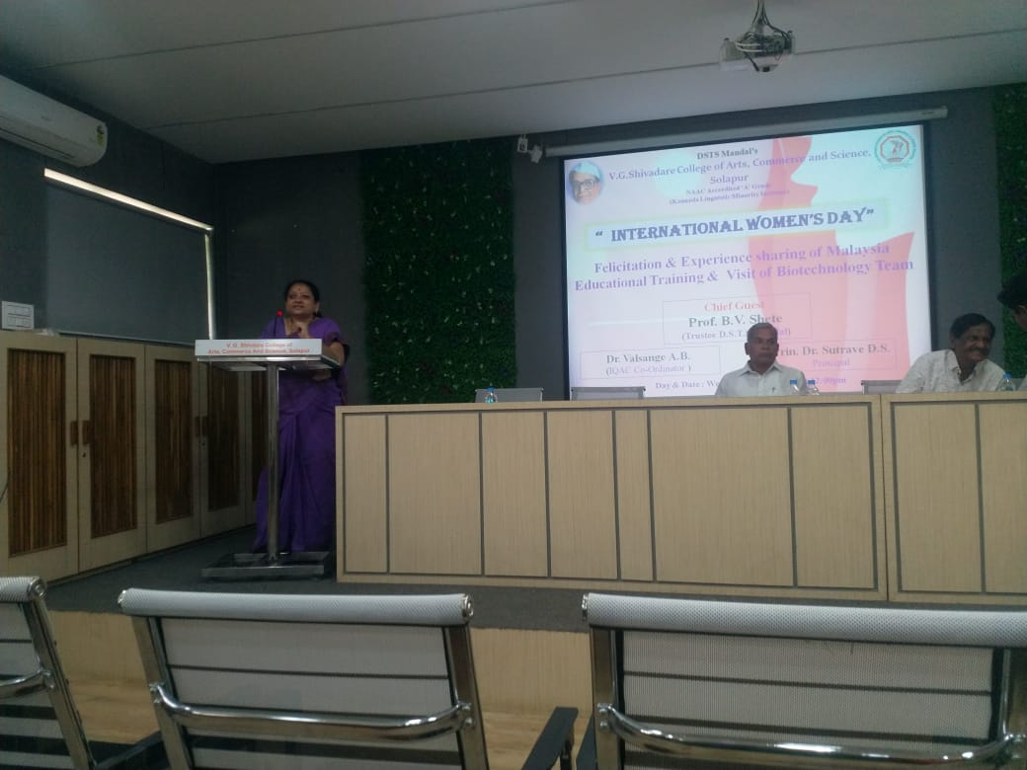
a) International Women’s Day
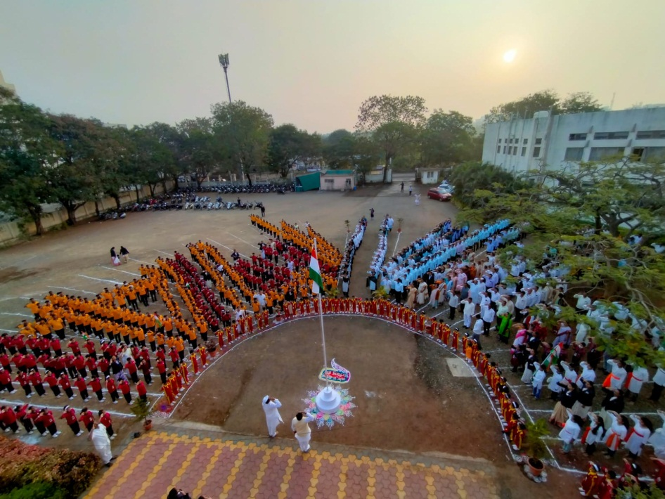

- Republic day celebration

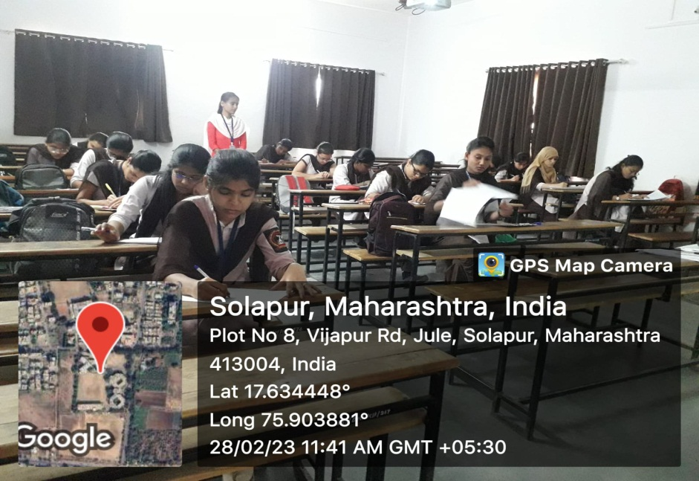
d)Science Day 2023 celebration with Guest Lecture and Essay Competition
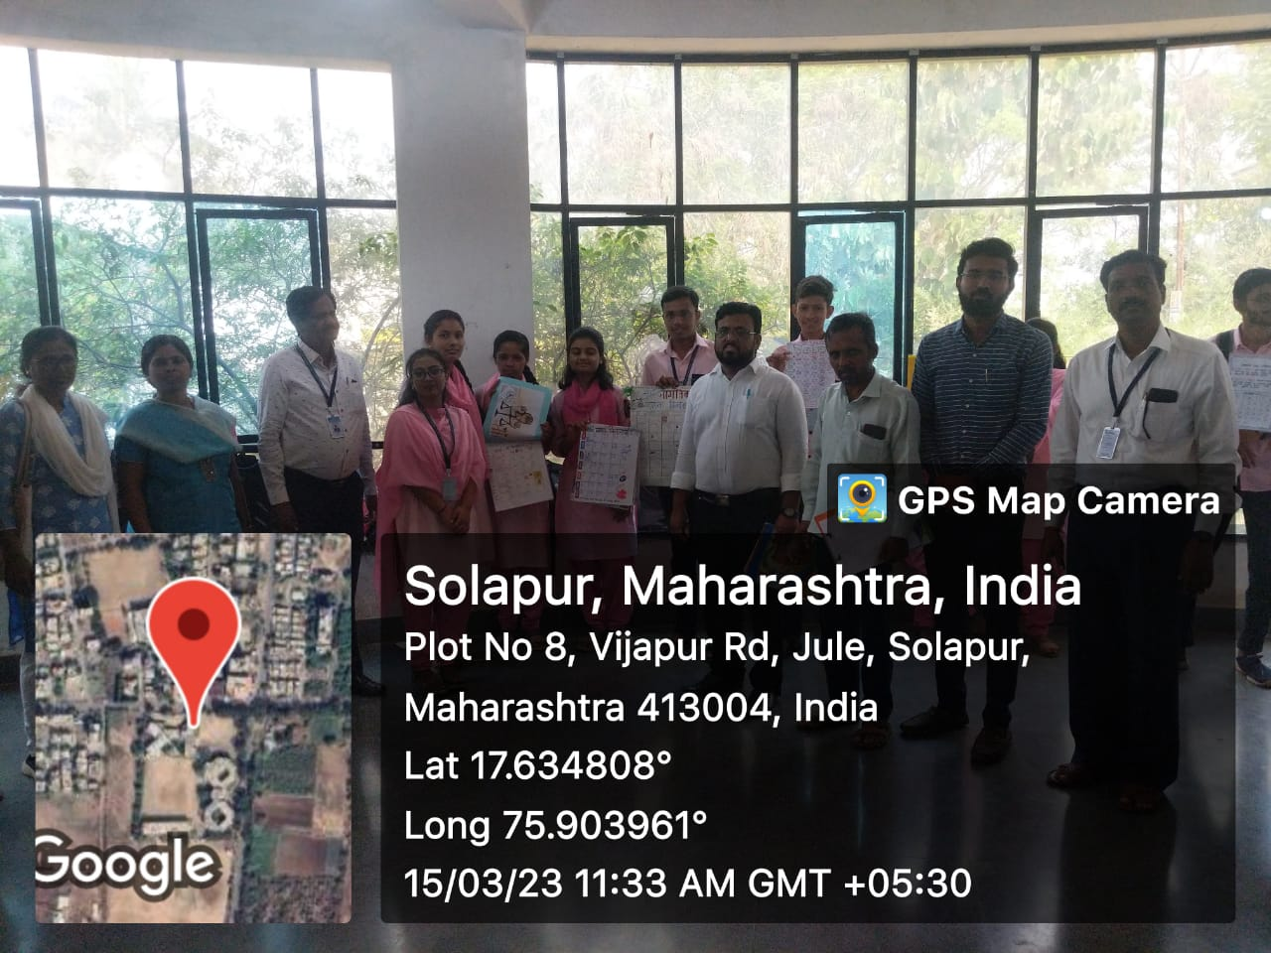
e)World Consumer Day Calendar Competition
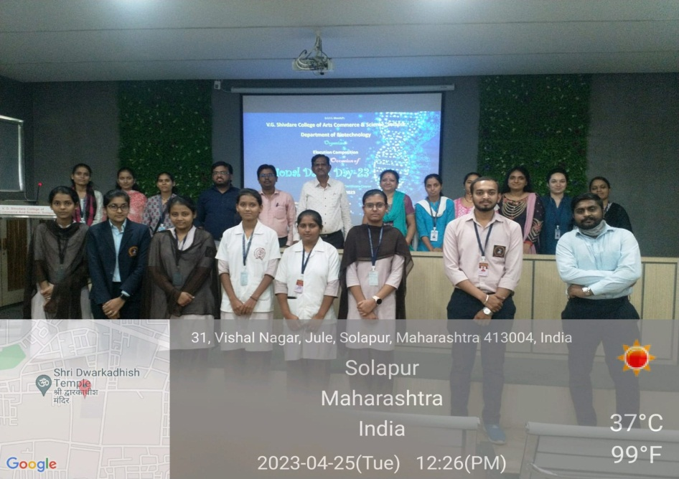
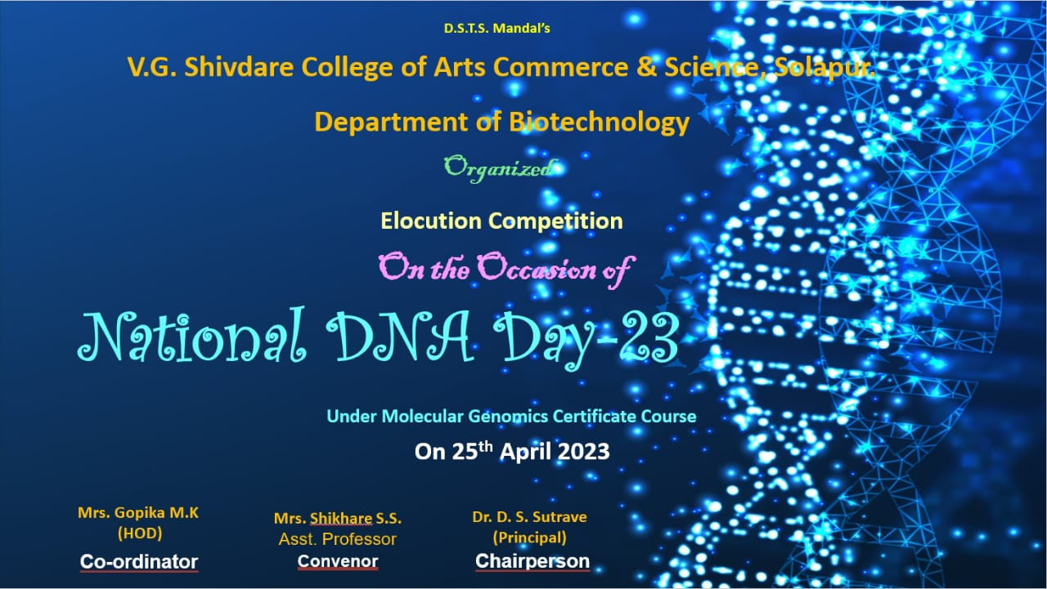

f) National DNA Day celebrated by department of biotechnology
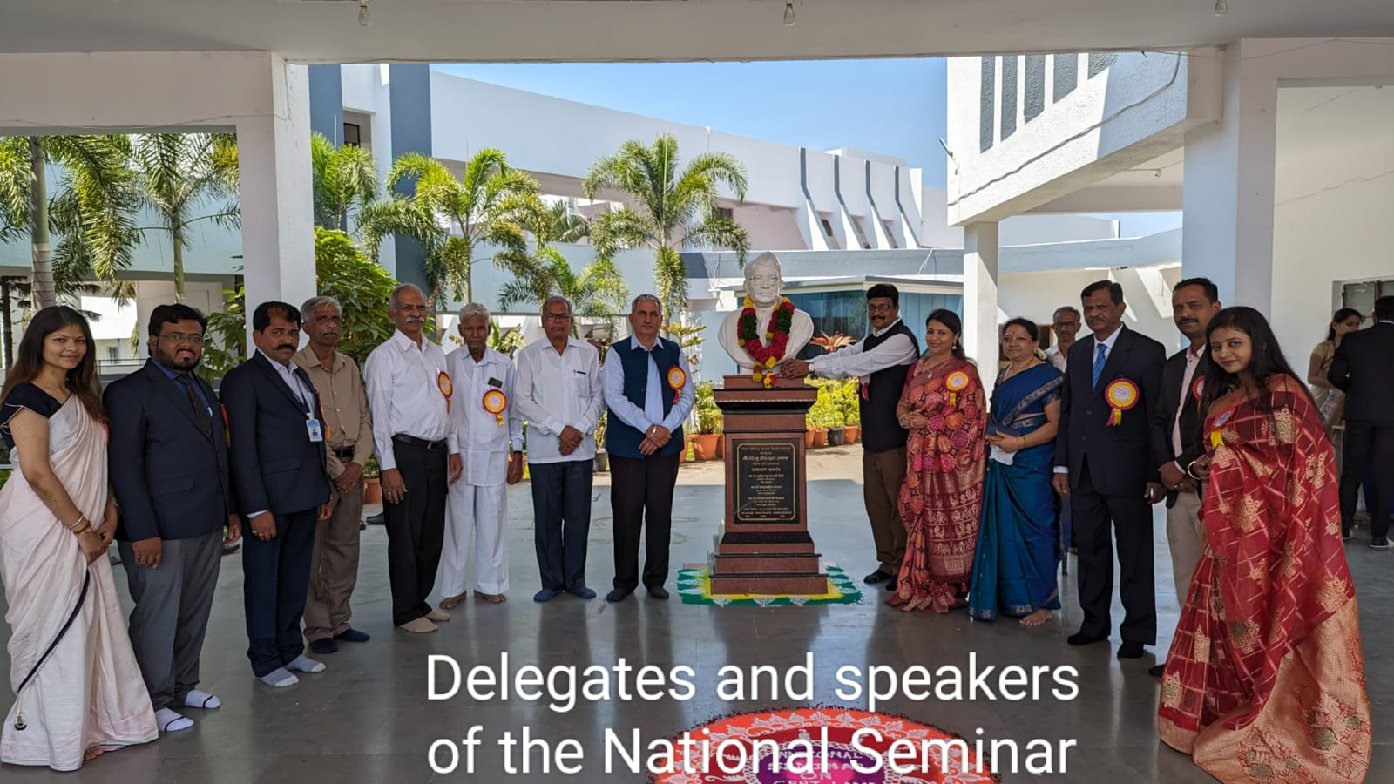
g) National Seminar on Tpoic ‘Cutting edges in research’ by department of biotechno

