Criteria 7.1.2
The Institution has facilities for alternate sources of energy and energy conservation measures
Solar energy
Wheeling to the Grid
Sensor-based energy conservation
Use of LED bulbs/ power efficient equipment

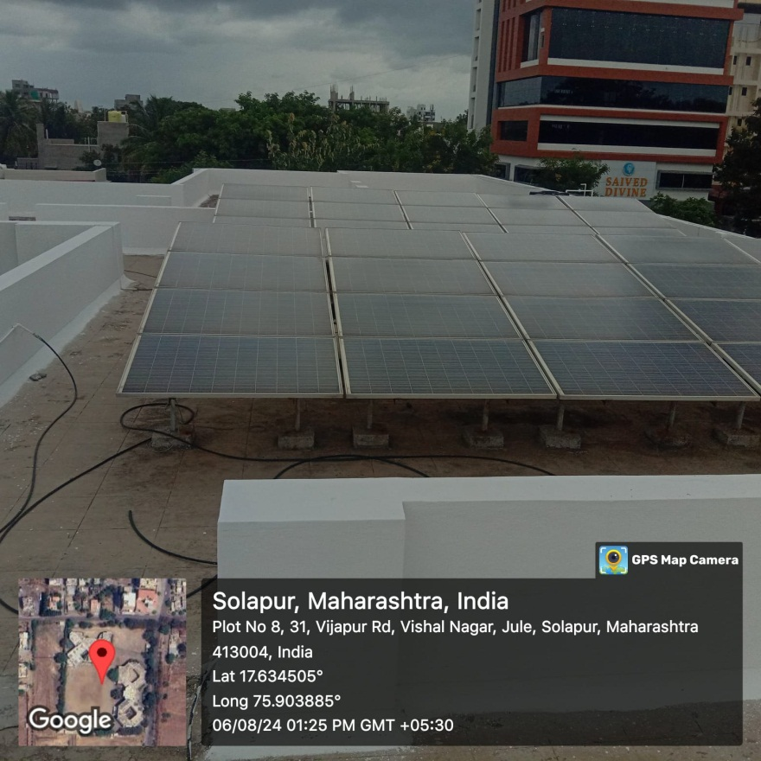
- Use of Solar ensrgy

Wheeling to the Grid

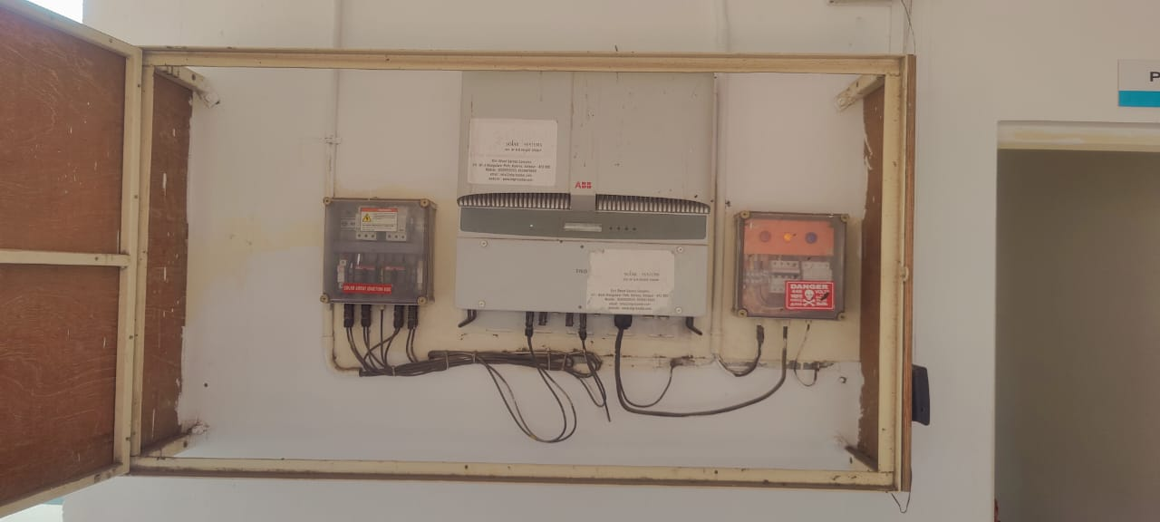

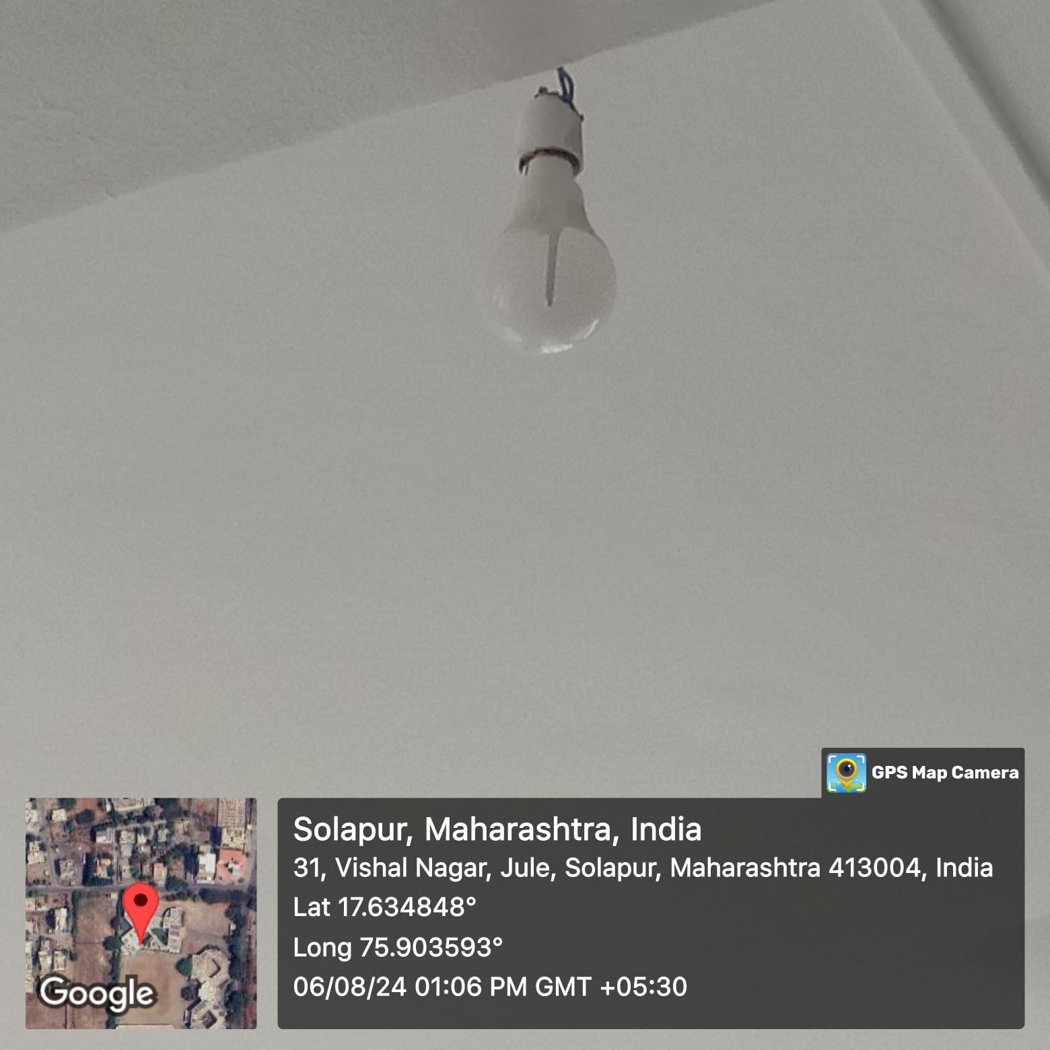
b)LED bulb using in the campus

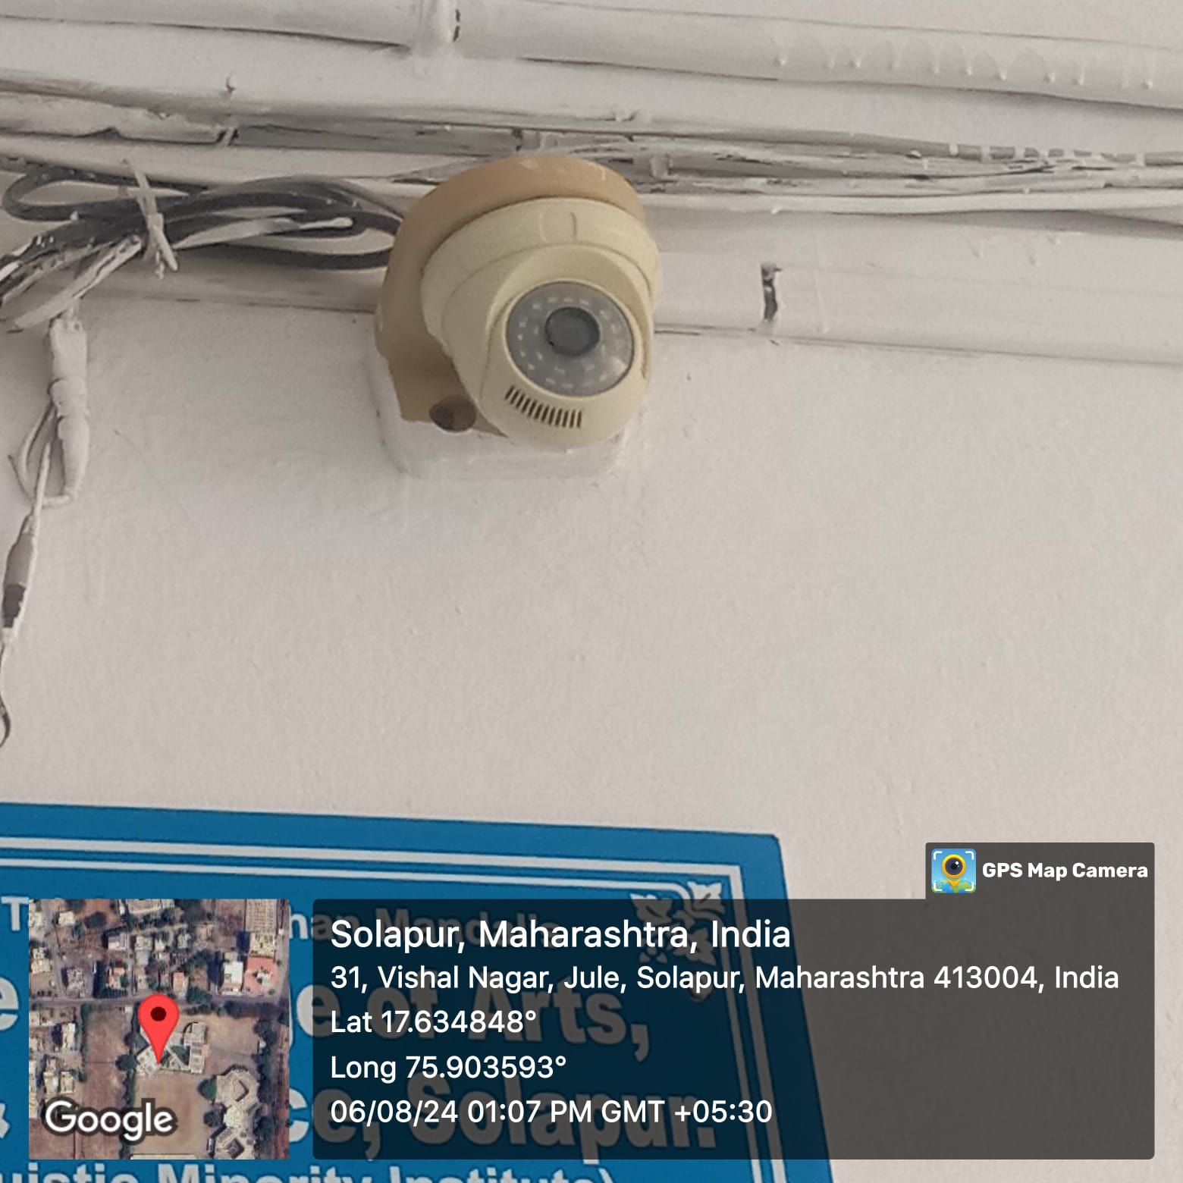

- CCTV Cameras were instolled in the campus for security purpose

