Criteria No.7.1.7
Two Best practices successfully implanted by the institution as per NNC format provided in the Manual
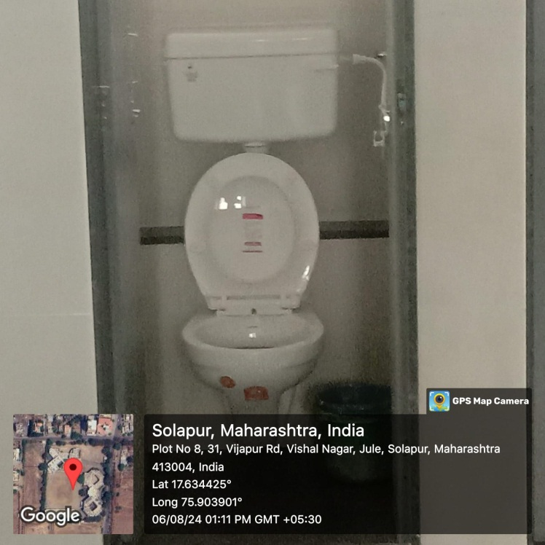
i)Western toilet
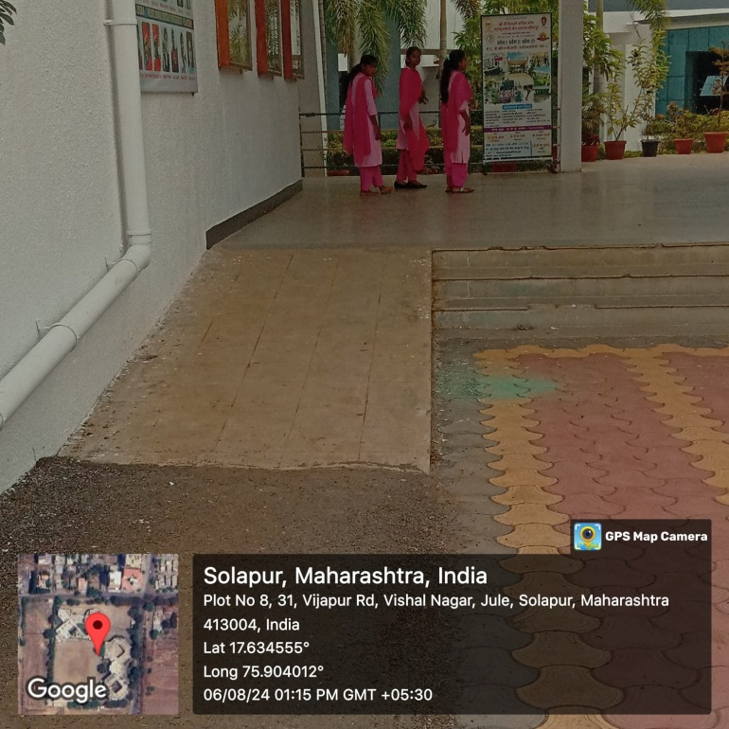
a)College developed new facilities for differently abled student( i) Western style latrin (ii) road for wheel chair

